Library Annual report 2015-16

Support for Staff and Students

Library Redevelopment
The University made a significant investment in the redevelopment of Levels 1 and 2 of the Library. This has increased capacity in the Library by over 250 seats, created an active learning zone on Level 2, where students can configure the space to meet their needs, and individual study spaces on Level 1, many with their own power and lighting. In addition, there is a new exhibition area open to the public, enhanced conservation and digitisation facilities There are two small auditoria on Level 2 (Kelvin and Clyde), which are available for use by staff, students and other Services. These redeveloped spaces opened in July 2016 and have been well received, and heavily used, by students. The Library redevelopment was supported by a generous donation from the Friends of the University of Glasgow Library and by a significant bequest from Noreen Scobie, an alumna of the University.

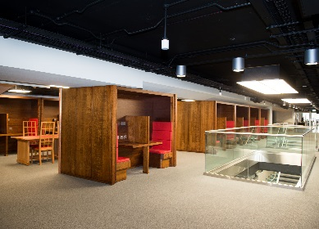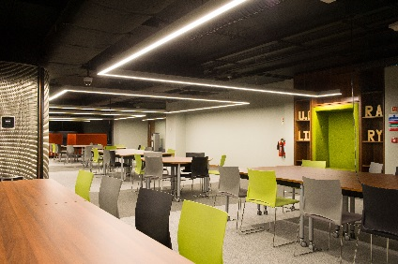
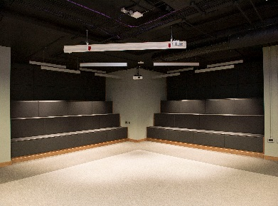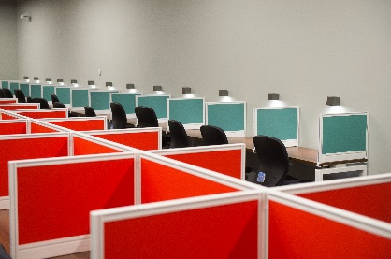

The Library has also created a new Reflective Space on Level 6, in consultation with the University Chaplain and Student Representative Council, which is available to students who wish to pray or take time for quiet reflection.

Research Information Management Services
The REF Open Access Policy was introduced in April 2016 and the Library launched new systems to support compliance with this policy. These include:
- A standard process to facilitate REF requirements for each publication
- Provision of regular reports by School and College
- Integration of open access information and reporting to funders into the Enlighten repository.
Enlighten has been updated to support the University’s preparations for the next Research Excellence Framework (REF) exercise, with an enhanced REF Selection Tool which will clearly shows staff if their selected publications are compliant with the REF Open Access Policy.
A new institutional KPI for research output quality was approved by the University Senior Management Group in May 2016.The Library calculated this Research Output KPI in June and delivered a baseline for Institutional and College level data from 2012-15. The Research Output KPI is underpinned by the SciVal bibliometric tool, to which the library has subscribed. SciVal is being used in a number of ways across the University, for example to support the Interim Research Reviews, to identify international collaboration opportunities and to inform recruitment activity.

Enlighten
Enlighten was updated with a new responsive web design in October 2015 which brought all the Enlighten services into line with the University’s online look and feel. This update has improved access from mobile devices and now provides a seamless user experience from staff profile pages to publications.
The new “look and feel” was an opportunity to consolidate and update Enlighten as the brand for our overarching repository services:
- Enlighten: Publications (formerly just Enlighten)
- Enlighten: Theses (formerly the Glasgow Theses Service)
- Enlighten: Research Data
A new Enlighten: Search service was launched, to search across Publications, Theses and Research Data. This was done in collaboration with the University Web Team. The new Enlighten home page also provides ready access to information about Open Access, the REF and ORCID.
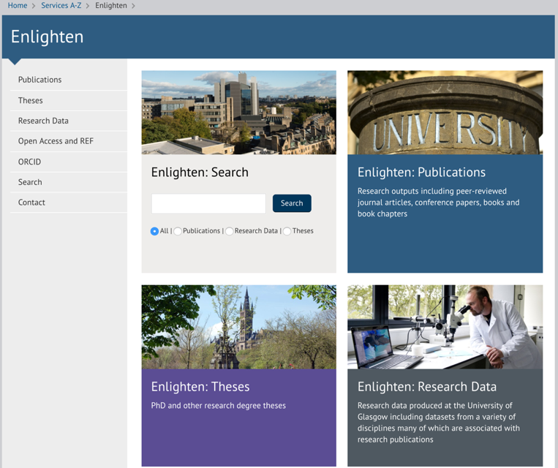
.
Knowledge Base and Information Skills Training
Launched in September 2016, after a successful bid to the University’s Strategic Investment in Online Course Delivery initiative, the Knowledge Base is developing a suite of digital and information literacy skills teaching resources for online delivery within BOLD, MOOC and Moodle courses.
The Library has produced a centralised online resource, which includes a student-led Library tour, help guides, links to bookings for personalised tours, interactive floorplans for each of the branch libraries and a Library Basics Moodle Course. This course provides information about the Library Services, College Librarians, Branch Libraries, Tutorial videos for software and equipment, key links and contacts. http://www.gla.ac.uk/services/library/usingthelibrary/librarybasics/
Reading Lists @ Glasgow
There were 840 lists available via Reading Lists @ Glasgow at the start of the 2016/16 academic year, with 51,603 individual items (an average of 61 per list). This is a significant increase of 255% on 2014-15. By October 2016, the number of reading lists had risen to over 1140. There were 950,999 page views in 2015-16 and four first-year undergraduate lists had over 10,000 page views with a key History list getting 19,007 page views.
The first full year of using the Talis Digital Component module has vastly improved the student experience, as there is no need for the user to authenticate to access digitised readings outside of the reading list, and this increased usage by 113% year-on-year. Digitisation of course materials continues to be popular, with 1600 readings made available for over 15,000 students.
Agile Services
Library Services are now successfully operating from levels 1, 2 and 3, delivering flexible, agile services from the Welcome Desk, High Demand Collection and a variety of pop-ups across the three floors depending on the demand at the time. This model will be extended to the upper floors over the course of the coming session, making maximum use of new technologies and existing staff expertise, and feeding into the development of service models for the Learning and Teaching Hub.

Our social media profile continues to grow, with approximately 5,500 followers on Twitter, 7,500 likes on Facebook and 7,200 followers on Instagram. Social media is now our primary method of communicating with our students, and the University’s Social Media Manager recently used our output as an example of best practice.

Maximising use of our Collections

Friendly Shelves

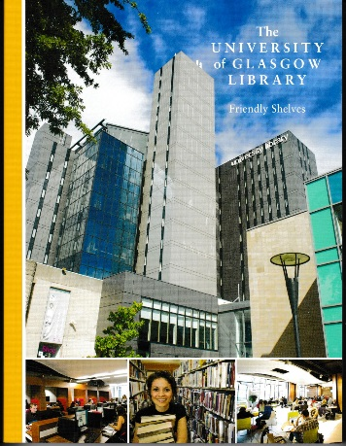

The Library and academic staff in the College of Arts worked closely with the Friends of the University of Glasgow Library in the production of the publication Friendly Shelves, produced to celebrate the 40th Anniversary of the founding of the Friends. Graeme Smith and Peter Davies of the Friends, and Lesley Richmond from the Library, put in a huge amount of work to ensure the success of this book. The book was launched at a well-attended University event in June hosted by Professor Frank Coton and with presentations from the National Librarian, Dr John Scally and from Professor Laurence Grove. The Friends of the Library undertook public engagement surrounding the book’s publication and have provided copies of Friendly Shelves to libraries across Glasgow and to Scottish University Libraries.

Public Engagement

There was great interest following the announcement in September that an anonymous donor had stepped in to purchase the papers of Benjamin Clapp, assistant to John Logie Baird, for the nation, and wished to donate the archive to the University of Glasgow. The Friends of the Library generously supported the development of supporting research materials with the purchase of the first five volumes of Television: The Official Organ of the Television Society (March 1928-December 1932)

On campus we partnered with The Hunterian to showcase University collections in three Night at the Museum events (attracting external sponsorship and attended by 2000 people) and in a major exhibition in the Gallery where 17 key items featured in the Comic Invention exhibition.

We exhibited the Library’s First Folio and other Shakespeariana at Dream On! the celebration of the 400th anniversary of Shakespeare’s death.

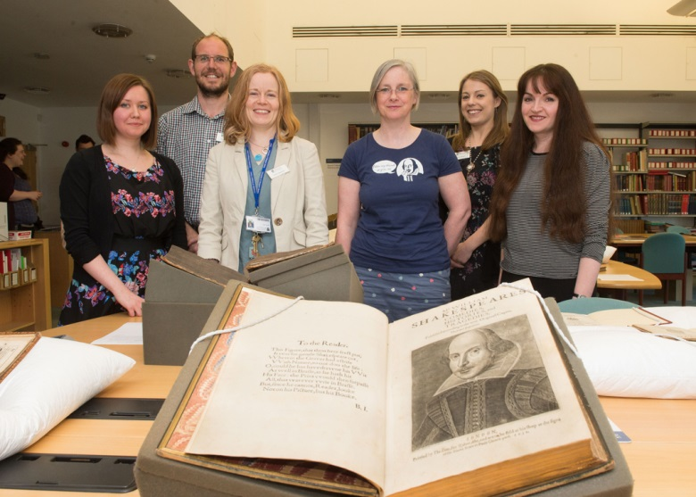

We enhanced the University’s global reach and reputation with significant loans of 19th century photographic material to exhibitions to the Prado (Madrid), National Museum of Scotland (Edinburgh) and Tate (London). Items from the archive of the Scottish Council for Research on Education were centrepieces in Professor Ian Deary’s exhibition on the forgotten IQ pioneer Godfrey Thomson held at Edinburgh University Library from July to October 2016 as part of the University’s contribution to the Fringe Festival

The University’s Great War Project expanded to include the Wellcome Trust funded Erskine Archive Project, which has been cataloguing the records of the veterans’ charity Erskine and assisting the organisation to make use of its history in its Centenary year. In June, the team showed the archive to HRH The Princess Royal at a service to celebrate 100 years of the charity’s work. A day was also spent in the summer filming with the BBC for an Erskine documentary, which was shown in November 2016.
A unique event was held in January 2016 to launch the Simon Frith and Pete Frame archives at the University of Glasgow. Simon Frith and Pete Frame were in in conversation with Dave Laing, discussing the material in the archives and their careers more generally. This donation is a great asset for the University's growing research in the field of Popular Music Studies and of value to the teaching of the University's postgraduate programme in Popular Music Studies.

Attracting Investment and Discoverability

In 2015-16, funding allocated to our work by the University Trust totalled £164,000. £50,000 was allocated to the project to develop our Heritage Engagement service to support the University’s Strategic Plan. The remainder was income from generous donors who requested the funds support the work of the Scottish Business Archive and the acquisition of the Benjamin Clapp archive.
Our Wellcome Trust Research Resources Scheme projects progressed well this year thanks to their £70,000 investment. The catalogue of the papers of Victor Webb (1915-c2004), relating to the Scottish Allotments and Gardens movement in the 20th century was completed, and the project to catalogue and make accessible the archives of Erskine Hospital has leveraged £25,000 Wellcome research funding for the History subject area. The project ran to December 2016 when an exhibition and public engagement event in The Hunterian marked the end of the Hospital’s centenary year. The conservation of the Library’s material; on syphilis to support the Catalogue of rare Syphilis Books Project, was also completed.

We made a successful application for £20,350 to the University Services Innovation Fund to create a new digital repository to preserve the work of the Communications and Public Affairs Office as they engage society with the world changing work being undertaken in Glasgow today.

The Library contributed to the UK medical heritage Library project funded by JISC and the Wellcome Library. Around 7,000 of our monograph holdings in medicine and related subjects published between 1780-1914 were digitised as part of the project. These works along with works from other partner libraries, over 60,000 texts, are now available and can be accessed via the Library catalogue, the Wellcome Library and the Internet Archive.

Over 250, 000 images have been generated for the Wellcome Metal Healthcare Records Project and are available to browse at http://wellcomelibrary.org/collections/digital-collections/mental-healthcare/

The Theses digitisation project will digitise all of the University’s research theses (approximately 15,000) and these will eventually be included in the Enlighten: Theses Service. The project will take around 3 years to complete. The first 1000 digitised theses will be added to Enlighten: Theses in early 2017.

Goodbye
We said goodbye to Lesley Richmond, University Archivist and Deputy Director of Library Services, who retired at the end of 2016. Lesley had worked in the University for almost 30 years and she made a huge contribution across the University. We wish Lesley all the very best in her retirement.

Statistics

Membership
Membership has increased by ten percent on last year due to the increase in the University’s staff and student population, and the number of external readers has increased by 14%. This is reflected in the minor shift in the membership profile, undergraduate membership is down 1% to 46%, and the external user population increased by 1% to 9%. Staff and postgraduate student membership remain unchanged.

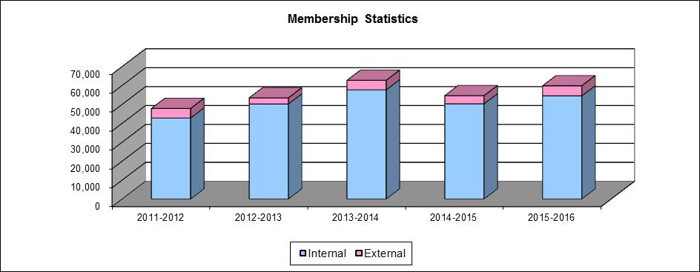

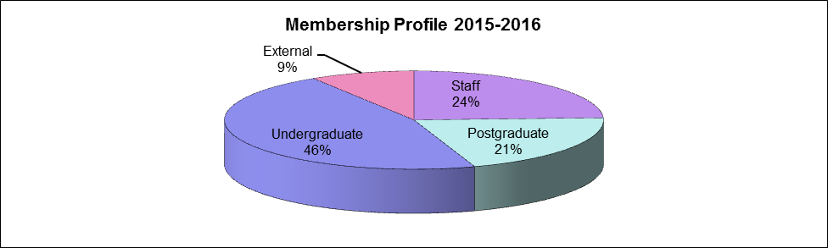

Visitors to the Library: Physical
The turnstiles in the Main Library were removed during the redevelopment of Levels 1 and 2, therefore we have no count of the number of visits to the Library for 2014-2015.
The perceived continued high demand for access to study space within the Library was supported by the high occupancy levels recorded in the both the morning and afternoon census figures

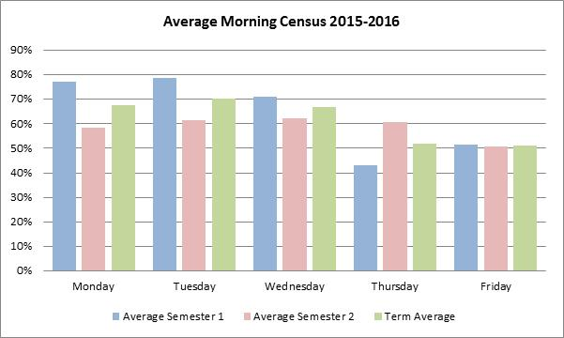

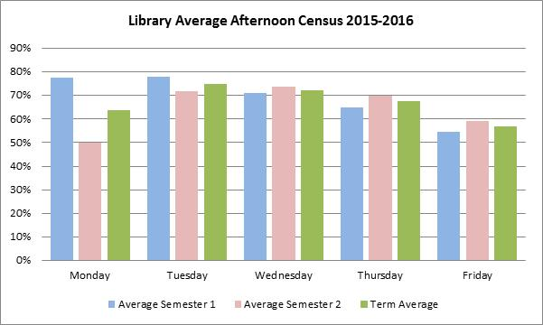

Use of Information Resources
Use of electronic information resources continues to increase. Use of e-journals was up 3% on last year, e-book use increased by 10% and the use of Online Course Materials increased by 113%. Use of the physical stock collection has dropped, by 5% to just over 0.5M transactions. 30% of all borrowing was from the High Demand Collection and a further 19% of borrowing was from items restricted to the one-week loan period. Undergraduates continue to be the largest users of the physical collection accounting for 57% of all borrowing.

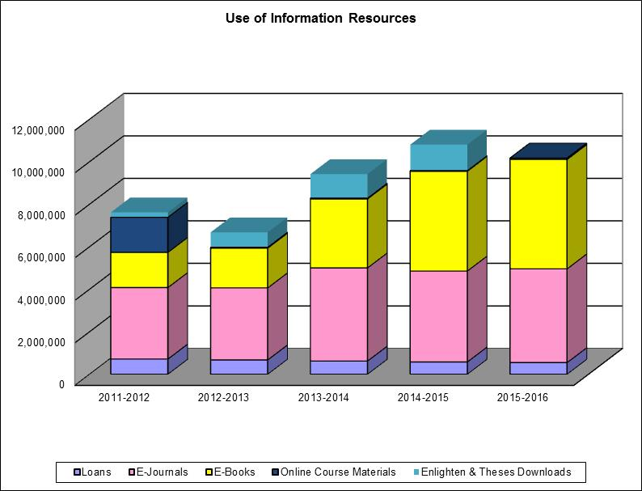
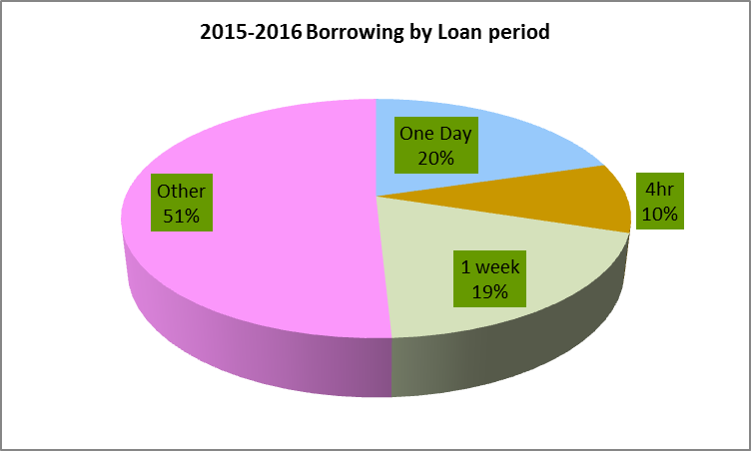

Consultation of Unique and Distinctive Collections
The Library has three closed access collections, Special Collections, Archives and the Research Annexe. In most cases, the material is only available for in-situ consultation, with the exception of some stock in the Research Annexe, which may be borrowed or made available for consultation in the Special Collections Reading Room.
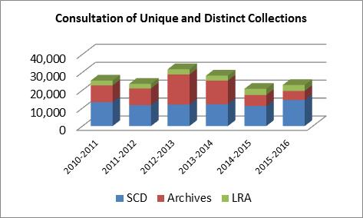

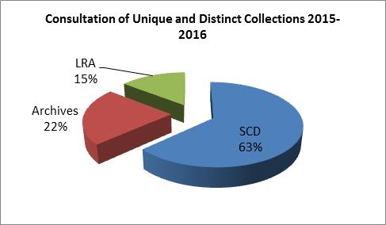

Susan Ashworth
University Librarian

