Library Annual Review

2016-17

Maximising the value of our collections

The Library’s unique and distinctive collections offer wide-ranging opportunities for students, academic staff and external users for research and discovery. We are continuing to take in new collections and to find new ways of exploiting the immensely valuable collections that we hold:

- John Hiden Baltic Research Archive: the Library accepted a substantial donation of materials from and about the Baltic states of Latvia, Lithuania and Estonia. This donation will extend and enrich this important research collection, which supports the longstanding tradition of Baltic research at the University of Glasgow.
- Moving Image and Sound: we instigated a digitisation programme of the Library’s multimedia collections enabling improved discovery and access, including rare and unique colour film of Leon Trotsky held in Archives & Special Collections. Acquisition was also made of the University of Glasgow Media Tape Archive from 1960’s – 2012. This analogue collection contains archive film of iconic buildings across the campus, with relevance to the current campus redevelopment.
- The School of Mathematics and Statistics moved into a new building to make way for the Learning and Teaching Hub. The decommissioning of the Mathematics class library, integrating material into the Library, culminated in an exhibition of the of mathematics collections from the 18th century for staff and researchers.
- There were 69 new archive and manuscript acquisitions and 17 rare book acquisitions this year. Significant donations included the Agnes Burns songbook; The Friends of the University of Glasgow Library and a bequest from Professor Christian Kay supported the purchase of a fourth edition of Johnson’s Dictionary for teaching use.

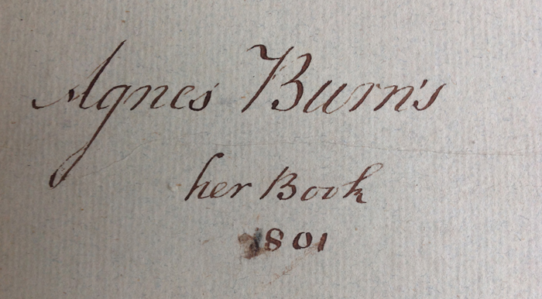
- A grant from the Wellcome Trust enabled the cataloguing of the papers of the entomologist Alexander John Haddow relating to his ground breaking work on the Zika virus; Wellcome also supported a project to transcribe the early manuscript catalogues of William Hunter's Library in order to determine which books belonged to him - as well as offering a resource for researchers exploring the interests and contributions of Hunter as a foremost member of the 18th century medical community. The outcome of this project will inform the celebrations relating to Hunter’s Tercentenary in 2018. The HLF Darning Scotland’s Textile Heritage project is developing the University's key textile collections as part of the Collecting Cultures initiative; this project will enter a new phase in 2018 with the recruitment of an engagement officer.
- The Library is working closely with the Hunterian on preparations for an exhibition for the tercentenary of William Hunter’s birth in 2018. This includes development of new software (EMu) to catalogue the University’s collections and to provide a portal for accessing those collections. Work has also progressed on creating EMu catalogue records for: the Hunterian Transcription project; the Senate Archives; and the Manuscripts Collection, with test records loaded for all of these.
- Theses Digitisation Project: this ambitious project will see the University’s research theses digitised and the digital versions made available through Enlighten: Theses. The records will also be loaded into and searchable via the library catalogue. Our project partners are ProQuest who are overseeing the digitisation of some 13,000 items. The project is expected to be completed in the next three years.
- UK Medical Heritage Project: we contributed 7,500 medical texts to a three-year, large-scale digitisation project of more than 15 million pages of 19th century published works, resulting in a valuable resource for the exploration of medical humanities. Since it was launched in 2016, the Library’s content has received more than 400,000 views by a global audience.
- Our collections were used in diverse ways to support public and academic engagement, including: Nights at the Museum; Hamish McCunn symposium; RSE networks; filming for TV, and loans to external exhibitions such as the high profile Frank Quitely show at Kelvingrove Museum.
- The University was given a donation to inaugurate the David Murray Book Collecting Prize. There were eight entries to the Prize and the winner was Edward Cole from the College of Science and Engineering with his collection of books and other materials relating to Scottish waterfalls.

Improving service delivery

The Library introduced a number of new services during Summer 2017 and we worked closely with other University Services and the Student Representative Council in developing these services:

- We introduced a Roving Service throughout the Library from Semester 1 2017: the Roving Student Ambassador Team are highly visible, trained to assist with a wide range of queries, including catalogue searches and how to find material in the library, demonstrate how to access resources via GUID on and off campus and connecting eligible users to Wi-Fi and Eduroam. They also act as building ambassadors, assisting with accessing rooms and research spaces, troubleshoot the different kinds of equipment located throughout the Library and support zoning, tech free and considerate use of the Library. The Team provide a referral service for more specialised support including subject and research support.
- Services for external users: the ‘walk-in’ service was launched in April 2017. This allows the Library’s external members and visitors access to appropriately licenced e-resources from dedicated PCs located on Level 2 in the new ‘Visitor Area’. To use the service, external members and visitors must register for their external GUID and password (created via the Visitor Management System). At launch, access was available to approximately 50 resource packages. Subscription members have been asking for this service for some time, and initial responses have been very positive.
- Family Study Lounge: the Library worked in partnership with the Student Representative Council and Equality and Diversity Unit responding directly to feedback from students asking for a space that enables Parents/Carers to use Library facilities with their children. The Lounge was opened in Summer 2017, providing a study space as well as books, a soft play area and comfortable seating. It has proved very popular.

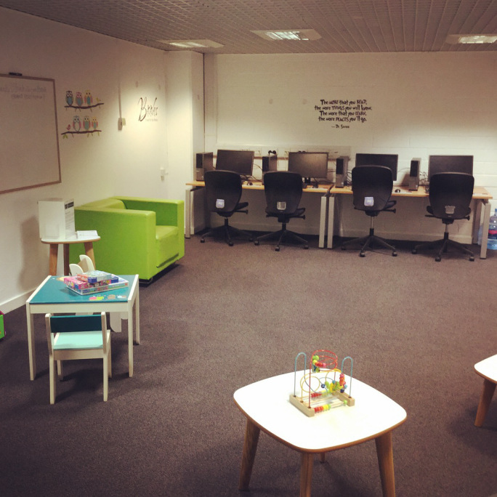

- The Library’s LearnLab on Level 3 was used effectively as a teaching space for Film & TV Studies during October 2016-March 2017. The initiative was supported by the Library (space, software costs) and IT services (software installation & support). This has provided a model for further collaboration with teaching departments.

- Use of Information Resources: E-journal usage increased 10% on 2015/16, from 4,581,816 to 4,964,951 full-text downloads. E-book usage increased 43% on 2015/16 due to increased numbers of e-book collections purchased and embedding e-book links in undergraduate reading lists. New subscriptions were taken out to a number of resources including the FT.com and Mass Observation Archive (a resource previously only accessible via microfilm).
- Support for Blended/Online Learning: a new open education resources (OER) repository, EdShare at Glasgow, has been developed and will be ready for a launch/promotion in 2018 (http://edshare.gla.ac.uk). It will provide an exciting new multimedia platform focussing on three areas of work - adding existing content to the repository, creating new content to be added to the repository, and working with partners across the University (e.g. LEADS, the IT Services training team within Information Services) to open up the repository to their content.
- Reading Lists @ Glasgow: this key service to support teaching has continued to see a large increase in use with 2016-17 published lists at 1,235, a rise of 43% on the previous year. The service continues to support academics in updating their lists. A significant development was the successful integration of the online reading list system with Moodle, enabling academics to embed lists fully within the course environment for students. The digitisation of course materials is now fully embedded within the Reading list service, increasing the speed of dealing with digitisation requests. The number of courses with digitised readings increased by 54% on the 2015-16 academic session and the number of actual readings increased by 47%. Arts & Humanities and Social Sciences are the biggest users of the service.
- A single search box, headed “Search the Library’s print and online resources” on the library home page was enabled in July 2016. This single search box replaced the 3-tabbed search box for QuickSearch, Articles & Exam papers.
We have now had our first complete year of using Summon as a single box search and we had a 203.51% increase in the use of Summon over the previous year (when it offered article search only).

- The Library website had over 3.1M page views. The most frequently accessed web pages continued to be those offering catalogue search options, such as Search For – Exam papers or Databases. An ongoing review of the Library website led to more prominent placement of help and guidance for library users.

Support for Research

- The Research Information Management (RIM) Team is working closely with RSIO on the Interim REF Reviews. The Team designed and delivered publications reports and produced the randomised REF selections that were sent out to internal and external panel members. The Enlighten team collated copies of outputs to send out for the Interim Reviews.
- The RIM team are at the forefront of open access developments and have provided expert advice to peers and funders. During the year, the team set up the Open Access Scotland Group https://oascotland.wordpress.com/, which is open to anyone in Scotland interested in open access, including HEIs, funders and suppliers. The team initiated a UK working group to develop data management assessment checklists for key funders. These help administrators to provide support to researchers and have been used across the UK:
http://eprints.gla.ac.uk/134440/ and https://research-data- network.readme.io/docs/compliance-tools
- University of Glasgow are one of the six pilot institutions for ResearchFish bulk upload and recently received agreement to upload non-publication items that have a digital object identifier. This will reduce the administrative burden on researchers.
- The RIM Team supported the delivery of the Research Gateway to assist researchers in finding the right information and support regardless of where that sits within the University. http://www.gla.ac.uk/myglasgow/staff/theresearchgateway/
- ORCID IDs have continued to be added to user records in Enlighten and from May 2017, theses were enabled in user records and browse views, providing a new ORCID ID badge. This badge links to an author’s ORCID home page.

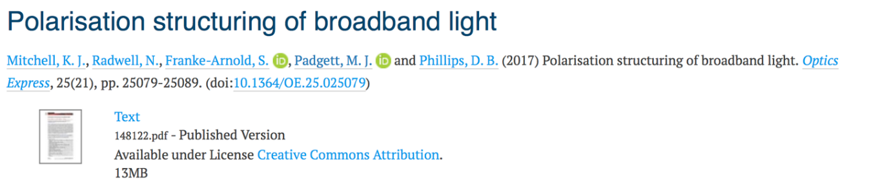

- Postgraduate researchers can now login to Enlighten: Publications and add their publications (and an ORCID ID). They can also now be associated with any publications which they have co-authored and will have a permanent Enlighten record, like staff.

Engagement

- The Library team actively promoted Level 2 as an engagement space to Colleges and University Services, and several new initiatives have taken place this term, including a hugely successful Human Book event, hosted by University of Glasgow Careers Service, in partnership with the Library Metadata team, which allowed students to “borrow” alumni as part of supporting career pathways. The alumni appeared on the library catalogue as available to borrow,which proved very popular.
- August 2017 Open Day saw a record 1,200 visitors to the Library, 153 of whom took a staff-led tour. Increasing demand and popularity of general Library tours has also led to an increased schedule, from two to five per week, including Saturdays.
- The Library utilised the new open public space on Level 2 to great advantage in 2017, hosting a number of exhibitions, supporting student curation, and highlighting the depth of research collections. These included an exhibition celebrating the history of the Maths and Statistics building, and in October 2017, the ‘Voices of the Revolution’ exhibition marking the centenary of the Russian Revolution, highlighting the extensive collections of materials from the period.
- The Library team held their first Researchers’ Fair in partnership with RSIO, the Hunterian and publishers. The fair was held on Library Level 2, making full use of the space and the Kelvin and Clyde auditoria. The Fair featured stalls, surgeries, subject support, lightning talks, serious play events and distance learners’ welcome event. The talks were live streamed, attracting over 150 participants, with over 400 attending in total.

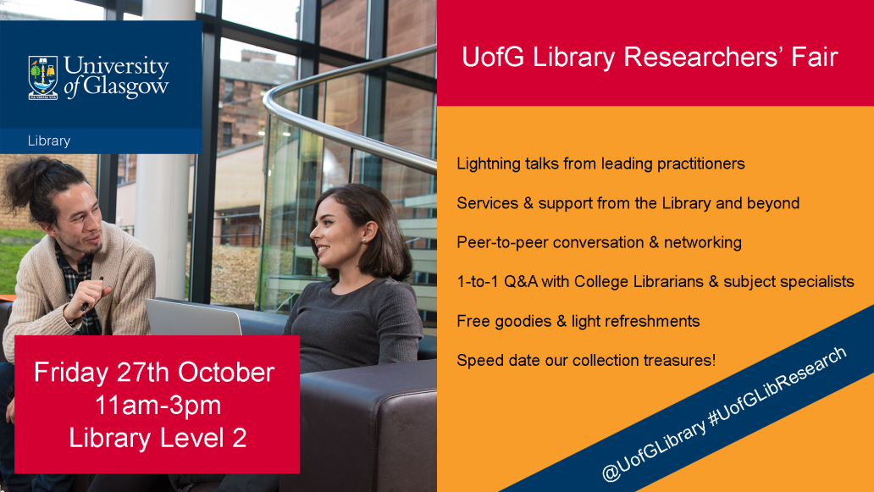

- The new spaces have also been used for public engagement, when the Library contributed to Glasgow Doors Open Day festival, welcoming 141 people over three days to see the Library’s collections and new spaces.
Statistics

Followers on Social Media:
Facebook 7,564 Twitter 6,209 (UofG Library) 6627 (UofGlasgowASC) Instagram 9,347
Membership increased overall by 1% due to the increase in the University student population: 6% in undergraduates, 3% in postgraduate taught and 2% in postgraduate research students. This is reflected in the minor shift in the membership profile, the undergraduate percentage of membership is up 2% to 48%, and the external readership reducing by 4% to 9 5%. Both staff and postgraduate proportions increased by 1%.

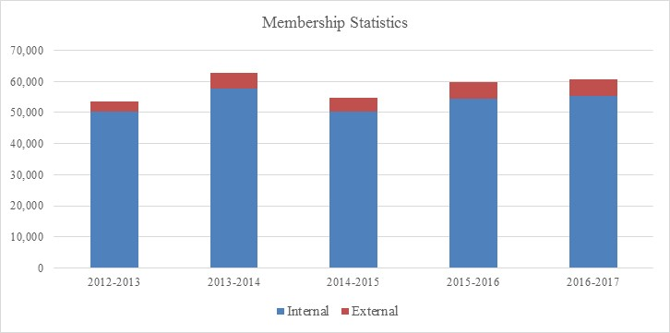

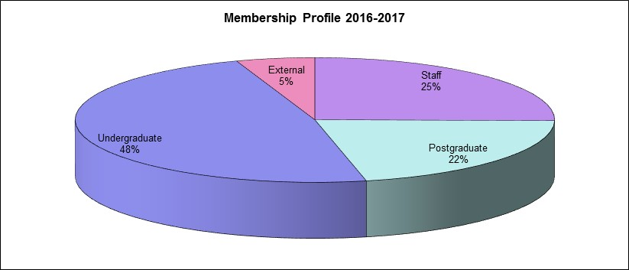

Visitors to the Library: Physical
Due to the installation of new turnstiles and the new University ID Cards, we only have reliable visitor numbers for the final two months of 2016-2017. The number of visitors through the turnstiles in June and July 2017 was 139,831, a 7% increase on the same period in 2014-2015 (last available figures).
The continued high demand for access to study space within the Library is illustrated by the high occupancy levels recorded in the both the morning and afternoon census figures. The occupancy charts by area show the high usage of the refurbished Levels 1 and 2.

There was a 28% increase in the use of information resources provided. The use of E-journals was up 10% on last year, e-book use increased by 43%.
Borrowing of physical stock decreased overall by 5% to 0.522M, however use of the High Demand Collection increased and equates to 27% of all unique borrowing. A further 20% of unique borrowing was from items restricted to one week loan period.

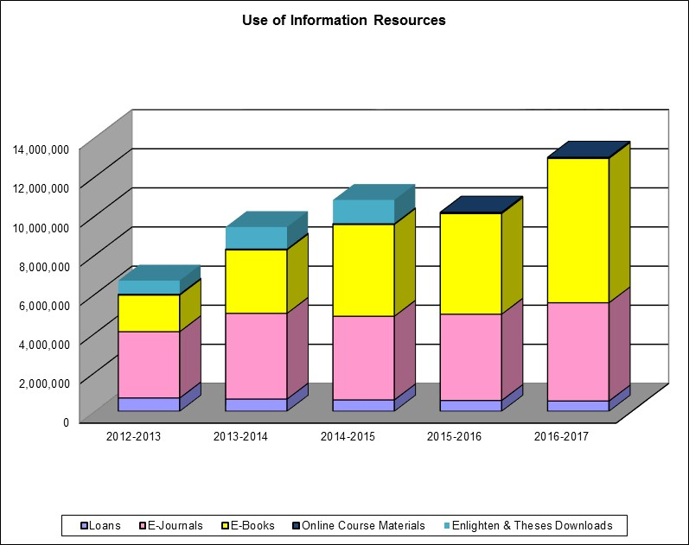

Consultation of Unique and Distinct Collections:

The Library’s unique and distinct collections are located on campus in Special Collections and Archives and off campus in the Research Annexe. In most cases, the material is available for in-situ consultation with the exception of some stock in the Research Annexe, which may be borrowed or made available for consultation in the Special Collections Reading Room.
In all, there were 22,352 consultations of 19,587 items from these collections.
Location | Items Consulted | Total Consultations | % Consultations
LRA | 2,560 | 2,560 | 11%
SCD | 10,735 | 13,067 | 58%
Archives | 6,292 | 6,725 | 30%
Total | 19,587 | 22,352

