INFORMATION SERVICES
LIBRARY ANNUAL REVIEW
2018-19
Susan Ashworth
Executive Director, Information Services
Martina McChrystal
Director of Library Services

Context and Background
This report reflects the work of two Directorates within Information Services, Library Services and Business Relationship Management and Engagement. This year has seen the Library offer new research opportunities with the introduction of Visiting Fellowships, and our participation in high-profile exhibitions showcasing the University’s unique and distinctive collections. Information Services have led on innovation in support of the student experience with the launch of Reach Out.

Maximising the value of our collections
Over the course of the year there were ninety-five new acquisitions in Archives and Special Collections. Notable amongst those was the family archive of Glasgow businessman, William Davidson. Davidson is best known as the client for whom Charles Rennie Mackintosh designed Windyhill and he remained a lifelong friend and supporter.
As well as family and business records, the archive of 20,000 items includes important correspondence relating to Mackintosh and his wife, Margaret Macdonald, enhancing our existing rich collections relating to the couple held in the Library and Hunterian Museum collections. The collection was purchased with the generous support of the National Fund for Art and the Friends of the National Library.

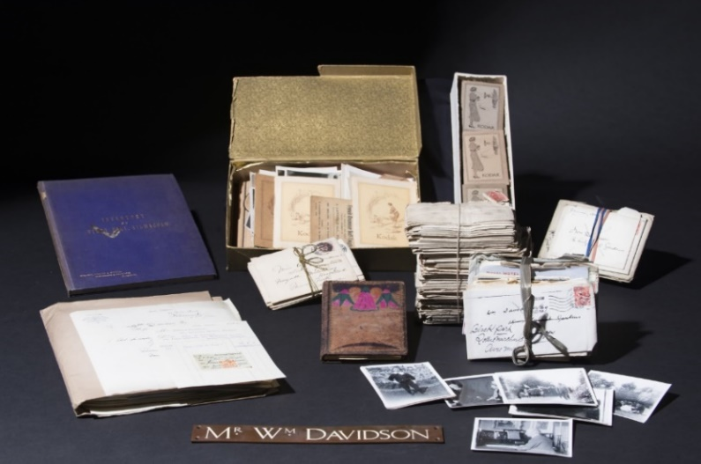
A selection from the Davidson Family Archive
Further donations included:

- Alex Morrison Book Donation: Archaeology gifted the Library an important collection of fifty books and pamphlets on Scottish crofting and post-medieval rural settlement from the Library of Alex Morrison, the first lecturer appointed in Archaeology in the University.
- Czigany Collection: The Library in partnership with Central & East European Studies accepted a donation of selected works from the personal library of Lorant Czigany, eminent scholar, broadcaster and Ambassador Extraordinary and Plenipotentiary at the Hungarian Embassy in London. The works will support teaching and research in the University and add to our widely recognised Central & Eastern European collections.

The exhibition William Hunter and the Anatomy of the Modern Museum opened in the Hunterian Art Gallery to mark the tercentenary of the birth of Dr William Hunter, the celebrated 18th century physician, anatomist, obstetrician, collector and teacher. While the exhibition showcased all aspects of Hunter's truly encyclopaedic 18th century cabinet of curiosities, his rare books and manuscripts were a major feature, with nearly 100 items from Hunter’s Library on display. The exhibition ran from September 2018 to January 2019 and attracted nearly 15,000 visitors. It then went on loan to Yale University’s prestigious Center for British Art, attracting a further 12,500 visitors. As part of the William Hunter tercentenary events a new portal specifically providing information on William Hunter and his legacy for the University was launched in conjunction with the exhibition at the Hunterian in September 2018.

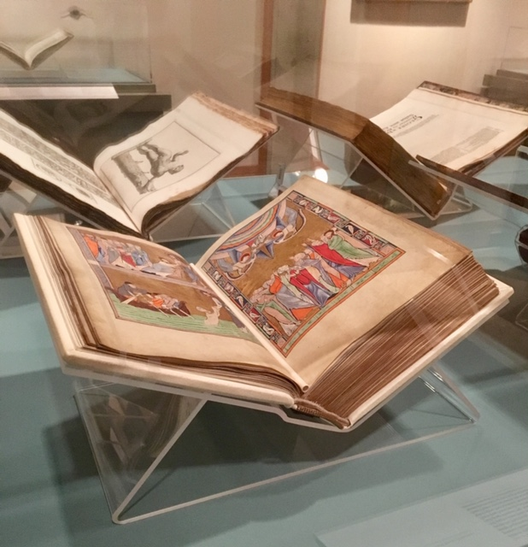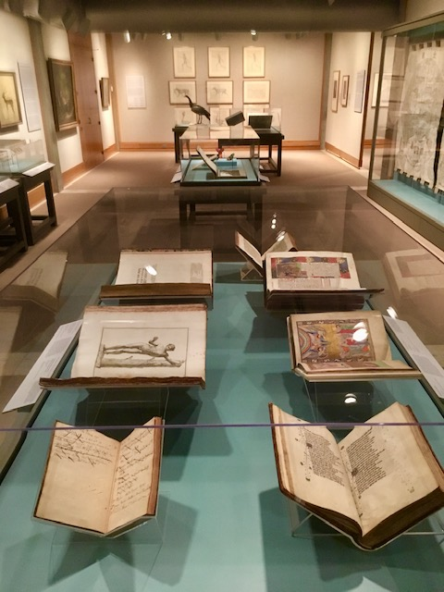
Some of the Library’s books and manuscripts on display at the
Yale Center for British Art in New Haven

September saw the completion of the Heritage Lottery Funded Darning the Thread Project. With an outreach programme which ran over a year, the project encouraged new audiences to engage with the University’s textile industry archives and the work of the textile specialists in the History of Art subject area. Fifteen workshops, crafting sessions, talks, tours and roadshows were held attracting an audience of almost 1000 visitors. A highlight of the project was a public exhibition at the Lighthouse in Glasgow which attracted over 10,000 visitors.

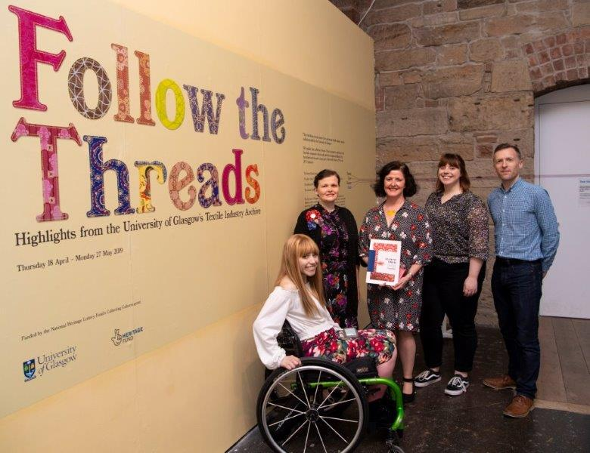
At the opening of ‘Follow the Threads’ exhibition at the Lighthouse Museum

The Library’s Archives and Special Collections continue to be used actively in teaching at both undergraduate and postgraduate levels. Over the course of the academic year, 112 curated sessions were delivered, involving over 1,500 students. Staff also collaborated with colleagues in the College of Social Sciences on the development of a new collections-based ‘hackathon’ teaching model; this approach will be presented at the University’s Teaching and Learning Conference in 2020. In addition, over 50 student placements and internships were hosted across Archives and Special Collections in 2018-19.

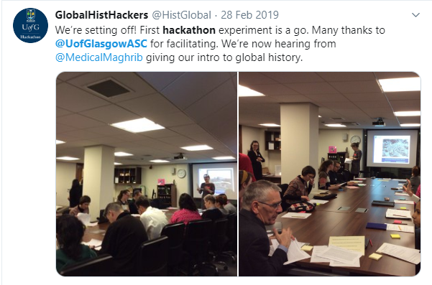
A Global History Hackathon in the Archives Reading Room
Our collections supported public and academic engagement events throughout the year, including the re-inauguration of the David Murray lecture with the School of Law; both Nights at the Museum; VIP visits to the University; ‘Collections Then and Now’ workshops and Friends of Glasgow University Library talks.

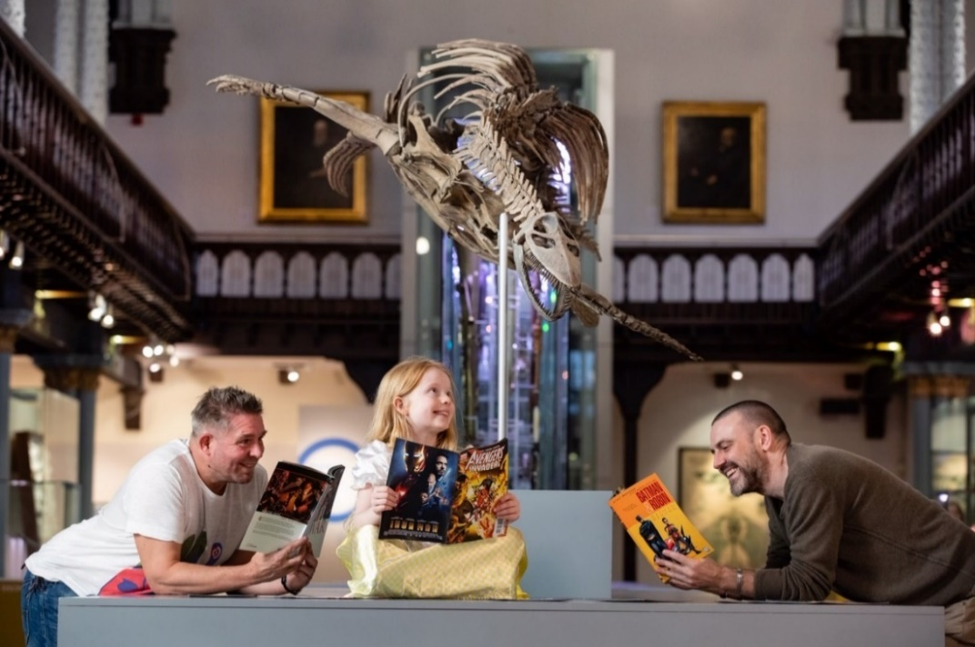
Professor Laurence Grove and comic artist Frank Quitely promoting
‘Comics Night at the Museum’, which featured the world’s first comic,
‘The Glasgow Looking Glass’ (1825)

The focus for lending activity was on managing the transatlantic loan of 100 rare books and manuscripts for the William Hunter and the Anatomy of the Modern Museum exhibition which went on display at the Yale Center for British Art.
The Library’s significant map collections were used in documentaries and publications, including the Sulman Bird’s Eye View of Glasgow, which featured in the BBC documentaries Central Station and The Singer Story: Made in Clydebank.
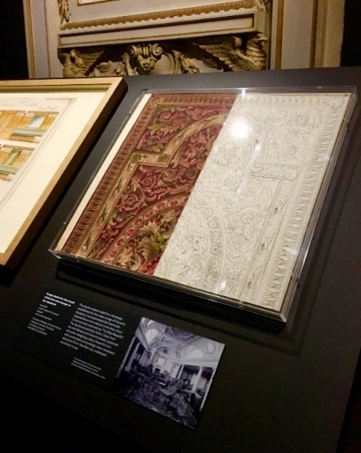

The Library also loaned carpet designs from the RMS Aquitania from the Stoddart Templeton Design Archive as part of the V&A Dundee’s inaugural exhibition Ocean Liners: Speed and Style.
In May, the remarkable story of a record-breaking family of doctors who all trained at the University of Glasgow featured in the Australian version of Who do you think you are? The story of the Robertson family of Dumbarton was shared with the actor Marta Dusseldrop by University archivists when she visited the Reading Room as part of the filming.

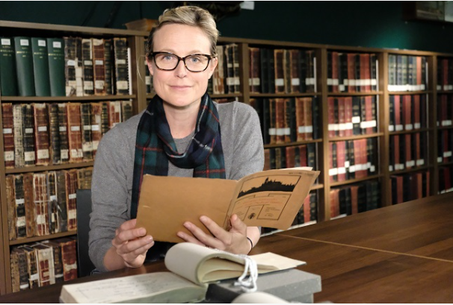
Australian actor Marta Dusseldrop at the University of Glasgow's Archives. Credit ‘Who Do You Think You Are?’

Supporting the student experience and improving service delivery

Partnership with the SRC
The dynamic and successful partnership between the Library and SRC continues to develop. The SRC and the Library planned and promoted 24-hour opening during exam periods throughout the year. The Library hosted several SRC campaigns on Level 3 of the Library, including exam destress sessions, a Kindness wall and the End Sexual Violence and Harassment campaign.

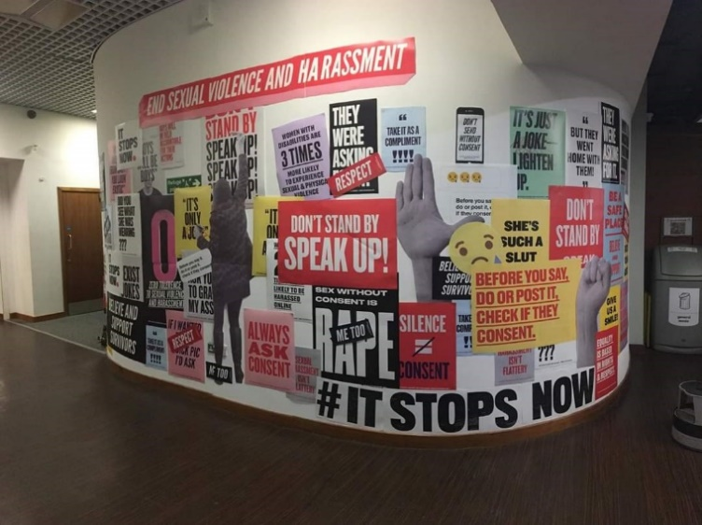
SRC campaign End Sexual Violence and Harassment Jan 19
Reach Out
A new, student-focused support model, Reach Out was launched this year. The service was developed and designed in response to student feedback that accessing services can be confusing. Information Services staff worked in partnership with Student and Academic Services and the World Changing Glasgow Transformation Team to plan, design and implement a single service identity for accessing the main student support services. Students were also partners in the design process and the name was chosen following a student competition where teams had to pitch ideas on what a new service identity might look like.

Reach Out teams are located in the Library, Fraser Building, Vet and Dental Libraries and at Dumfries campus and help is available through the UofG Helpdesk 24/7. Feedback from service users since launch has been very positive. The service will be expanded into the James McCune Smith Learning Hub when it opens this year.

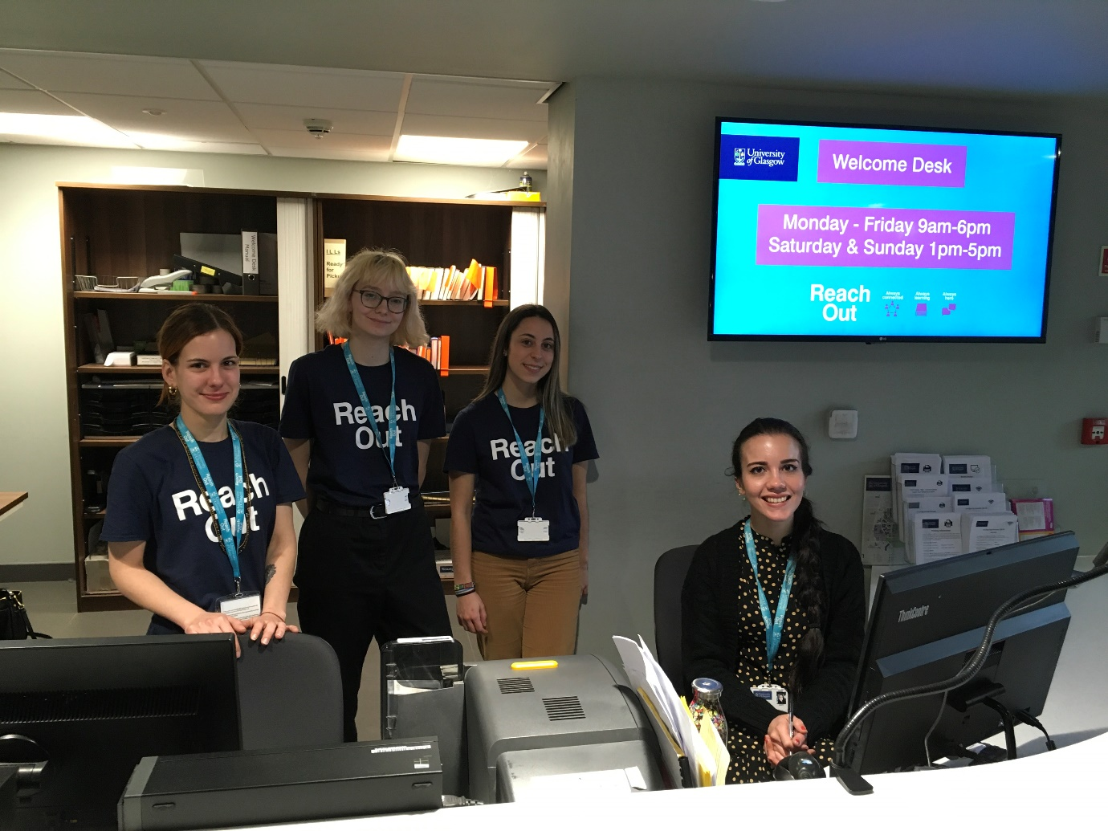
Library Reach Out Team

Continual Review
As part of Reach Out, frontline services have developed a programme of continual review, to ensure services evolve to meet user needs. The continual review approach is supported by a management group who provide direction to the services on the basis of user feedback and data. We have worked with the SRC to run student-led feedback programmes, where students visited the main service points and reviewed the interactions. Feedback from the inital round was overwhelmingly positive and we will continue to build on this approach as we develop new services and spaces for students.

UofG Helpdesk
Information Services delivered a new helpdesk system and knowledgebase in 2019. UofG Helpdesk is a single online point of entry for information and support for all students and staff at the University. It launched in April 2019 and in the first 6 months the system handled over 60,000 support calls. UofG Helpdesk is being used by Reach Out teams to support students across campus, and by numerous other services who are taking advantage of its dynamic online forms and workflow capability to improve service provision and retire paper-based processes.

EdShare Open Education Repository
EdShare continued to mature as a service and to support self-service and 24-hour availability, particularly for academic engagement. One example of this is the creation of a suite of resources for literature searching for MVLS students. The usage data and downloads from these resources are also helping us to discover gaps in our student support. Advocacy and promotion of the service is ongoing and we worked with Professor Jo-Anne Murray, Assistant Vice-Principal (Digital Education) to produce a promotional video for EdShare which was featured in Campus News.

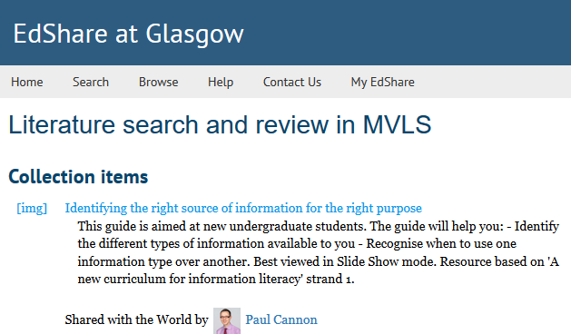
EdShare: Literature search and review in MVLS collection

Kanopy
In response to a request from student representatives on the Library Committee, we launched a new streaming service Kanopy, https://glasgow.kanopy.com/ The service is a patron driven model which means videos viewed more than 4 times are triggered for purchase. A purchase is a 12-month subscription. Currently there are no restrictions and users can access all content from categories such as Movies, Documentaries, Independent Cinema, Short Film and Politics & Current Affairs. Since the service began there have been over 16,000 visits to Kanopy. The majority of views are from a desktop, with our users accessing the resource from countries such as Cyprus and the US. Movies is the top category, closely followed by Drama and Independent Cinema and Documentaries.

Lapsafe Lockers
The Laptop Loan scheme has proven to be very popular with students. There were multiple occasions when all 24 laptops were on loan during January - April 2019. After a review of usage, we added 36 additional laptops in June 2019 bringing the overall total to 60. Across the University, the Library Management System will support additional laptop locker installations in the Colleges and on the Crichton campus. The first of these will be an installation for College of Arts staff.

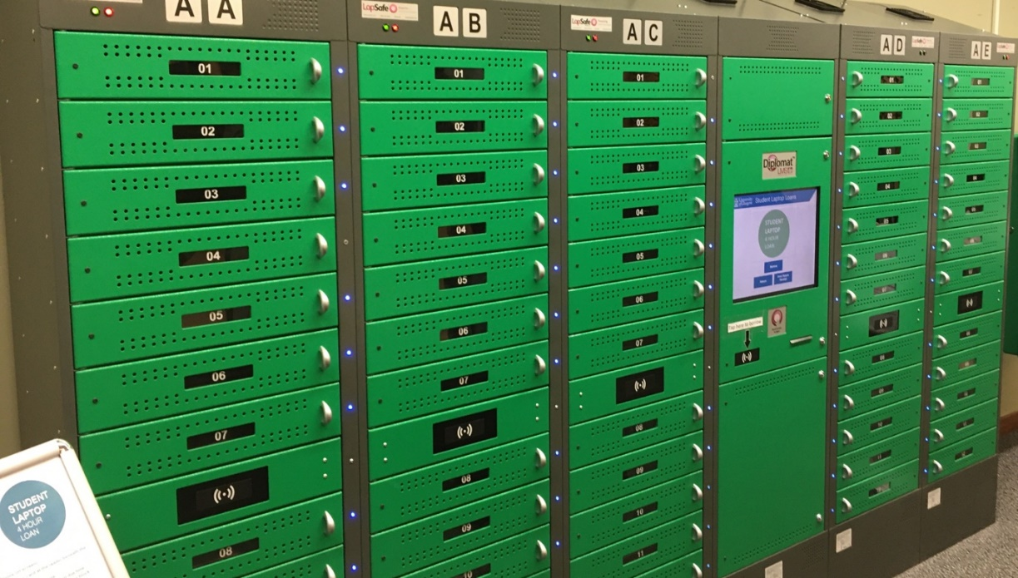
Student Laptop Loan Lockers

Digitisation
As part of the Library’s ongoing project for the digitisation of pre-2007 doctoral theses by ProQuest, over 3000 theses and accompanying metadata were loaded to Enlighten Theses by July 2019 and therefore publicly available (over 5,000 now available by end of 2019). The College of Science and Engineering’s Aerospace technical reports from 1960-2000 were also digitised, enabling discovery and access for current teaching and research via Enlighten Publications.
Reading Lists
The Reading Lists @ Glasgow service continues to see considerable growth with an 18% increase on the previous year in the number of lists made available online in 2018-19. The service successfully moved the 3,000 plus digitisations of course materials over to the Copyright Licensing Agency’s Digital Content Store in 2018-19, which has improved the student’s experience of accessing digitised chapters and pages. The reading list system used, Talis Aspire, has a new interface that has improved the student experience of accessing, via any device, lists and online resources, meeting the new legal accessibility standards in the UK. The service will help support the adoption of the Accessible and Inclusive Learning Policy across the institution as well as academic developments in online learning.

Study Environment
A key priority for the Library is to maximise the number and variety of study spaces we can offer our growing body of students. This summer, there was an extensive programme of works in the main Library building which included:
- creation of 62 new study spaces with power on Levels 3 and 4
- investment in a further 36 laptops for loan on Level 3, bringing the total to 60
- redecoration and new carpets to Levels 4 and 7
- installation of solar blinds on Levels 6 and 7
- repainting of both stairwells and stairs sanded and varnished throughout
- long-term programme begun to replace Library’s fluorescent lighting with energy efficient LED lamps

There was also considerable investment in the study environment at The James Herriot Library on the Garscube Campus. With 142 study spaces, it is a much-used Library space for staff and students, however, with furniture over 20 years old an upgrade was overdue. Over the summer, that upgrade began with new seating and desks with power installed and the library completely redecorated.

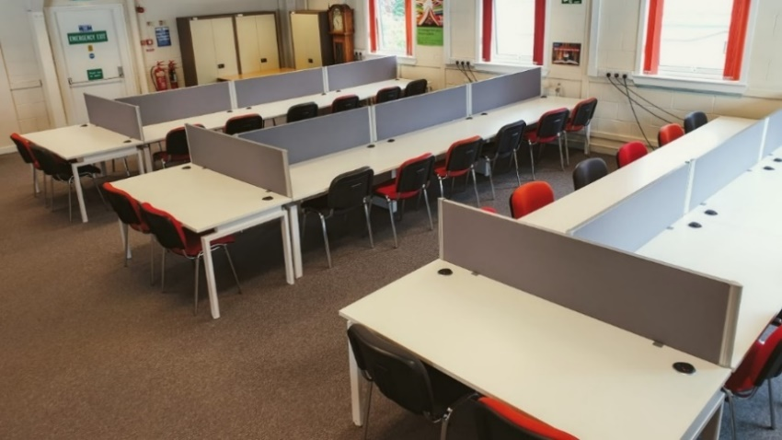
New chairs and desks with USB, A and C power at James Herriot Library

Support for research

Visiting Research Fellows Inaugural Programme
This year saw the launch of an exciting scheme to enable scholars from across disciplines to come to Glasgow to work on our unique research collections. Supported by the Library, the William Lind Foundation and the Friends of Glasgow University Library, nine Visiting Research Fellows were appointed with the successful scholars coming from USA, Canada, New Zealand, England, Spain and Ireland. They worked on a diverse range of projects, including studies of 19th century Gàidhlig learning aids, alchemical collections, to early modern English recipes and Glasgow business firms operating in Bombay from 1850-1920. The Fellows’ extended stays also offered opportunities to share and exchange knowledge with University colleagues.

Enlighten
New academic esteem functionality was launched in May 2019 in Enlighten: Publications to enable Research and Research & Teaching staff to capture and record indicators of academic esteem. Staff can log in to Enlighten and enter their esteem indicators under six main categories:
- Editorial Boards
- Grant Committees
- Professional & Learned Societies
- Research Fellowships
- Prizes, Awards, and Distinctions
- Selected International Presentations

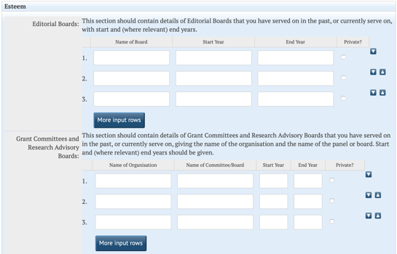 | 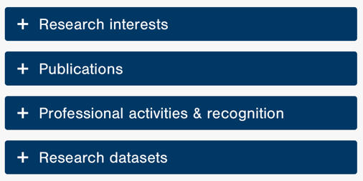
Enlighten: Esteem functionality and professional activities and recognition in Staff web profile

Staff can choose to publish all or some of their entries on their staff web profile under Professional Activities and Recognition.

Plan S: Open Access Publishing Initiative
A revised version of Plan S was released in May 2019. The new version has a later start date of 1st January 2021 and allows for some transition arrangements. Members of Information Services staff represented the University on expert groups formed by UK Research and Innovation (UKRI) prior to opening consultation on their new policy which is expected to be published later in 2020. This engagement has also informed the University’s preparations and support for Plan S. The Wellcome Trust announced their new policy in May 2019. The major changes made were in line with Plan S and included the requirement for a CC-BY licence.

Research Excellence Framework (REF2021)
Information services staff organised several UK-wide workshops on audit compliance for REF including discussion around OA, impact, and generic REF requirements. The Enlighten team streamlined their processes and provided supporting physical and digital material for the University’s preparations for REF2021.

Outreach and engagement

James Watt 2019
The Library took part in the University’s celebration of the works and legacy of James Watt in the 200th anniversary of his death, with an exhibition in the Library. The exhibition explores Watt’s early life, his work as an instrument maker at the University and his breakthrough moment which had such an impact on the Industrial Revolution. The exhibition also features a 3D printed working model of the Boulton-Watt engine which was produced by the student-run organisation, JetX Engineering.

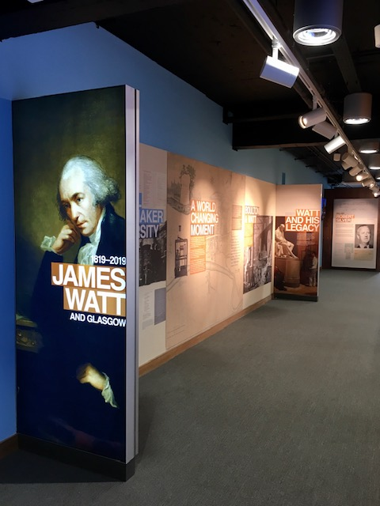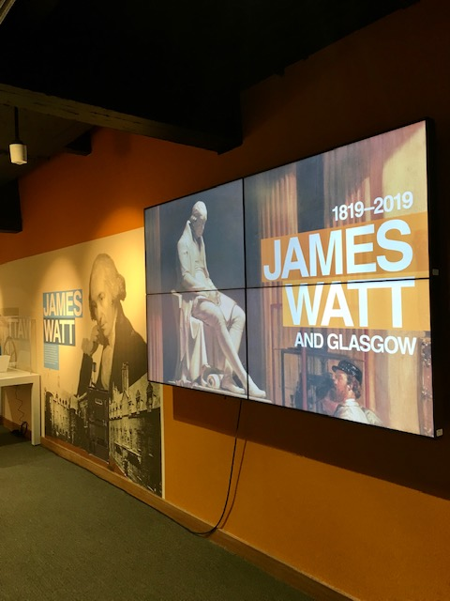
James Watt exhibition on Level 2 of the University Library
Kindness at University of Glasgow Library
The Library worked in partnership with the Carnegie Trust Kindness Innovation Network (KIN), bringing kindness into spaces and interactions with students, working to embed a kindness culture. Reach Out is one example of using a kindness approach. The KIN is a collective of representatives from personal and professional backgrounds from the UK including local and national government, higher education and the voluntary sector to identify and test practical approaches to encourage kindness in communities and organisations and to promote cross-sectoral collaboration and shared learning. The project also included physical initiatives in partnership with the SRC such as the Kindness Wall and exam de-stress sessions. Work is ongoing to build kindness into everything we do. The University Library features in the Kindness Innovation Network’s final report The Practice of Kindness.

The Kindness wall in the University of Glasgow Library,
featured in the Carnegie UK Trust’s final report
‘The Practice of Kindness’

Social Media
The Library’s Instagram account is the second most followed university library account in the UK (after Oxford). We continue to add followers for our Twitter and Facebook accounts.

Settlement Exhibition
A graduate intern, based at the University Archives, worked with Library staff and The University of Glasgow Settlement to mount an exhibition in the Wolfson Medical building to commemorate 120 years of the pioneering organisation. Famous Glasgow graduates involved in the Settlement included Janet Galloway, Isabella Elder, Marion Gilchrist and Madge Easton Anderston, and the exhibition aim was to inspire continued and future student social action.

50th Anniversary ARLIS (Art Libraries Society UK & Ireland) Annual Conference
The 50th Anniversary ARLIS (Art Libraries Society UK & Ireland) Annual Conference was hosted by the Library, offering three days of keynotes, presentations, workshops and library and art-related visits around the city from July 15–17 2019 with the Charles Wilson Building as the Conference Hub. There were 120 delegates and 40 speakers, including 12 international delegates from eight countries. A summary of the conference programme and details of all conference keynotes and presentations can be found on the conference website.

Call and Response: The University of Glasgow and Slavery
In August 2019, the University signed an historic Memorandum of Understanding with The University of the West Indies to establish a Glasgow-Caribbean Centre for Development Research. This was one of the recommendations that came from the publication in 2018 of the report, ‘Slavery, Abolition and the University of Glasgow’, which acknowledged the significant financial benefit the University has derived from slavery. To compliment the event the Library, in conjunction with colleagues in the Hunterian Museum and College of Arts, curated an exhibition in the Chapel. Drawing on the University’s archives, books and museum collections, the ‘Call and Response’ exhibition sought to continue this important conversation by widening the range of responses to our collections. The exhibition is also available as an electronic resource on the School of Humanities Slavery Studies website.

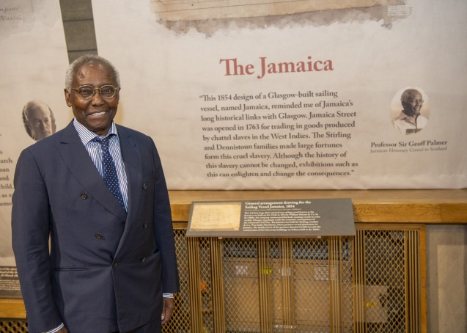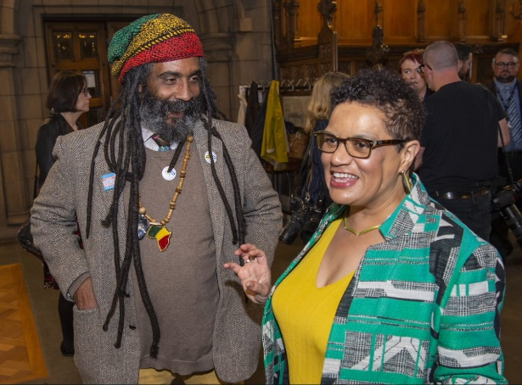
Professor Sir Geoff Palmer, Councillor Graham Campbell and
Scots Makar, Jackie Kay, at the launch of the exhibition

