INFORMATION SERVICES

LIBRARY ANNUAL REPORT 2021-2022

Susan Ashworth  
Executive Director, Information Services & University Librarian

Martina McChrystal  
Director of Library Services

## Background

This report covers developments in library services over the past year, detailing the work of the Library Services and Business Relationship Management Directorates in Information Services over the academic year 2021/2022.

One of the highlights of the year was the restoration of full walk-in access to all library and study spaces across the campus, without the need for occupancy management. The development of the UofG Life App gives students real time choices for group, social and quiet study in the Library, James McCune Smith Hub, McMillan Reading Room, and the Fraser Building. We retained some spaces to provide more distanced study for students, and clusters of spaces were created to support students attending online lectures whilst on campus.

The Library building was well-used during the academic year 2021-22 with, on average, between 25,000-40,000 visits to the building per week during semesters one and two. This trend has continued into the current academic year, and demand for study spaces remains high. The Library is currently trialling a new technological solution to give richer data about the use of spaces which will be of real value to students and staff.

Teams continued to innovate in services to support blended learning. The Archives and Special Collections Team were honoured to be the recipients of a Teaching Excellence Award for their work on their Virtual Classroom. The Photographic Unit were also the recipients of an ACPME national award for in-house photography.

Access and discovery of print and electronic resources remained a priority across Library Services. The challenging publishing negotiations landscape continued over the year, with complex negotiations with Springer Nature still ongoing at the time of writing this report.

Cost of living issues are embedded in Library strategic planning. Fines for delayed return of material, which were suspended during the pandemic, have now been permanently withdrawn. The self-service laptop loan lockers in the Library were upgraded to USB-C connectors and refreshed with 60 new laptops with the latest virtual desktop build. In addition, the move to e- theses copy only will provide savings in printing costs. We continue to work closely with the SRC (Student Representative Council) to support students and to promote the offer from Library Services, particularly with significant and extended access to e-resources.

## Maximising the value of our collections

## New acquisitions and cataloguing

New acquisitions to the collections ranged in size from large deposits of corporate and personal archives to purchases of rare and special works.

## Books from the The Cruickshank Collection, Archives and Special CollectionsDon Cruickshank Collection of Spanish Golden Age literature

The Library received a bequest of a valuable collection of 220 books from the library of Professor Don Cruickshank, an expert on Spanish Golden Age Literature and biographer of Calderón. His collection contains many rare Spanish playtexts (sueltas) and will boost the Library’s holdings of early Spanish imprints. A project to catalogue the collection, funded by the Friends of Glasgow University Library, is now underway.

The Cruickshank Collection,   
Archives and Special Collections

## Sir Kenneth Calman Archive

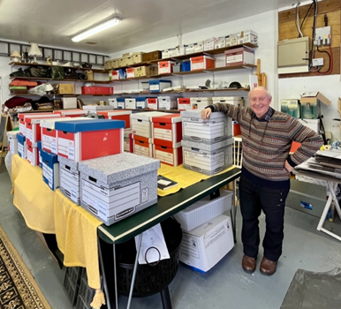In March 2022, the archive of Sir Kenneth Calman, former Chancellor of the University, was deposited with the Library. The collection charts the range of Sir Ken’s professional career across medicine, public service, the third sector and higher education. His ‘firsts’ include being the first Professor of Oncology (1974) and being appointed Chief Medical Officer at the Scottish Home and Health Department and subsequently CMO in the Department of Health in London. The archive captures his professional career but also his interests in the arts, in writing and his period as Chancellor at Glasgow (2006-20).

Sir Kenneth with his archive at his home   
on the Isle of Arran.

## Scottish Amicable Archive

Enhancing the Scottish Business Archive, the archives of Scottish Amicable Life Assurance Society were transferred to the University in April 2022.  An extensive collection, the archive provides evidence of the Scottish and UK’s insurance industry across the nineteenth and twentieth centuries. Founded in 1826, the company traded for 170 years until it was acquired by Prudential in 1997. The Archive will be processed across 2023 and made accessible in 2023-24.

## Digital Preservation Service

Investment in people and infrastructure has brought a step-change in the Library’s capacity to meet the challenges of preserving the University’s digital records and collections. This has helped the Library develop a digital preservation service and infrastructure that will best meet the diverse needs of the University’s students, researchers, staff, services, and partners. Engagement across the Archives & Special Collections, IT Services, Data Protection & Freedom of Information, Research Information Management, and Library Digital Strategy teams through the University’s Digital Preservation Working Group is supporting the development of a service which can meet the needs of each user group. Highlights from the year include publishing Archives & Special Collections’ Digital Archiving Workflow, securing investment for the development of an Archival Forensics Lab, scoping requirements for digital preservation processing software and long-term preservation storage, and developing the service to support e-only deposit of University theses.

## Academic engagement

Support for collections-based teaching in Archives and Special Collections returned to pre-pandemic levels, with a year-on-year percentage increase of 80% in both the number of teaching sessions provided and the number of participating students.

Fig 1. 2021/22 ASC Collections teaching: number of sessions
 Virtual Blended In-person
Semester 1 7 15 8
Semester 2 7 3 30
Total 14 18 38




Fig 2. 2021/22 ASC Collections teaching student visit: virtual and in-person
 Semester 1 Semester 2 Annual 2020/21 Annual
Virtual 7 7 14 39
Blended 15 3 18 0
In-person 8 30 38 0
Total 30 40 70 39
 Semester 1 Semester 2 Annual 2020/21 Annual
Virtual student visits 691 1068 1759 1186
In-person student visits 274 232 506 0
Total 965 1300 2265 1186



Demand for the three types of collections-teaching was high for Semester 1, with half of all demand being for blended. This reflected teaching staff’s desire for in-person learning, while acknowledging the reality of students needing to isolate at short notice without disrupting their learning. Teaching demand in Semester 2 was unprecedently high. With an increasing return to campus, and restrictions easing, a marked pivot back to in-person teaching was witnessed with three quarters of all classes being in-person (fig. 1). The new Virtual Classroom camera technology continued to play an important part in in-person teaching throughout the semester, being used in many classes to share details of objects with the class in the room.

## Student Placements

There were over 70 student placements in Archives & Special Collection across 2021-22, supporting a range of post-graduate courses, including Information Management and Preservation, Museum Studies, History of Art, and Technical Art History.

## Equality, Diversity, and Inclusion

Information Services’ Inclusive Community has developed into a strong network with members working to pull together training, events, information sharing, and networking with other groups on campus, including the ‘Decolonising the Curriculum Community of Practice’, which have recently partnered with the Library to launch a bespoke reading list.

In addition, alongside eight other UK institutions, the Library participated in research carried out by Manchester-based consultancy, Alterline, looking at the experiences of students of Black background in UK university libraries. The final report gives insight into how spaces can be modernised to make services valuable to a diverse student body.

Nationally, Glasgow has been leading the Scottish Confederation of University and Research Libraries (SCURL) Equality Diversity and Inclusion Network which is working towards creating a toolkit to support academic libraries decolonise their working practices and collections. Members of IS staff are also collaborating with colleagues from the Research Libraries UK network to curate and deliver the ‘Inclusive Collections, Inclusive Library’ seminar series which has featured speakers from Smithsonian National Museum of African American History and Culture, University of Liverpool, and University of Cape Town.

The University of Glasgow’s‘Diversity History Project’ also began in January 2022. This year-long exploratory project is part of the University of Glasgow’s institutional commitment to address racism on campus and beyond. More particularly this project is part of the College of Arts and the University Library’s response to the ‘Understanding Racism, Transforming University Cultures report and Action Plan’. In exploring the University’s own archives and records, ‘Diversity History’ is collaborative in its approach, combining the skills and knowledge of archivists, historians, and social scientists.

## Exhibitions & Loans

Throughout the course of the pandemic, there was an understandable drop in requests from borrowing institutions for loans from our collections. However, over the course of 2021/22, the Conservation and Preservation Team supported the loan of five items to the Royal Academy in London’s major exhibition, ‘Whistler’s Woman in White: Joanna Hiffernan and James McNeill Whistler’. Closer to home, the Library collections also featured in the Hunterian Museum’s exhibitions, ‘Alasdair Gray’s Lanark: a world made in paper’ and ‘Demon Drink’.

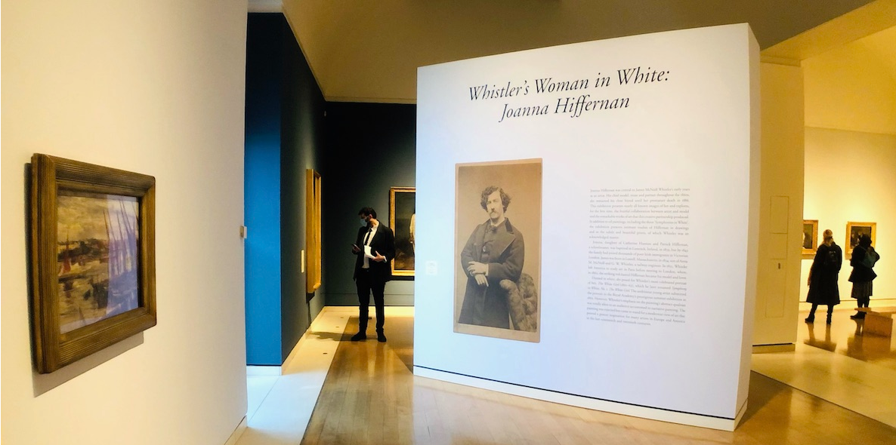

*‘Whistler’s Woman in White’ exhibition at the Royal Academy*

## Awards and Grants

## University of Glasgow Teaching Excellence Award

Library Services was delighted that Archives and Special Collections’ commitment to innovation in collections-based learning and teaching was recognised this year by a Teaching in Excellence Award. The nomination was made by the College of Arts and recognised the value of interactions with the University’s world-class collections for students across a wide range of disciplines and all four colleges.

## National Manuscripts Conservation Trust Conservation Grant

A collage of a person conserving a book

A grant from the National Manuscripts Conservation Trust (NMCT) enabled the full conservation and rebinding of the *Historia de Tlaxcala* (MS Hunter 242), an internationally important 16th century history of the state of Tlaxcala in Mexico. The project successfully fulfilled its goal of enabling future access to MS Hunter 242 for research and teaching, as well as full photography of the book. Other benefits included technical analysis that revealed evidence of a previously unknown earlier binding, and the formation of a ‘Special Interest Group’ of academics and researchers who tracked the progress of the conservation and who now have an international symposium in planning.

## Breslauer Prize for Bibliography

Jack Baldwin with the  Breslauer Prize for Bibliography
*'A catalogue of fifteenth-century printed books in Glasgow libraries and museums*' by Honorary Research Librarian, Jack Baldwin, won the prestigious ‘International League of Antiquarian Booksellers’ (ILAB) Breslauer Prize for Bibliography. Chosen from a highly competitive field of 99 submissions, this is a significant accolade for the Library’s Archives & Special Collections. The catalogue was published in 2020 with support from the Friends of Glasgow Library and is the culmination of over ten years in depth research.

Jack Baldwin with the award-winning publication

## National Award for Photographic Unit

The Photographic Unit’s talents were recognised nationally with the ACPME (Association of Creative and Print Managers in Education) 2022 award for ‘Best In-House Photography’ in the Student & Subject Profile Project category.

A person sitting in a library
A woman smiling in front of a wall of art



A person looking at a microscope



*A group of students sitting working on a device

*

*Four of the prize-winning photographs*

## Collections Management

The first phase of the Journals Review was completed in September 2022, freeing up 960m of shelving space over the main Library and Library Research Annexe. All titles have been made available through electronic access via JSTOR. The removal of journals enabled better access to the Social Sciences periodicals; the team moved 100m of stock and removed 130m of shelving from main floor level 6 to enable the creation of additional study spaces. The relocation of the Language Resource Library (LRL) collection from the Hetherington Building to Level 8 Annexe in the Library resulted in the movement of 178m of stock

## Supporting the student experience

## Digital Infrastructure

The Library Management System’s (Sierra) test and production environments were upgraded to the latest software release. A significant development, supported from Sierra 5.4, was an access upgrade to easier authentication from name & barcode to the University’s GUID for staff and students. This upgrade provides improved usability as well as security. Library external members without GUID continue to login with barcode but now with the addition of a personal password which they can set and/or change online. This is the first phase of development which will bring a closer integration with Library Search.

New hardware was procured for LOCKSS (digital preservation of e-journal content) and for the Photographic Unit’s image storage. Content was migrated by the suppliers and hardware support for both services has now transitioned to the IT Server Team.

## James McCune Smith Learning Hub

Teaching was launched in the James McCune Smith Learning Hub in the academic year 2021-22, with Reach Out providing support to staff in the use of technologies to support learning, and to students, from helping them connect their devices to Eduroam to accessing information and support from services across the University.  From September 2022, the building was fully timetabled for teaching and Reach Out worked to support building users and manage flow at peak times. The building has been very popular with both students and staff and tours have been developed in response to demand from the wider university community and the general public.  As was envisaged in the original building concept, SRC student clubs and societies make use of the rooms for activities outside of teaching hours and this has been a success, with the JMS team, Timetabling and the SRC working together. Members of the public have benefitted from the launch of the University’s public wifi service.

## Reach Out Library – developing an 8-8 service

With the success of the 8-8 Reach Out model in the James McCune Smith, a change piece was launched in the Library to extend the Reach Out Library team to 8am-8pm across 7 days. This involved organisational change of the weekend service, which previously ran 1-5pm (during term-time) and also required extending service hours Monday-Friday. The project was successfully completed in 2022 and Reach Out Library staff are now available to support users in-person 8am-8pm 7 days a week, ensuring a simple, consistent service model and offering additional employment opportunities to students as Reach Out Student Ambassadors.

## Extended virtual support

Alongside the in-person expansion of services, virtual support for users was extended to 8-8pm 7 days a week. Reach Out staff are available to answer enquiries via UofG Helpdesk and by telephone and can support users across the full range of Reach Out Services as well as signposting/triaging to other university services. This is a planned growth area for the coming year.

## Rapid ILL (Inter Library Loan)

Following a successful pilot of Rapid ILL, an initiative aimed at simplifying access to electronic journal articles for users, the University Library is now a full partner in the Rapid ILL service. Rapid ILL has the benefit of a larger number of participating institutions than previous services, meaning more requests are filled, and the technology allows for direct links to journals which simplifies the user experience. Rapid ILL is also a key part of our modelling strategies as part of ongoing big deal negotiations.

## Books on Prescription

Books on Prescription is a new service run by the Barclay Medical Centre and supported by the University Library. Its aim is to provide people living with health conditions information to manage their health and wellbeing. Books are prescribed by health professionals as an alternative to, or alongside, medication and therapy services. A collection of 30 new titles covering common health conditions supported by staff at the Barclay Medical Centre have been added to the Self-Help collection in the Library. Each book was chosen by health experts at the Centre. The Self-Help collection is located on Level 2 of the Library.

## Supporting Learning and Teaching

## Reading Lists @ Glasgow (RL@G) service and Course Materials in 2021-22

The Reading Lists @ Glasgow service continues to see growth in the number of published lists, an increase of 11.2% in 2021-22. The service is key to supporting the aims of the University’s Accessible and Inclusive Learning Policy and improving online accessibility for students.

**The Course Materials Policy** (https://www.gla.ac.uk/myglasgow/library/staff/readinglists/#coursematerialspolicy) of e-preference for essential teaching materials was approved at Library Committee in May 2022 as Library Services continue to support e-textbooks and moves to electronic versions of resources.

Demand for electronic content to support teaching continues to grow and spend has been committed to large textbook collections such as Sage Catalyst, Law Trove, Oxford Chemistry Primers and ClinicalKey, as well as individual textbook titles via aggregators (Kortext and Browns) and publishers (e.g., Bloomsbury). Subscription continued to the Academic Complete package which now contains around 200k titles. The RL@G service continues to see demand for the digitisation of course materials, providing over 5000 accessible scans of in copyright works for teaching. This figure is consistent with demand during the pandemic.

## Multimedia

In response to the increasing demand for streamed video content, staff worked with the team at the British Film Institute to secure a University-wide subscription to the BFI Player. Previously this resource had only been available to selected students studying film related courses. The subscription is being run as a one-year trial to assess demand. An outright purchase of Sage Research Methods Video was made with end of year spend, and purchase continued of individual titles via Kanopy in response to demand, as well as purchasing streamed licences of individual titles when required from other suppliers.

## Student Enquiry Support

This year, reference management software support and training was benchmarked against other RLUK (Research Library UK) peers, which has resulted in a refresh of Library support webpages to highlight support services available to students and staff from Information Services. In addition, software provision was upgraded by designing a new course on the use of EndNote in systematic reviews, which was well attended by both students and staff across the University.

The College Library Support Team has continued to expand its subject support offering to undergraduates and postgraduate taught students, offering in-person and virtual consultations to students across all Colleges, as well as designing and delivering bespoke training to specific courses in collaboration with the individual Schools and the Digital Education Unit.  80% of one-to-one consultations last year were with students from the College of Medical, Veterinary and Life Sciences. The team also provide in-person Library and Reach Out enquiry services at the James Herriot Vet Library and James Ireland Dental Library.

## Support for research-resources

Year on year investment for resources has resulted in significant expansion to our holdings. Additional resources to support multi-disciplinary research were purchased towards the end of the financial year in 2022. These included:

* *Exeter Medieval Online,* a multidisciplinary collection for English and History.
* *OSEO’s Latin Poetry Collection* giving all the major Oxford Classical Texts for Romina poetry research online in perpetuity.
* *OSEO’s Romantic Collection* which includes key Drama, Poetry, and Prose texts.
* *Bloomsbury E-Book Collections including* Linguistics, Music, Film & TV, Religious Studies, Semiotics and Theology
* *The De Gruyter E-Book collections* for Theology, Philosophy, Religion, Jewish Studies, Islamic and Islamic and Middle East Studies
* *Edward Elgar Law Journals* - a collection of 13 titles (current content and backfiles) across several areas of law, significantly adding to eBook collections of legal titles.
* *Royal Society of Chemistry* frontlist e-book collection.
* *World Scientific frontlist e-book collections* in areas such as Chemistry, Computer Science, Engineering, Environmental Science, Mathematics and Physics.
* *Sciencedirect All Access e-books subscription* has continued to complement the existing Scottish HE frontlist deal with Elsevier.

The Scottish HE e-books tender exercise was completed in 2022 and has opened compliant routes to purchase future large-scale collections from e.g., Taylor & Francis. After a successful trial of Wiley’s Patron Driven Acquisition model for healthcare subjects last year, the PDA model has been expanded to all subjects across the collection following a cost-effective offer from Wiley.

## Major journal negotiations

The Library contributed to lengthy UK-wide negotiations resulting in a new three-year Read & Publish journals agreement with Elsevier, which significantly reduced spend both on journal subscriptions and Open Access publishing. The agreement was launched in March 2022 and the resulting savings enabled added support for Open Access publishing and the purchase of additional online library resources.

Following the success of the Elsevier journal negotiations, attention turned to negotiation of a UK-wide transitional Read & Publish with Springer Nature, with the aim of limiting total costs and delivering full and unlimited Open Access publishing across Springer Nature’s full portfolio of journals. The negotiations continue into early 2023, with sector consultation on next steps.

The University of Glasgow is a member of N8+ as part of the Scottish Confederation of University and Research Libraries (SCURL). The consortium has now expanded the scheme to include all libraries in Research Libraries UK. If a deal is agreed, this initiative will continue, taking forward valuable content collaboration and will benefit the UK sector.

## Supporting Research

## Research Outputs

Across the three core Enlighten Services, publications, theses, and research data there were nearly 2M (1,999,550) downloads of open access content.

## Enlighten: Publications

There were 10,788 records added to Enlighten and nearly 1.3M downloads (1,297,666).

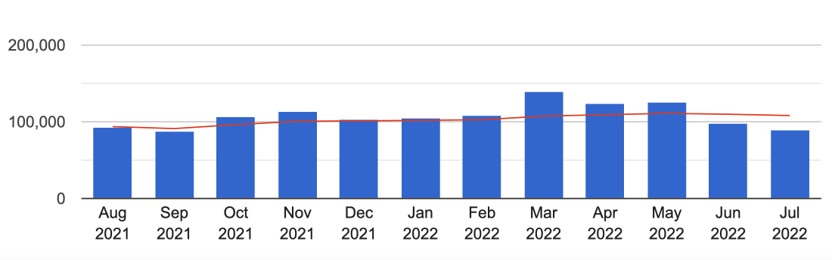

## Enlighten: Theses

There were 667 theses added to Enlighten: Theses and nearly 700K downloads (689,537).

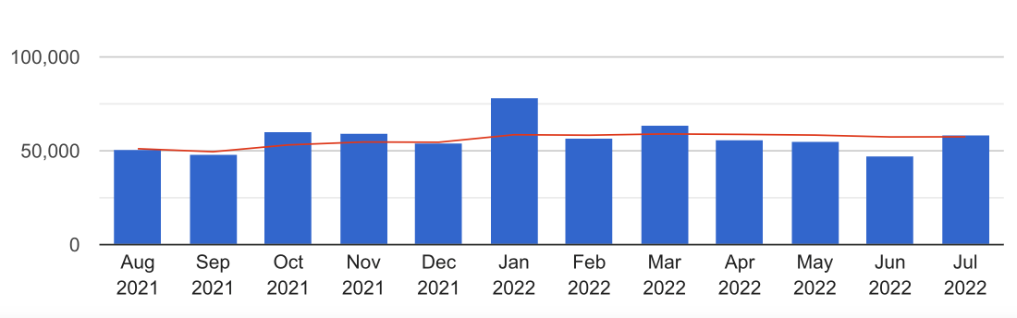

## Enlighten: Research Data

There were 122 research datasets added to Enlighten: Research Data and over 11.5K downloads (11,577)

Chart showing there were 122 research datasets added to Enlighten: Research Data and over 11.5K downloads (11,577)


## Support for Open Research

The [open research pages](https://www.gla.ac.uk/myglasgow/openresearch/) were given a complete overhaul and have been extremely popular. The service continues to receive excellent feedback. An open research coordination group and a network of champions have been established with additional roll out planned. The University of Glasgow is a partner in the [UKRN (UK Reproducibility Network) Open Research Programme](https://arma.ac.uk/recording-introduction-to-uk-reproducibility-network/).  The Library is active in providing coordination and support for the programme. A site licence for protocols.io, a platform for creation, management, and sharing of research methods and protocols, was set up in response to researcher demand.

## Open Access

Annual figures for open access show the general trend is for an increasing percentage of research outputs to be openly available: 83% of all outputs in 2022 compared with 29% in 2014.

Chart showing an increasing percentage of research outputs to be openly available: 83% of all outputs in 2022 compared with  29% in 2014.
 

Processes were set in place to ensure support for Research Excellence Framework (REF) open access compliance to reduce the risk of a large backlog of concerns at the next REF.

UKRI issued a stricter open access policy with a suitably augmented budget from April 2022. Articles and conference proceedings must be open access immediately with a CC-BY licence. UKRI open books policy comes into effect in 2024. Wellcome have a pre-existing policy and during 2022 other funders, notably The National Institute for Health Research, the Chief Scientist’s Office, and the European Union, announced similar policies.

The Library has been involved in many expert groups, e.g., [The UKRI OA Policy Forum](https://www.ukri.org/publications/open-access-policy-stakeholder-forum/), and continue to actively raise awareness of the policy changes. Glasgow have also been instrumental in the set up and initial development of the [Scottish Universities Press](https://www.sup.ac.uk/) which opened for book submissions from November 2022.

## Rights Retention

Like several other research-intensive institutions, to support good research practice and respond to drivers such as funder open access policies, the Library has been working with VP Research, Research and Innovation, and other key parties to develop a rights retention policy.  This will allow authors to share their accepted manuscript with a liberal [creative commons licence](https://creativecommons.org/licenses/by/4.0/).  An extensive consultation process was carried out with colleges, and discussion is ongoing with Legal Services, as it was agreed that Intellectual Property policy and the Code of Good Practice in Research should be strengthened in tandem. The Human Resources Policy Review Group are regularly updated. It is recognised that communication and support for the policy will be key and Library research support teams will invest considerable time working with colleagues to embed it.

## Research Data Management

Research data migration has been moved from locally managed storage to the cloud to ensure a more robust archival environment and up-to-date tools to manage the ingest and storage of datasets for staff and students.

## Research Dashboard & Bibliometrics

The Library was involved in the early planning of the research dashboard and fed into designing the bibliometrics used. This work will continue in partnership with Research and Innovation in 2023.

Bibliometrics has been an ongoing service over the year. The Library has fed into several projects that have required bibliometric use such as the University Research KPIs and the submission for the 2021 Times Higher Impact rankings, as well as local projects, such as bibliometric presentation for a writing retreat in the School of Education and individual requests for promotion/PDR.

## Outreach and engagement

Information Services staff continue to lead and make a significant contribution to national and international professional networks.

## Community Engagement

Following on from two successful placements, the Library, in partnership with the National Autistic Society Scotland Prospects Employment Service, delivered the first Employer Taster Session in Autumn 2022. An in-depth session was delivered, exploring the varied roles available within a library services environment in an academic library. This session was delivered as part of the Scottish Government Moving Forward + initiative.

## Social Media engagement

Followers have grown across the uofglibrary social channels- now totalling 48,415 followers across Twitter, Instagram, and Facebook. These channels were of vital importance to deliver key messages, particularly in promoting the UofG Life app and in supporting access to buildings and services throughout various levels of protective measures.

## Acknowledgments

This year once again presented a variety of challenges in managing our spaces and delivering services, and we would like to record our huge thanks to all Information Services staff who have been so committed to service delivery and excellence over the year. We would also like to thank our colleagues across the University community who have supported us throughout the year.