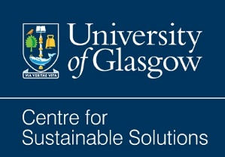
McLaughlin & Harvey Built Environment and Net Zero Poster Competition
Contributor information and submission form

Name:
University
College / School / Dept / Institute:
Email:
Telephone:
1 | Poster title
2 | Undergraduate or Postgraduate entry? | UG / PG
3 | I give permission for my entry to be added to the Conference website | Yes/No
4 | I give permission for my entry to be posted on social media | Yes/No
5 | I give permission for my entry to be added to the University’s webpages | Yes/No
6 | Social media handles/Web links:  Are there any social media accounts or websites you would like us to tag/link online? For example, Twitter or Instagram handles or hashtags used by your university/school/institute.
7 | I am available to attend the Conference on 11/11/2021 | Yes/No

Please use official university email address.
Please register for the Conference here if you wish to attend: https://www.eventbrite.co.uk/e/built-environment-and-net-zero-conference-tickets-189947797977

