R
NRRWNG WRLD

aggressive censorship in the arts and access to education
all censorship is aggression to freedom of expression and the human right to learn

7.30pm, 22nd June 2011 at The Tron Theatre, Changing House
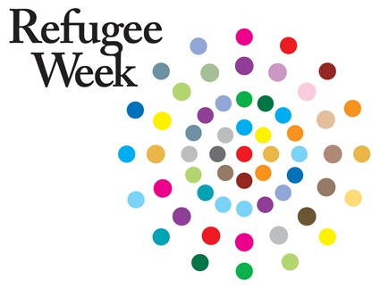
www.tron.co.uk / ragged-online.com FREE EVENT

Ragged Presents an evening of talks, rehearsed readings and an informal discussion on
“Our Narrowing World”

The Ragged activist side comes out at this evenings free event. In a narrowing world where we have increasing access to information and faster travel between borders, we could presume that freedom of thought and expression had equally been made universal. We could think that as some opportunities expand (and the barriers to accessing these opportunities are seemingly reduced) that aggressive censorship was a thing of the past. We would be wrong.
In what could be seen as a reaction to ‘our narrowing world’ we see governments repeatedly ignoring fundemental human rights. Dictatorships who control ‘public opinion’ through gagging an individuals thoughts, and through threats of exile, rape and imprisonment are creating communities who are trapped into living lies. Expression through the arts has long been a voice which releases the pressure of societal gagging. But there is fear among dictatorships of the power the arts hold : the power to encourage ownership of thought, feelings and action. It is this power that we wish to acknowledge. Practitioners not only have the right to wield this power, but are essential to providing a form of dialogue which can lift an oppressed psyche out of depression. As theatre makers and free educationalists we are angered at the aggressive censorship and violent threats international peers are exposed to in 2011. This is not something that only happened in the past, but still persists in countries such as Belarus, Iran, Brazil, and Palestine among many others.
The Ragged wish to raise awareness of the plight of companies such as The Freedom Theatre in Palestine, whose Artistic Director Juliano Mer Kamis was recently assassinated for his proactive theatre work in the Refugee camps. Juliano made such an impression on youngsters there “ that they no longer saw suicide bomber as a career option” (The Guardian, April 2011) ;and the Free Belarus Theatre whose Artistic Director Natalia Koliada and company have been imprisoned for speaking out against the current regime. Koliada was recently threatened with rape and beatings after being arrested at a demonstration where she had been identified as a human rights activist and being part of the dissident theatre company.
This evening will include rehearsed readings, screenings and talks from exiled refugee artists and Scottish arts enthusiasts about censorship.
Please come along and contribute to our discussion.
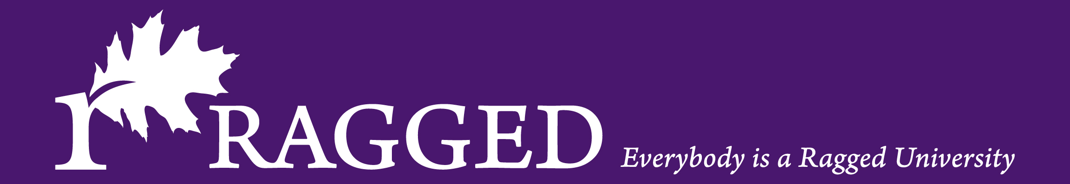
www.ragged-online.com 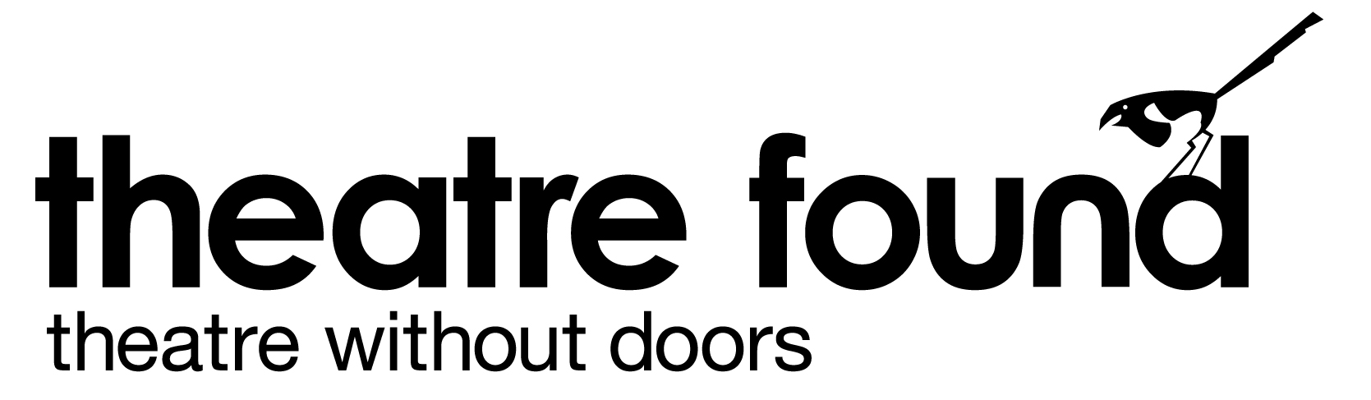
For more information on Ragged and this
Free Event contact : carrie@raggeduniversity.com

