Contents
Introduction 2
Web Strategy at the James Watt School of Engineering 2
Research structure 3
Research impact 6
Web Coordinator Responsibilities 9
Quality Control Checklist 13
Useful Resources 14
Appendix 1: Research Theme page design example 15
Appendix 2: Research Division page design example 16
Appendix 3: Research Group page design example 17
Appendix 4: Research Project page design example 18

Introduction
This guide is designed to support you as a Web Coordinator in the James Watt School of Engineering by:
- outlining the web strategy for the James Watt School of Engineering
- outlining your responsibilities regarding managing your web content
- providing advice and resources for best practices for the management of written content on your web pages
- providing advice and resources for the management of images on your web pages
- providing resources to help you meet accessibility and quality standards on your web pages.

Web Strategy at the James Watt School of Engineering
The James Watt School of Engineering website underwent a refresh in 2025 to:
- introduce a consistent look and feel across all our web pages
- improve clarity and relevancy of content for key audience (prospective students and researchers)
- ensure navigation of the content is easy and intuitive for key audience
- fix and improve website functionality
- improve Search Engine Optimisation (SEO)
- remove outdated or irrelevant content.
A key area of focus during the website refresh was content related to research which has been improved and restructured to better reflect our strategic direction and research priorities. Improvements included:
- refreshing content on the Research Impact section of the website
- moving the Research Group content into a new template with automated functionality which reduces requirements for manual maintenance
- redesigning the Research Themes content pages to increase engagement
- increasing strategic cross-linking of research content so that visitors on a Research Theme page will have the opportunity to engage with related content across Division, Group, and Project pages (and vice versa)
- improving use of CTAs (Calls to Action) in the right-hand column of many of our web pages to help guide visitors to the most relevant associated content and to encourage visitors to complete the actions we are hoping they will (e.g. apply now, contact us, submit a form, visit a page for more information, etc.).
Research structure
The research structure at the James Watt School of Engineering is designed to foster interdisciplinary collaboration and address global challenges through a structured, multi-layered framework.
At the highest level are the Research Themes — broad, strategic areas that reflect the School’s ambition to tackle pressing global issues through interdisciplinary inquiry and innovation. While these four Themes provide a unifying direction and shape the School’s overall research vision, they do not map directly onto specific Research Divisions, Groups, or Projects. Rather, they act as overarching lenses through which a wide range of research activities can be interpreted and aligned.
The School comprises five Research Divisions, which serve as the principal organisational units, each focused on a distinct area of engineering. These Divisions house a variety of Research Groups, which are specialised teams undertaking focused research within specific domains.
There are multiple Research Groups within each Division, though many of these groups engage in work that cuts across Divisions, reflecting the inherently collaborative and interdisciplinary nature of engineering research.
Complementing this structure are over 100 active Research Projects, which form the most dynamic and applied layer of the School’s research activity. These projects often originate within specific Research Groups and may span more than one Group or Division, depending on the scope and nature of the work. Some may also align with one or more Research Themes, though this is not a formal requirement.
Due to the complex and often interdisciplinary character of engineering research, there is a degree of overlap between all these elements. Research Groups may engage with multiple Divisions or Themes, and individual Projects may sit at the intersection of several Groups or thematic areas. This fluid structure allows the School to remain agile, collaborative, and responsive to emerging challenges and opportunities.
Term | Definition
Research Themes | Broad, strategic areas that address global challenges and guide the School’s research vision; not directly linked to other structural units.
Research Divisions | Organisational units focused on specific engineering disciplines; they provide structure and oversight for related Research Groups.
Research Groups | Specialised teams undertaking research in specific areas, often spanning multiple Divisions and supporting interdisciplinary collaboration.
Research Projects | Discrete research initiatives—often externally funded—led by individuals or teams, frequently nested within Research Groups but potentially overlapping divisions or themes.
See Appendix for page design examples for Research Theme, Division, Group and Project pages.
It is useful for Web Coordinators to understand both the external-facing and internal-facing research structure within the School. The following diagrams explain this.
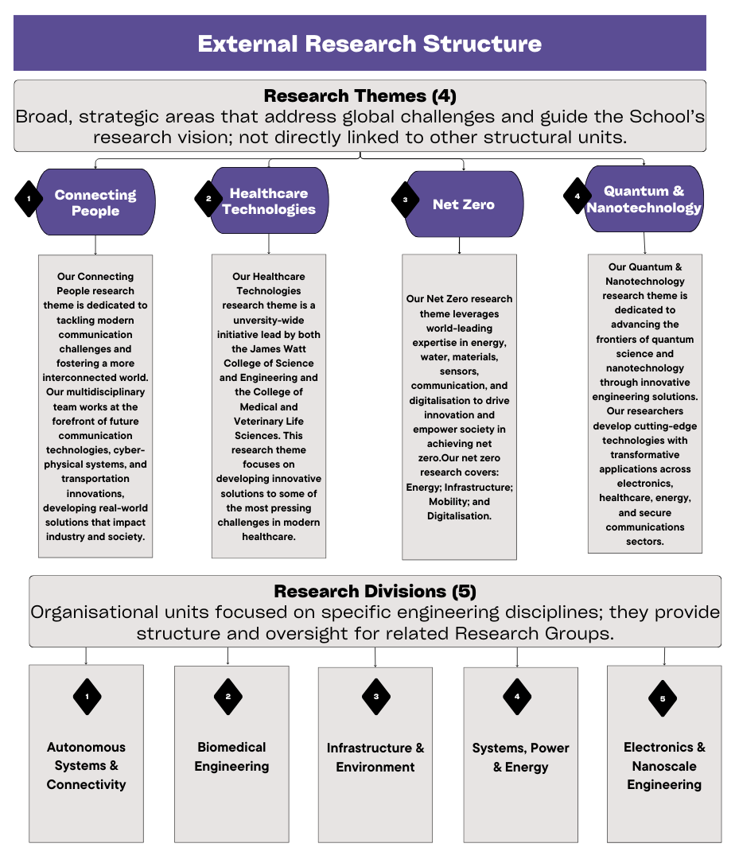
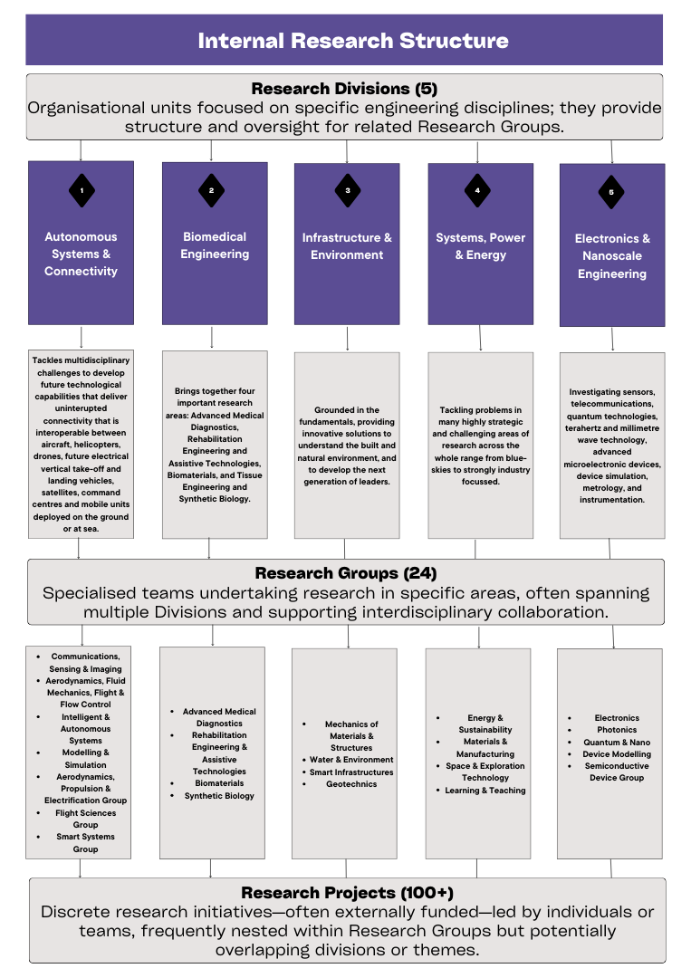

Research impact
At the James Watt School of Engineering, research impact is at the heart of everything we do. It’s not just about academic outputs; it’s about how our research makes a tangible difference in the world.
Research impact refers to the positive changes that arise beyond academia as a result of our work. This might mean shaping public policy, improving healthcare, driving technological innovation, supporting economic growth, protecting the environment, or enhancing everyday life for individuals and communities. Sometimes, it also means stopping or preventing harm by identifying risks or influencing decisions.
To support this, the School has created robust pathways that help researchers translate their work into real-world outcomes. We work closely with industry and other partners, drawing on our excellent facilities and established mechanisms for knowledge transfer. These partnerships have led to the licensing of intellectual property, the creation of successful spin-out companies, collaborative product development, and specialist consultancy services.
In REF 2021, 94.4% of our research impact was judged to be either ‘world leading’ or ‘internationally excellent’ — a reflection of the strength and reach of our research environment. To help researchers and web editors communicate this effectively, the School has introduced a new Research Impact Case page design. This aims to provide a consistent, accessible format for presenting the outcomes and significance of our research, particularly to non-academic audiences. The goal is to clearly articulate not just what was done, but what changed as a result.
Understanding impact can sometimes be complex, as it often develops over time. It may begin with a workshop, prototype, or public engagement activity. These are important steps, but they are not impact in themselves. Rather, they are part of a pathway. The immediate effects of such activities, like improved understanding or uptake of a tool, are considered outcomes. True impact is the broader, longer-term change that happens when those outcomes influence policies, shift behaviour, improve quality of life, or transform practices. It’s the difference research makes in the real world.
To ensure that researchers have the right support from the earliest stages, the College has developed the Impact and Innovation Framework. Launched in 2022, the framework provides a structure for identifying, developing and tracking research impact opportunities from the pre-proposal stage onwards. A dedicated Impact Officer works alongside the Commercialisation Team, Research Development Manager, and others to create a bespoke Impact Development Plan.
Ultimately, the role of web coordinators is vital in ensuring that the value of our research is visible and compelling. By using information provided by researchers in the Impact Disclosre Form, Web Coordinators can draft content that will fit easily into the new Research Impact Case page design. This approach will help tell clear, engaging stories about how engineering at Glasgow is shaping the world around us.
Below is an example of a Research Impact Case web page using the new page design. As you will see the page is composed of:
- Title of Research Impact Case
- Relevant image (700px x 300px and set to width of main text)
- Useful links on right hand side (these can be the same across all Research Impact Case pages)
- Sub-headings including:
  - Transforming research into societal impact
  - Collaborative excellence
  - Driving innovation and commercialisation
  - Engaging stakeholders and communities
  - Evidence of impact
  - Supporting future research and impact
Using t4, Web Coordinators can ‘duplicate’ the page building blocks from an existing Research Impact Case webpage and then just edit the text and images.
See Appendix 5 for an example of the Research Impact Case page design.

Web Coordinator Responsibilities
As a Web Coordinator, your responsibilities are outlined below. Please note that at a minimum you should be carrying out a quality control review of your web pages every three months.
- Regularly update content to ensure accuracy and relevance
Web Coordinators must review website content frequently to ensure that all information remains accurate, up-to-date, and relevant to the intended audience. This may include checking and updating course details, research information, staff listings, and event listings to ensure that no outdated or misleading information is presented. It is especially important to ensure all dates and deadlines are current.

Information that is removed and deleted can be archived offline (take a screenshot or copy and paste text and save elsewhere).

When removing content, it’s also important to consider whether any internal or external links point to it and update them accordingly.
Regular updates improve user experience, avoids confusion and help maintain the credibility of the website.
- Regularly check content functionality
Web Coordinators must review website content frequently to ensure functionality (e.g. that links are working, images are showing and embedded videos are playing correctly) and should fix or remove any issues identified.

It may be appropriate to request that redirects are set up if popular content moves to a new URL, this can be requested via webteam@glasgow.ac.uk
Broken elements on web pages can negatively impact user experience and harm search engine rankings, making it essential to routinely check for them.
- Follow WCAG 2.2 standards to ensure your content is accessibility compliant
Web Coordinators must ensure that all web content adheres to the Web Content Accessibility Guidelines (WCAG) 2.2. This includes:
- providing alternative text for images
- using clear and structured headings
- ensuring adequate colour contrast
- making content navigable via keyboard.
Compliance with these standards ensures that individuals with disabilities can access information without barriers. This is particularly important for an academic institution like the University of Glasgow, which must meet legal accessibility requirements under UK law.
- Respond to and action content update requests from staff
Web Coordinators should liaise with faculty members, marketing teams, IT staff, and other departments as appropriate to ensure accurate and timely updates. This includes:
- gathering and verifying content from different sources
- resolving technical issues with IT or Web Team support
- aligning web content with broader university communications strategies.

Web Coordinators should prioritise and process web content update requests from staff in a timely manner. It is also your responsibility as Web Coordinator to ensure the content provided:
- has been factchecked
- has been proofread
- conforms to best practice with regards to writing for the web
- is accessible
- has been approved by relevant subject matter experts and managers.

Where necessary, Web Coordinators should communicate with requesters for clarification or additional details before making changes or additions to web page content.
Timely, accurate and well-presented content updates ensure that visitors to the website get the most relevant content and helps maintain the credibility of the website.
- Choose appropriate images to accompany text where they can add value
Web Coordinators should ensure that selected images are high quality, properly sized (e.g., 700 pixels wide by 300 pixels high for navigation tiles), and relevant to the content.

Images should be natural, candid photographs that align with the university’s brand and ethos. Stock images that look overly staged or artificial should be avoided.

Diagrams and text-based images should not be used unless the accompanying text also outlines everything conveyed in the image (for accessibility purposes).
Adding images can improve user engagement and help break up large blocks of text, however, images should add value to the text-based content and be used sparingly to ensure impact and relevance.
- Maintain compliance with data protection policies (GDPR)
Web Coordinators must ensure that all published content complies with GDPR (General Data Protection Regulation). This includes:
- handling personal data with care
- avoiding the publication of sensitive information
- ensuring that consent has been obtained where required (e.g., for images featuring individuals).
- Ensure consistency in tone, style, and formatting across all pages
Web Coordinators should ensure consistency in:
- tone (e.g. keeping content engaging, to the point, friendly and professional)
- writing style (e.g. consistent use of bullet points, hyperlinks, etc. across pages)
- formatting (e.g. using headings, page components, bullet points and hyperlinks uniformly across pages).
Maintaining a uniform tone, formatting, and writing style across all web pages helps to create a professional and cohesive experience for users.
- Adhere to the University of Glasgow's web publishing guidance
The University of Glasgow has specific guidelines for web publishing, communications and branding. Web Coordinators must familiarise themselves with these guidelines and apply them consistently to maintain a professional and cohesive online presence.
Following University guidance ensures that all university-related content meets institutional standards and provides a seamless experience for users navigating across different sections of the website.

Quality Control Checklist
Task | Complete? (Y/N)
Review all assigned pages for outdated content and inconsistencies
Check for accessibility compliance using automated and manual tools (e.g. all images should have alt text).
Ensure formatting, layout, and structure align with best practices.
Verify that all links are functioning correctly.
Ensure your web pages maintain compliance with University branding and style guidelines.
Ensure written content is clear and concise while adhering to Writing for the Web: Best Practices:
  - use short paragraphs and clear headings.
  - keep sentences concise and to the point.
  - use plain English and avoid jargon.
  - spell out acronyms.
  - optimise for readability with bullet points and lists.
  - use meaningful link text (avoid 'click here').
Choose appropriate images:
  - Images should be natural and candid rather than staged.
  - Use landscape images at 700 pixels wide and 300 pixels high for navigation tiles.
  - Avoid overused stock photos or ones that feel overly corporate.
  - Ensure images are relevant and enhance the page content.
  - Ensure that consent is obtained for use of images that include students, staff, visitors or members of the public.

Useful Resources
- University of Glasgow – Advice for T4 users
https://www.gla.ac.uk/myglasgow/staff/webpublishing/advicefort4users/
- University of Glasgow - Web Publishing Guidelines
https://www.gla.ac.uk/myglasgow/staff/webpublishing/
- University of Glasgow – Writing for the Web Guidelines
https://www.gla.ac.uk/myglasgow/staff/webpublishing/advicefort4users/writingfortheweb/
- University of Glasgow Brand Toolkit
https://www.gla.ac.uk/myglasgow/staff/brandtoolkit/
- University of Glasgow - Tone of Voice
https://www.gla.ac.uk/myglasgow/staff/brandtoolkit/brandelements/toneofvoice/
- University of Glasgow – Style Guide (language and writing)
https://www.gla.ac.uk/myglasgow/staff/brandtoolkit/resources/languageguide/
- University of Glasgow – Photography
https://www.gla.ac.uk/myglasgow/staff/brandtoolkit/brandelements/photography/
- LinkedIn Learning – Writing for the web
https://www.linkedin.com/learning/learning-to-write-for-the-web/
- Web Content Accessibility Guidelines (WCAG 2.2) https://www.w3.org/WAI/standards-guidelines/wcag/
- UK Government Digital Content Design
https://www.gov.uk/guidance/content-design/writing-for-gov-uk

Appendix 1: Research Theme page design example
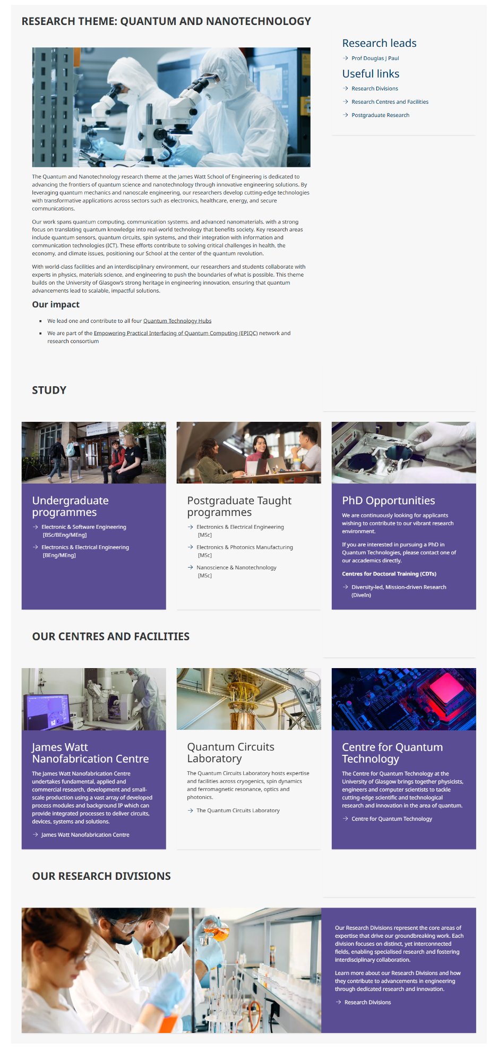

Appendix 2: Research Division page design example
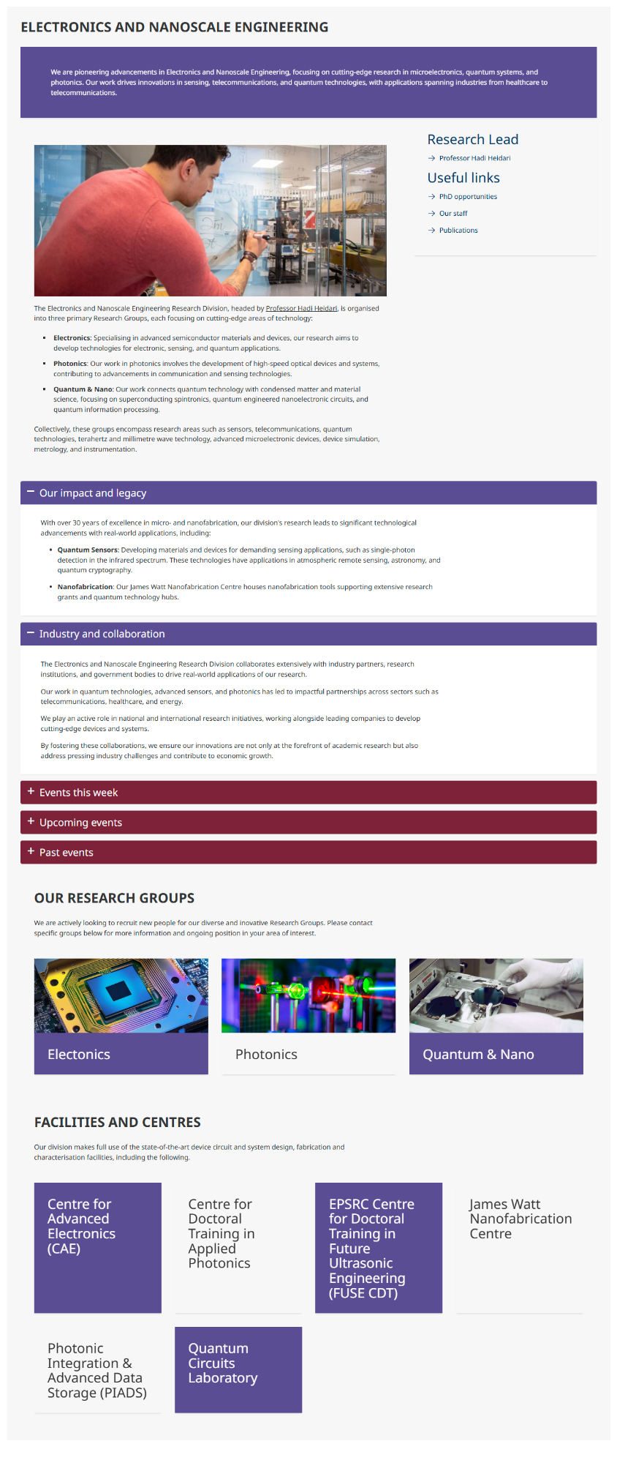

Appendix 3: Research Group page design example
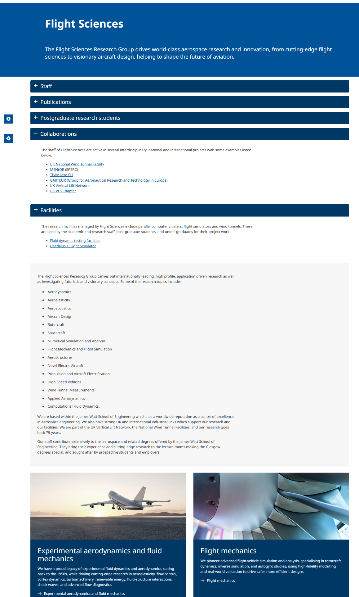

Appendix 4: Research Project page design example
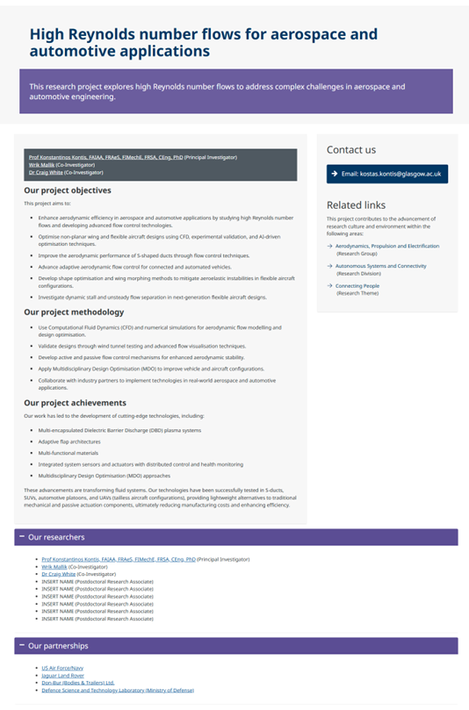

Appendix 5: Research Impact Case page design example
