
BACKGROUND
If a student paid for TAAC expenses with their own money they follow this process.
Only students with UK bank accounts can use the new system.
Expenses must be claimed within 93 days of the date on the spend receipts. Can’t submit receipts with dates in the future.
Spend/receipts that are over the agreed 93 days, the student should submit this under the ‘Other’ category – anything under this category needs to have an additional note in the budget holder pre-approval given to the student to approve this ‘out of policy’ spend.
An extra note with an explanation can be given to the student to attach to the claim. The student would then pick a date within the 93 days using this ‘Other’ category to get it through.

Student logs in to their MyGlasgow Student Portal and clicks on the student expenses tile.
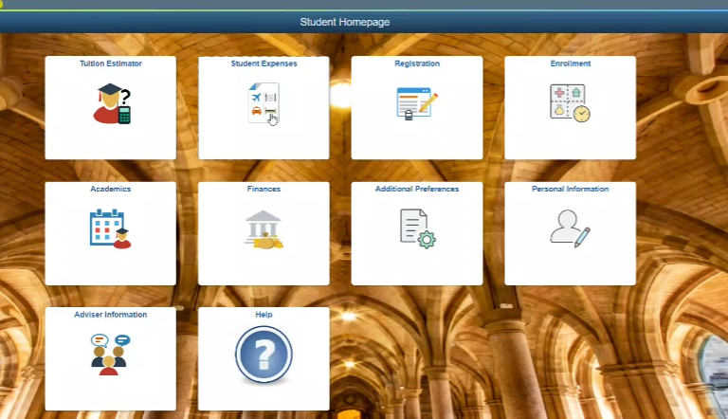
The following page opens:
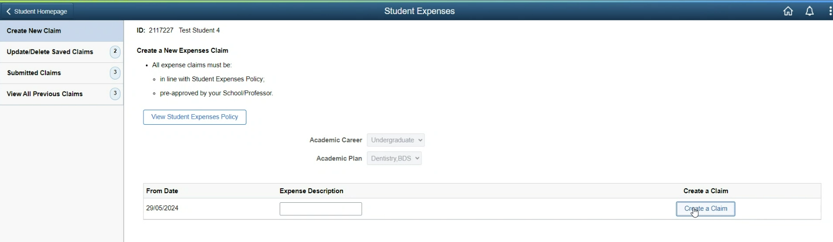
The student types in one of the expense descriptions:
- TAAC – Conference Funding Claim
- TAAC – Skills Training Funding Claim
And clicks create a claim.

PRE-APPROVAL
All four stages on the left need to be ‘complete’ before submitting. Submissions go to the school where the plan code belongs, which may not be the school they’re actually in. If this happens, the PGR school admin can make a request to redirect the claim to another PGR admin in another school.
They can be completed in any order, and must do terms and conditions.
The student needs to upload approval for their claim.
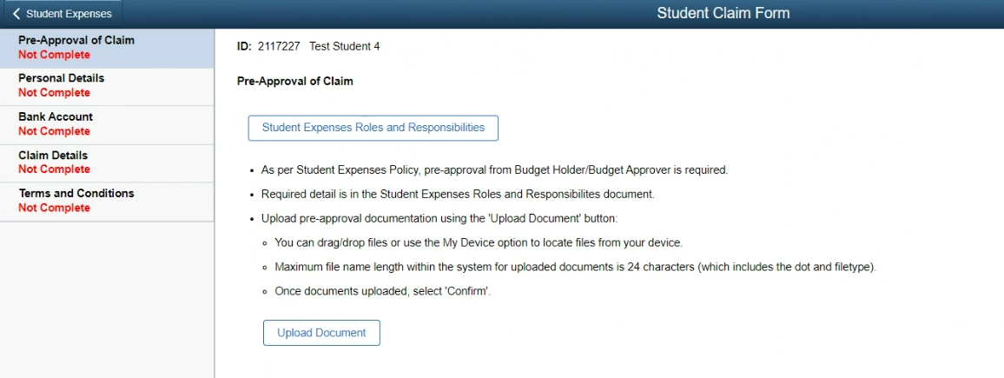
Approval need to be an email from the Graduate School.
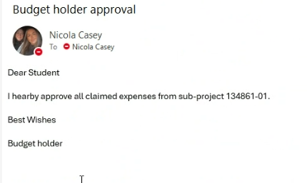
CLAIM DETAILS:
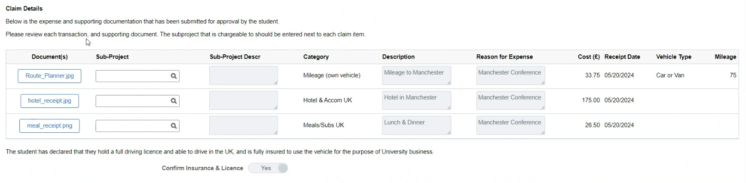
The admin checks all the receipts are correct. The dates are not in the future. The dates are within 93 days of the dates on the receipts.
Sub-project codes need to be put into sub-project section. This should be the school/supervisors project code. The Grad School then reimburses this project code.
If any part of the claim details are incorrect, the whole claim must be rejected and sent back to the student with a reason.
If their receipts add up to more than the total award given, that’s ok. The cost(£) amount column must add up to what the total amount of the award is, regardless if the receipt states it’s more than the max amount.
Example:
- We award them £750 funding towards conference attendance. Their hotel receipt is for £950. Student completes the cost(£) column with £750, not £950.
- We award them £1500 funding for a skills training course. They have several receipts adding up to £1750. Student adds all receipts and
completes the cost(£) column with amounts, that when totalled, match £1500, regardless.
- If we award them £750 and they pay for travel/accommodation at £500 using a project code and use the other £250 for extra travel/other costs with their own money, the students needs to let us know of the project code/transaction numbers and also completes a student expenses claim on MyCampus using the project code they used for travel/accommodation. We then complete a non-reversing journal form for the total amount of £750.
Admin are notified that there is a claim to review.
Students can update/delete saved claims:
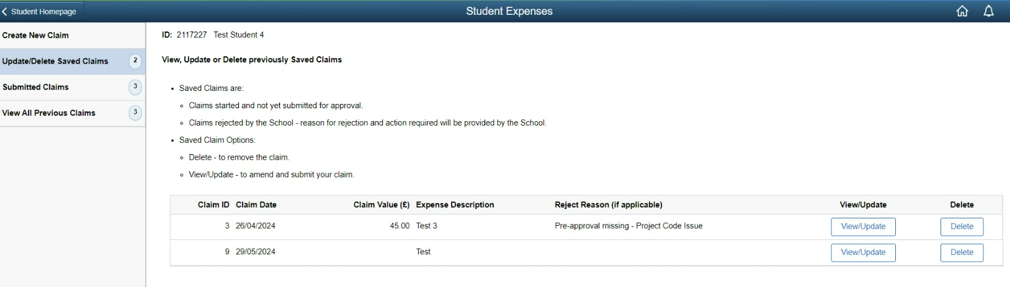

Students can see their submitted claims and status in their student portal:
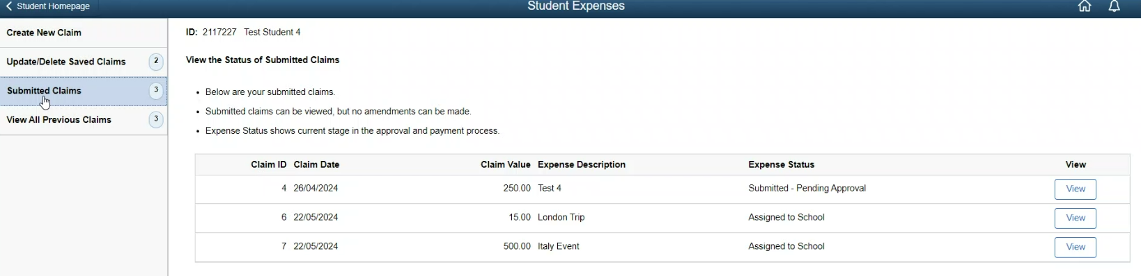

Students can view all previous claims:
