Logging into an SSD 11 workstation via the Cisco AnyConnect VPN Service  
  
Sections:

Power on your device Connect to Wi-Fi Connect to VPN

Additional notes VPN combinations

Sync OneDrive Files

# Power on your device and allow Windows to boot

* Power on your device
* After Windows boots, mouse click, or key press will remove the welcome screen
* Click OK to accept the University of Glasgow workstation usage policy and you will be presented with the SSD 11 login screen.

# Connect to Wi-Fi

## Note: At home If you connect to a wired network connection, either directly or via a docking station, skip the Wi-Fi connection step.

* **Note: On campus If you connect to a wired network connection, either directly or via a docking station, skip the Wi-Fi and VPN steps**

Click on the Internet/WI-FI button to open the wireless network screen:

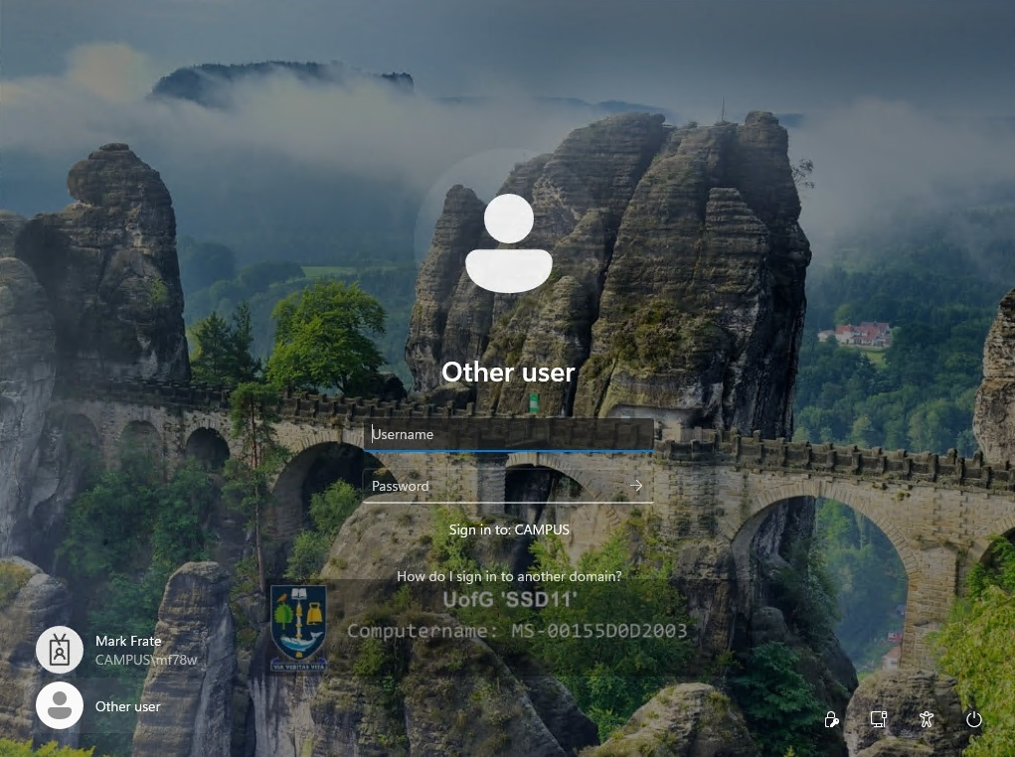

* + If you are on campus you will connect to the Wi-Fi network named “FlexAccess”
  + If you are elsewhere (home) you will connect to a wireless network in your location following the network provider’s guidance. Select Automatically Connect so that it will connect to this network when within range.

# Connect to VPN

When you are connected to your selected network, click the highlighted icon on the bottom right of the screen labelled **Network sign-in**.

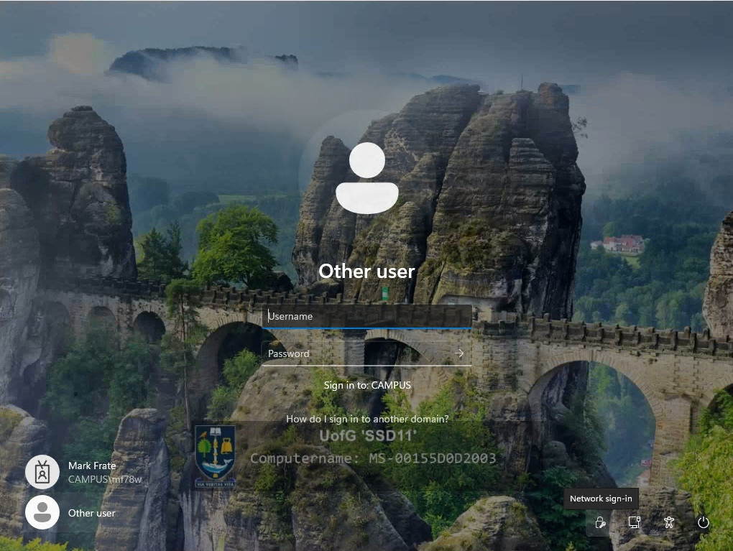

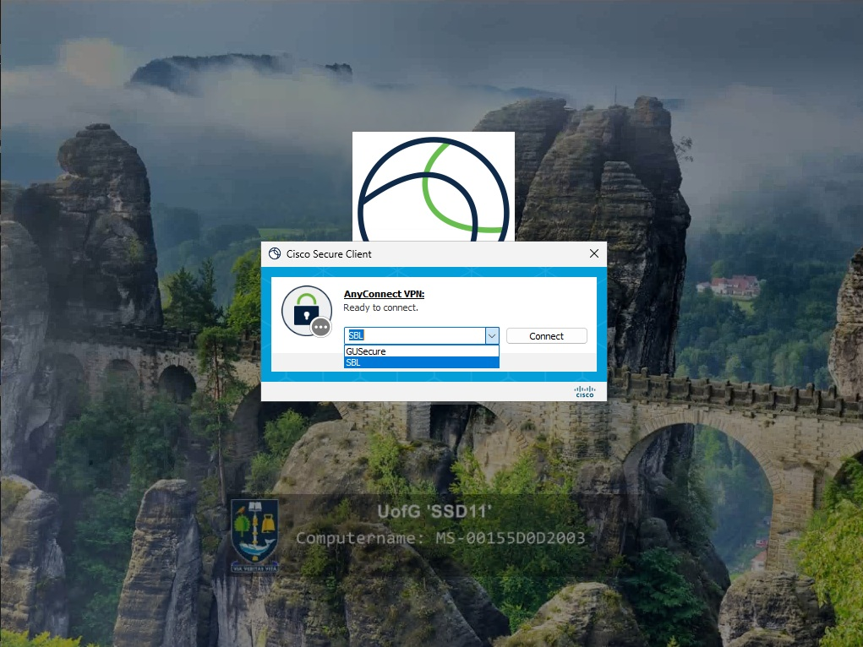

From the **Group** drop down list select **SBL**. Enter your University of Glasgow GUID credentials and click **OK**.  
Some users may see the following screen when connecting to VPN for the first time

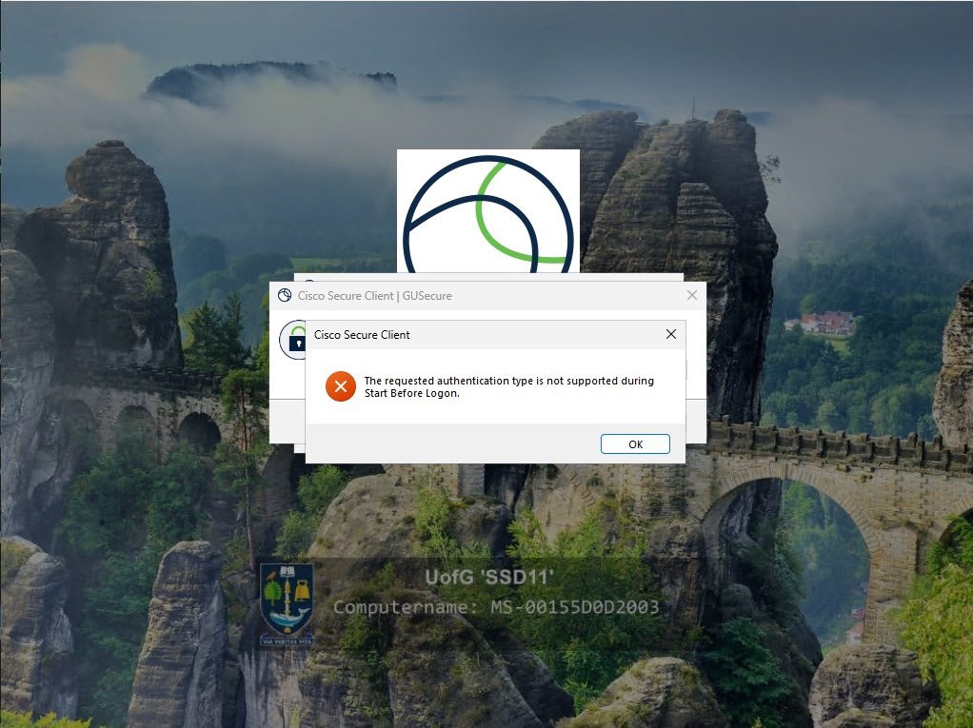

If you see this, close the box containing the red circle with the X and then click on the drop-down in the Cisco AnyConnect | SBL box and choose either SBL, if off campus, or SBL_on_Campus, as below

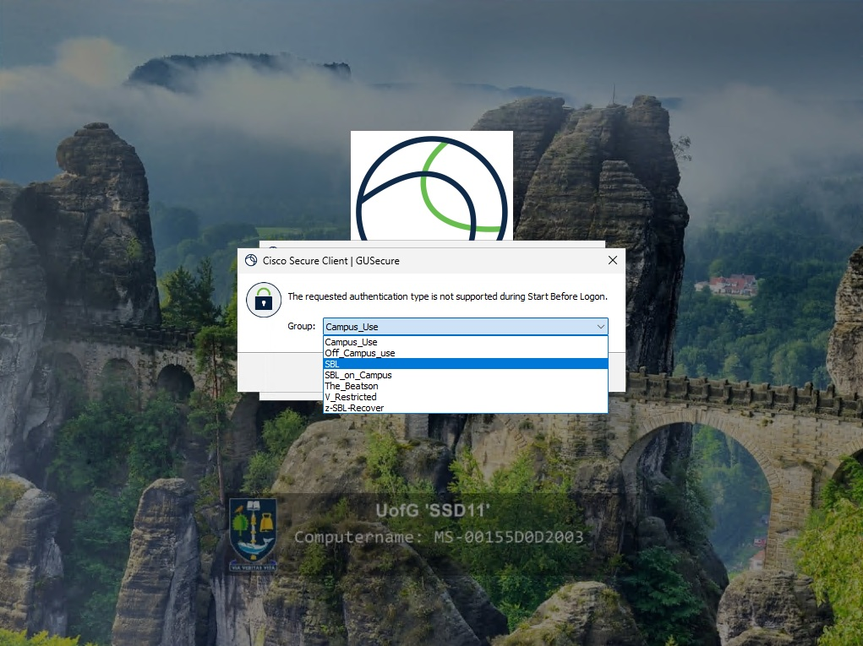

Then enter your GUID and password and click Connect.

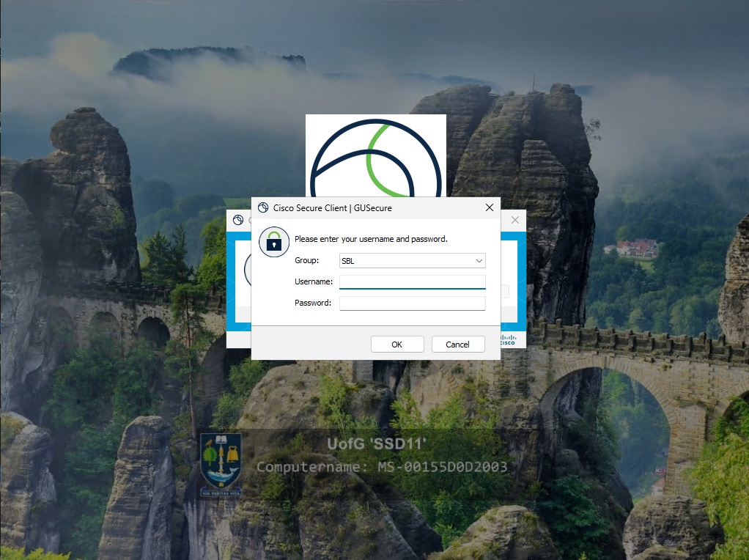

Once VPN is connected, you will now be presented with the normal SSD 11 log in screen. If there is already a “username” in the first field click “**Other User**” at the bottom left then enter your University of Glasgow GUID credentials and press the Enter key or click the right facing arrow. First time login can take up to 10 minutes to complete.

Laptop login screen.
GUID and Password.

**Note: Every time you power on or restart the device, we recommend that you connect to the VPN prior to Windows login to gain full function of SSD11.**

Additional Notes

The wireless network “FlexAccess” on its own will not grant access to the internet. The first time you connect to this network, windows may tell you that it cannot access the internet.

This is normal and you are safe to close this window.

|  |  |  |  |  |
| --- | --- | --- | --- | --- |
| VPN combinations |  | | | |
| Wi-Fi: FlexAccess | > | VPN Server: SBL | > | Group: SBL campus |
| Wi-Fi: Eduroam | > | VPN Server: SBL | > | Group: SBL |
| All other Wi-Fi | > | VPN Server: SBL | > | Group: SBL |

# Sync OneDrive files

On the taskbar, click on the **OneDrive icon** and click **Sign In**:

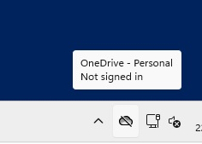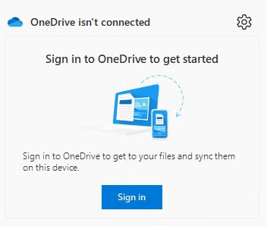

Enter your **University Email Address**, click **Sign In** and approve the MFA prompt (if setup) Click **Next** on the Location

Click on “**Use this folder**” if prompted Follow on-screen instruction

After a few minutes, your files should now appear in the relevant folders.

For any issues, please contact our helpdesk <https://www.gla.ac.uk/myglasgow/it/helpdesk/> or 0141 330 4800