# Common issues

Note: you may not be able to remediate the following unless you have administrator privileges on the system. If you do not, please contact [contact the UofG Helpdesk](https://www.gla.ac.uk/myglasgow/it/helpdesk/)

## Hard disk space

As this is a major operating system upgrade your device must have a minimum of 64GB of free disk space.

If you have insufficient free disk space, you may receive a warning similar to this where you will be given options.

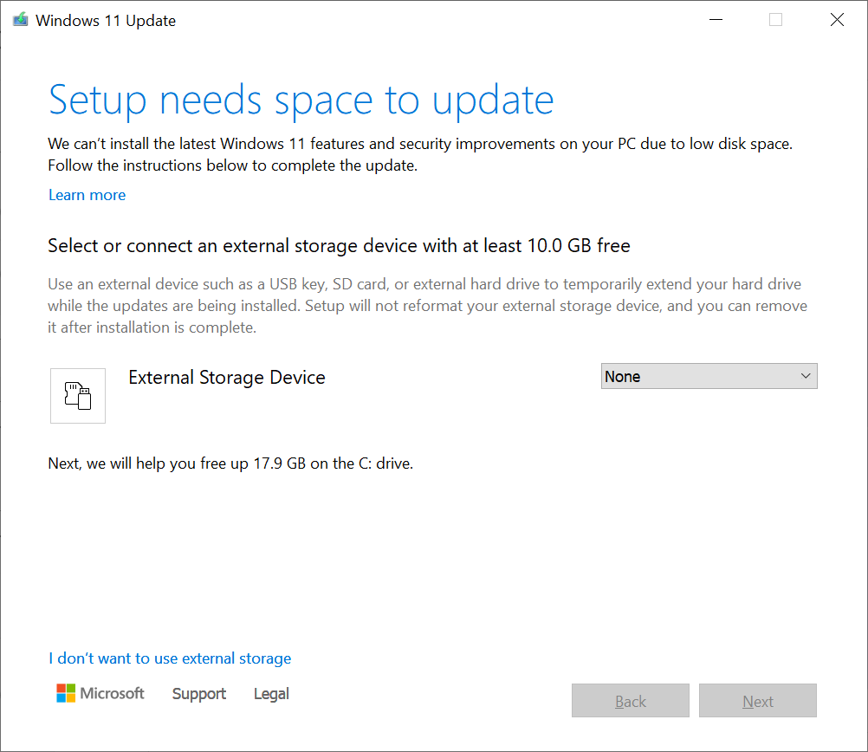

* If you are unable to free up enough disk space by following the suggestions provided, please [contact the UofG Helpdesk](https://www.gla.ac.uk/myglasgow/it/helpdesk/) for further assistance.

## Application Compatibility

The Windows 11 updater should flag up any applications that are not compatible with Windows 11 before proceeding with the update.

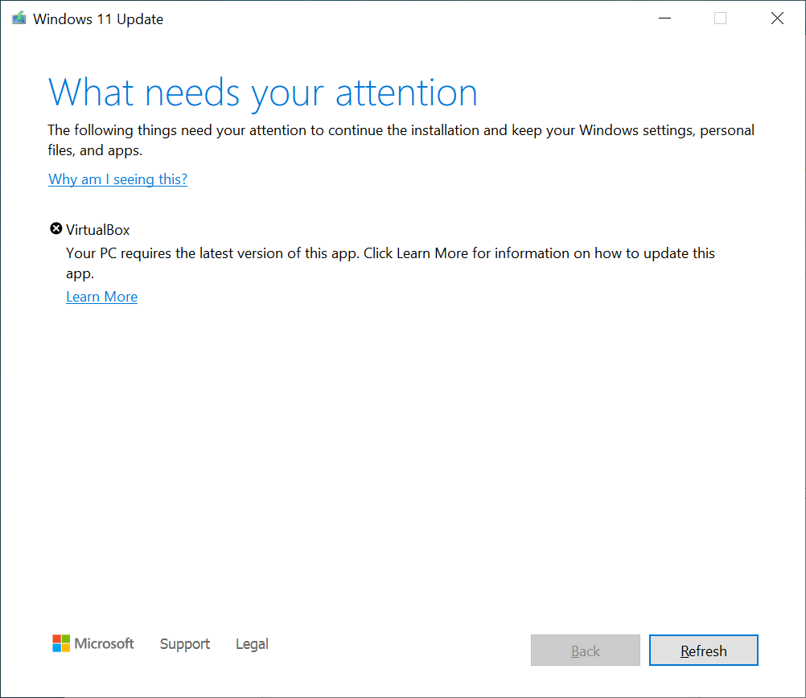

* It is recommended that you upgrade or uninstall any applications that are flagged up in this manner. If you are unsure on how to accomplish this, please [contact the UofG Helpdesk](https://www.gla.ac.uk/myglasgow/it/helpdesk/) for further assistance.

## Hardware compatibility

On some occasions the device or some hardware within the device may not be compatible with Windows 11. This is usually the case for older systems.

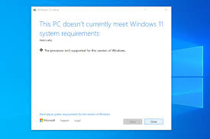

If this is the case, and your corporate device is centrally for managed then arrangements will be made in due course to facilitate replacement hardware if appropriate.

* If your device is personal or you are unsure whether it is centrally managed, then [contact the UofG Helpdesk](https://www.gla.ac.uk/myglasgow/it/helpdesk/).