**Criteria for inclusion in the NSS Population**

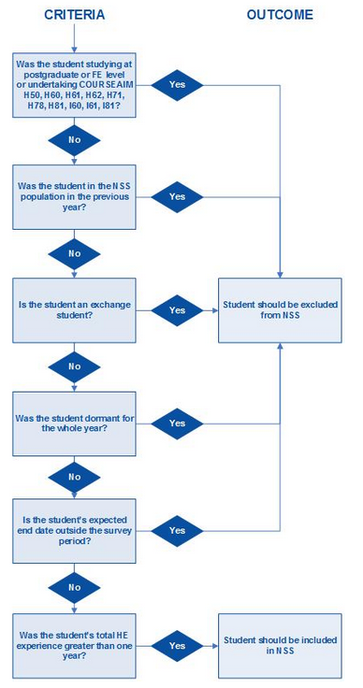

**Is the student a postgraduate?**