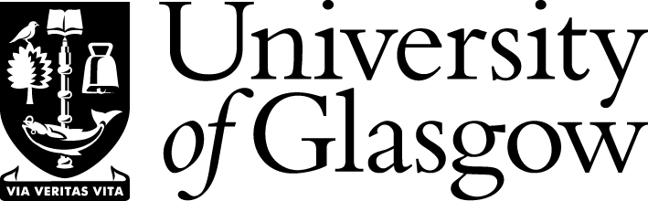

**Semester 1 – 2024 - 2025**

**Friday Celebrity Organ Concerts and Wednesday Lunchtime Organ Concerts in the Memorial Chapel**

October 2nd Kevin Bowyer Glasgow University

October 9th Andrew Canning (Uppsala, Sweden)

October 16th Richard Powell Glasgow

October 23rd Malcolm Sim Glasgow

October 30th James Lancelot Durham

November 6th Colin Andrews U.S.A.

November 13th David Hamilton Royal Scottish Conservatoire

November 15th Damin Spritzer U.S.A.

November 20th Will Briant Edinburgh

November 27th Kevin Bowyer Glasgow University

**Funding by the Ferguson Bequest.**

**Professor Thomas Ferguson (1900-1977), Henry Mechan Chair of Public Health (1944-64), bequeathed his estate to the University, with the instruction that the money should be used to foster the social side of University life.** 