

Life Sciences - Excel

V1.2

e-mail: training@glasgow.ac.uk

web: gla.ac.uk/services/it/training

copyright © University of Glasgow

Course content created by Blair Thompson

Last edited by on 17/09/20

Contents

Introduction iii

Objectives iii

Session 1: Excel 4

Setup 4

Section 1: Using Charts and Tables 7

1 Creating Charts: 7

2 How do you decide what type of chart is best? 12

3 Cell formatting & creating Tables 14

4 Manipulating Data 16

Section 2: Manipulating data using Excel 17

1 Using Statistical Functions 17

*2* Organising data before creating a chart. 19

3 Information on Integrating *Word* and Excel Files 22

4 Information on printing in Excel 25

5 Further Training 27

Appendix I – Word Processing for lab reports, essays and papers. 28

Appendix II – Additional material you may find useful to work through. 31

1 Charts: Category Labels 31

2 Logical Functions 31

Appendix III – Remote desktop 33

Introduction

### IT Skills Course developed in partnership with Level 1 Biology

This IT course has been created to give you comprehensive support to develop your digital literacy and gain confidence in essential IT skills.

Appropriate presentation of your scientific data is essential to obtain good grades in marked assessments throughout Level 1 Biology, throughout all levels of your degree, and further into employment.

The course consists of two sessions (for which there are online notes).

Objectives

### Session 1

##### Creation of tables and graphs including:

##### selection of appropriate chart types

##### manipulation of data using formula

##### simple statistics & error bars

##### understanding cell referencing

##### creating different types of charts

##### Embedding figures into Word documents.

### Session 2

##### EndNote X9 for PCs

The IT Tutors delivering both session 1 and 2 are there to help you, please ask during the sessions if you are having issues or do not fully understand something.

Level 1 Biology has weekly formative exercises involving graph drawing to give you practice using the skills you will gain from the IT course.

Information on all aspects of remote learning, including how to obtain free access to Office 365, which includes Excel 2016, can be found via this link

[My Glasgow Anywhere](https://www.gla.ac.uk/myglasgow/anywhere/)

The instructions in this manual are appropriate for *Excel 2016*. Your personal computer may have a different version of *Excel* and therefore have slightly different ways to achieve the tasks. It is your responsibility to identify this. You can either access Excel within Office 365 from your own machine or the University machines to produce your work, or check that you know how to complete these tasks using the version of Excel you have on your own PC.

Session 1: Excel

Setup

## Before You Start

Download an *Excel* workbook file onto your own machine so you can complete the tasks in the course.

#### Go to [https://www.gla.ac.uk/myglasgow/it/training/courseresources/#goingfurtherwithspreadsheets](https://www.gla.ac.uk/myglasgow/it/training/courseresources/" \l "goingfurtherwithspreadsheets)

#### Download the file **Life_Sciences_worksheets.xlsx**

#### When you download the file, save it as Life_Sciences_worksheets.xlsx

## Downloading files

**Note**: the downloaded document can be used immediately but often downloadable documents like this are set as Read-Only files. Often, too, documents are sent (e.g. via email) for comment in a Read-Only format. If you wish to edit such files you must first save them under a different name from that of the original.

You must also save any downloaded or email-attached documents to a new folder when you open them: such documents are sometimes saved as temporary files which you may not be able to access later and you must save them in a folder that you know will still exist the next time you try to access them. When you are creating folders remember to give them a meaningful name associated with the course e.g. BIOL1001IT_ITCourse.

## Glossary

Excel uses terminology that you may not be familiar with. This glossary will help you to understand what some of the terms mean.

**Excel Ribbon** – an image of this is shown in Figure 1 below.

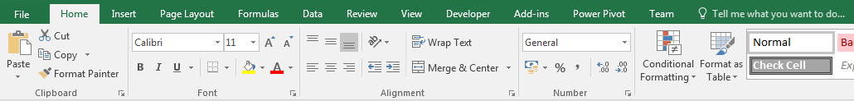

**Figure 1**: The Excel Ribbon: each tab gives groups of options. **Home** is selected here.

**Charts** – Graphs - referred to as Figures in scientific papers, posters and presentations.

**Contemporaneous data -** Data originating during the same period of time

**Cell referencing -** When you use formulas in Excel, e.g. you want to divide by the number in cell A1 then you highlight the cell A1 in the formula. This is what is known in Excel as the cell reference.

There are two types of cell referencing absolute and relative, which one you use depends on what you want to do.

**Relative referencing** - A relative cell reference adjusts to its new location when the formula is copied or moved. Therefore, if you use a formula in cell C1 of =A1*B1 then fill down the column then in cell C2 formula will become =A2*B2, in cell C3 the formula will become =A3*B3 and so on down the data.

Each number in row A is multiplied by the number in the corresponding number in row B

**Absolute referencing -** An absolute cell reference does not change when the formula is moved. So, this time if you use the formula in cell C1 =A1*$B$1, in cell C2 =A2*$B$2, in cell C3 =A3*$B$1,

So, each number in column A is multiplied by the number in cell B1

**Functions in Excel -** Functions apply a formula to data within Excel. You will use simple arithmetic functions e.g. add and multiply as well as statistical functions such as standard deviation.

## Why you need to be able to use Excel

##### Including Tables and Figures in your assessed work is essential. This part of the course will give you experience in working with data in Excel. You will have opportunities to practice these skills throughout the Level 1 Biology Course.

##### In your assessed work, you will be required to collect, analyse data within Excel and perform statistical analysis on that data before presenting it in graphical format.

##### We expect all Tables and Figures to be correctly formatted and labelled with a Title above each and a descriptive Figure Legend below.

We expect you to gain the skills to be able to produce figures such as the one below.

**Graphs with error bars shown**

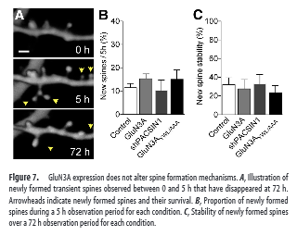

**Effect of GluN3A expression levels on spine formulation**

**Title**

**A descriptive figure legend**

Figure adapted from: Kehoe et al, 2014, The Journal of Neuroscience, p9213 -9221

This course will show you how to complete each point on the checklist below to allow you to create appropriate figures required for scientific writing.

### Checklist

##### Have I used an appropriate chart type to display the data?

##### Does the chart have an appropriate title?

##### Are the X and Y axes labelled clearly?

##### Are the axes scaled to the data?

##### Are the data legends labelled clearly?

##### Are there not enough or too many Grid lines?

##### Have I chosen colours to aid understanding?

##### Are the data points clear and an appropriate size?

##### Have I included a figure legend that describes the data?

##### Creating Charts using Excel

Section 1: Using Charts and Tables

By the end of this section you should be able to:

##### Create charts from data in spreadsheets

##### Create charts with different formats

##### Create semi-log graphs

##### Understand cell references

##### Be able to format data as a table

##### Use the table format for searching and sorting data

# Creating Charts:

There are many different chart types you can use to present your data. It is important that you are clear why you are using a particular type of chart to present your data. You will get help with this throughout the Level 1 Biology course.

Work through the material below to help you develop this skill.

This will specifically support you for the following throughout Level 1 Biology:

**Formative practice** - You will need to do this weekly as part of the laboratory sessions

**Summative assessment** – You will need to do this to produce your lab reports.

## Recommended Charts

The latest version, Excel 2016, has a new feature that helps you to decide what kind of chart to use with your data.:

#### Highlight the data that you wish to include in your chart. You normally include both the data and the row/column titles in your selection

#### Click on the **Insert** tab and from the ribbon select **Recommended Charts** (found in the **Charts** group

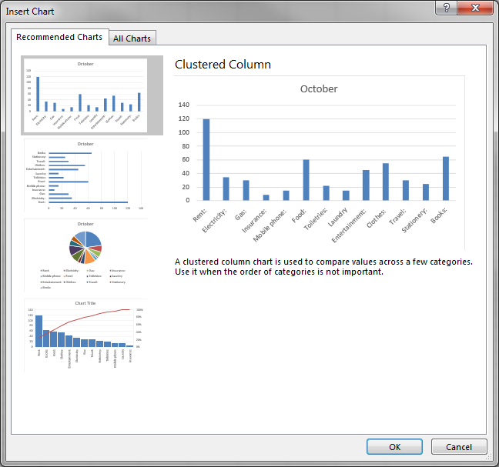

#### In the dialogue box that appears you can see a selection of recommendations on the left.

#### Clicking on any of the recommended charts in the dialogue will reveal a preview and a description of the chart. Pick a chart that represents your data well.

#### Click **OK** to create your choice of chart

**Note:** The choices that are offered to you using the **Recommended Charts** tool are based on the structure of your data. Occasionally options will be offered that are not appropriate.

## Creating a chart manually

You may have a good idea as to the type of chart that you would like to use to present your data. If this is the case, you can create this chart directly using one of two methods

### Method 1

#### Screen shot of recommended charts for scatter graphSelect the data to be charted, including row or column headings to be used as labels, and then

#### Access the **Charts** group under the **Insert** tab.

#### Select the chart type that you wish to use from the **Charts** group

#### Select from the drop down the chart sub-type that you wish to use

#### Your chart will appear in the worksheet.

#### At the same time new chart options appear on the **Ribbon**.

These options affect the way your chart will appear – so you should choose carefully as good choices will make it easier for others to understand what your chart represents.

### Method 2

Use the **Insert Chart** dialog box from the Excel **Ribbon**

**Note**: this dialog box does not allow you to format the layout of charts you choose nor add labels, legends or gridlines. However, **Chart Tools** has options that allow you to do this (see below).

### Task 1.1a: How To Create a Basic Chart

#### Go to the **Income_expenditure** worksheet in your Excel workbook file.

#### Select the first two columns and then access the **Chart** group on the **Insert** tab.

#### Select the **Column** option then select a **Clustered Column** sub-type.

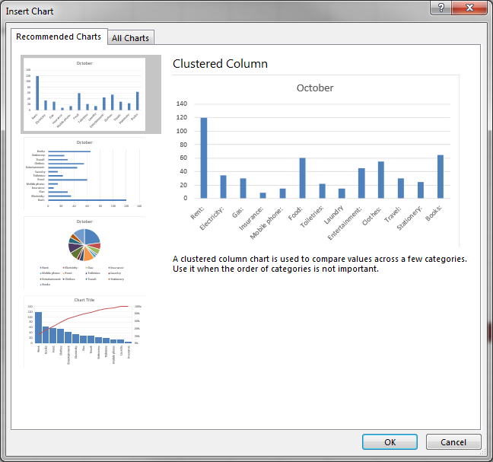

## To change the chart layout:

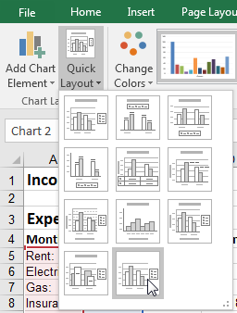Excel contains a quick way to alter the chart to a pre-set layout:

#### If your chart is not selected, click it to select it

#### Click the **Quick Layout** option (under the **Design** tab)

#### When you hover over the selection of layouts that appear, your chart will offer a live preview of your chart.

#### Below you see one that displays a data table below the chart.

#### To change the colour of the bars on your chart - select the **Chart Styles** option under the **Design** tab.

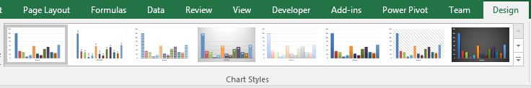

#### **To change the location of size of your chart on the screen** - Click once the chart to select it, this places sizing handles around it.

#### To move a chart to a separate worksheet - select the **Move Chart** button.

### Task 1.1b How to Alter the Overall Layout of the Chart

#### Select the chart and apply a new chart layout from the **Chart Layout** options under the **Design** tab (under **Chart Tools**) on the **Ribbon**.

#### Apply a new **Chart Style** to the chart, done well this can improve the look of the chart and make it easier to interpret.

## To alter the data and how it displays,

##### Add another set of data to the chart

##### Completely change the data on the chart

##### Swap what is plotted on the y vs the x axes.

Click on the chart to select it, then click the **Select Data** button in the **Data** group.

This can also be used to compare contemporaneous data: e.g. you may have a chart with one set of data and you want to add other, related data for comparison. This will be valuable to compare your data sets.

sc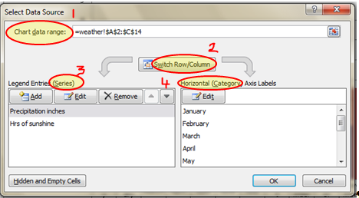

The **Select Data Source** dialog box opens, which displays your selections.

You can make a selection by typing in the cell references the **Chart data range (1)** box or by dragging over the data with the mouse.

To swap the data on the axes use the switch **Row /Column box (2)** and to change what is on the **series (3)** and **the category (4)** side.

### Task 1.2: How to add data to a Chart

#### Go the **Weather** worksheet and select the **A** and **B** columns. Now create a simple **Line** style **chart** using this data. Move the chart to a separate worksheet.

#### Select the chart then under **Chart Tools 🡺 Design** use **Select Data** to extend the data used to include the next column of data (**Hrs of sunshine**).

## Working with Chart Elements

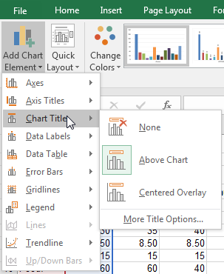Before, we saw that we can use the **Quick Layout** to make significant changes to the overall chart appearance. Unfortunately, it is likely to be the case that you will not find a **Quick Layout** that exactly meets your needs. If this is the case, you should try and find one that is as close as possible to the chart that you require. From there, you may edit the individual elements of the chart to your exact requirements. There are several different ways to add and edit chart elements in Excel 2016:

### Add Chart Element

You may add chart elements via the **Design** ribbon:

##### The first command within the **Design** ribbon is **Add Chart Element**. Clicking this with your mouse will present a menu that contains a list of all the types of chart elements that can be added to your chart.

##### Each of the element types has an additional sub menu where options are offered to you.

##### Each also has a **More … Options** item that will open a pane giving you detailed control over formatting of the related elements

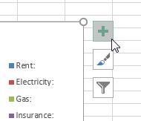A possibly more direct method to add or format chart elements is via buttons on the right of your chart:

#### Select the chart you wish to edit

#### On the right three buttons will appear.

#### Selecting the first item offers you a list of elements that you may add to a chart.

### Formatting Chart Elements

Formatting of chart elements is done via panes on the right-hand side of the Excel 2016 application. You may enable the format pane using the **More … Options**, found in the menus we looked at previously. You may also enable the pane via the **Format** ribbon:

#### Click on the **Format** tab

#### From the top of the **Current Selection Group**, select the combination box and choose the chart element that you wish to format. This will select the element on your chart

#### From the **Current Selection Group** select **Format Selection**

### Task 1.3: How to change chart gridlines, data labels, axis and chart titles

#### Select the **Weather** chart you created and choose **Design 🡺 Add Chart Element** and then **Gridlines**.

#### Select **Primary Horizontal** **Gridlines** (if they are not already enabled)and then **Minor** **Gridlines** to display gridlines that give more detail to the chart.

#### Select **Design 🡺 Add Chart Element** and then choose **Data** **Labels**. From the menu that opens, choose **Above**.

#### If there is time you can practice altering the axis labels and titles

# How do you decide what type of chart is best?

You will receive practice in identifying when to using each type of chart and drawing each throughout the level 1 Biology course

## Commonly used chart types

**Bar charts**. Give a horizontal display of data.

**Column charts** Similar to Bar charts except they give a vertical display.

**Line charts** are best for presenting a continuing sequence of data to highlight the relationship of one variable to another

**Scatter charts** display series as a set of points.

Having a proper scale on your chart is important (avoid showing one quantity that is drastically larger or smaller than the rest).

## Information on Semi-log charts

Occasionally you will create charts from data that is best plotted on a logarithmic scale on one axis and the normal numerical scale on the other i.e. a semi-log graph. This is a way of visualizing data that are related according to an exponential relationship.

This is used when one of the variables being plotted covers a large range of values and the other has only a restricted range. The advantage is that it can bring out features in the data that would not easily be seen if both variables had been plotted linearly.

Other features you will require for the following task are **Chart Layout**, **Format Selection** and **Format Trendline**. The task below will describe how each is to be used.

### Task 1.4a: How to create a Semi-log chart (part 1)

#### Access the worksheet, **Semi log data***.* Select the data in cells **B3** to **C5** and then click on the **Insert** tab. Select the **Scatter** chart option and make sure the first chart sub-type is chosen.

#### Click the **Design** tab on **Chart Tools** then choose **Select Data**. The dialog box will open. Select **Series 1** and **Edit** it. Add the **Series name** *Carnivore*. Click **OK**.

#### Now click the **Add** button. Enter the **Series name** *Herbivore*. Now with the cursor in **Series X values**, drag over cells **E3-E5**. With the cursor in **Series Y values**, drag over cells **F3-F5**. (You should delete the “**{1}**” first). Click **OK** then **OK** again

### Task 1.4b: How to create a semi-log chart (part 2)

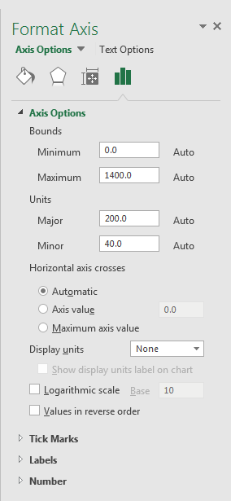How to change an axis to a logarithmic (log) scale

#### With the chart selected choose the **Format** tab then under the **Current Selection** group choose **Vertical (Value) Axis** from the drop-down menu.

#### Click on **Format Selection** to open the **Format Axis** task pane. Then under **Axis Options** tick **Logarithmic scale** and ensure this is set to **10**. Click **Close**.

#### Click the **Design** tab

#### Select **Chart Layouts**-**Quick Layout**

#### Select **Layout 3**.

#### Right-click on one of the Trendlines: the **Format** **Trendline** pane appears

The default **Trendline** **Options menu** should be selected.

#### Select **Exponential** and then **Close**. Now repeat this for the other Trendline.

#### Now select **Add Chart Element** and add a title to the chart.

## Chart Checklist

When you have created your chart – ask yourself the following questions and alter the chart if you cannot answer YES to each

##### Have I used an appropriate chart type to display the data?

##### Does the chart have an appropriate title?

##### Are the X and Y axes labelled clearly?

##### Are the axes scaled to the data?

##### Are the data legends labelled clearly?

##### Are there not enough or too many Grid lines?

##### Have I chosen colours to aid understanding?

##### Are the data points clear and an appropriate size?

##### Have I included a figure legend that describes the data?

# Cell formatting & creating Tables

In *Excel 2016*, you can apply a predefined table format to a cell range.

The **Format as Table** feature displays an extensive **Table gallery** with formatting thumbnails divided into three sections — Light, Medium, and *Dark — each of which describes the intensity of the colours used by the various formats.*

When you apply this format, a **Filter** is also applied to the table. We will look at filtering (**AutoFilter**) later in the course.

#### Select your data by placing your selected cell within the data table

#### Choose **Format as table** from the **Styles** group (on the **Home** tab).

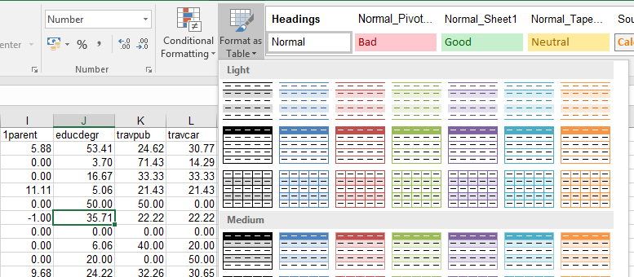

A gallery of table formats appears. (You can also build your own custom table format by clicking the **New Table Style** button below the table formats).

#### screen shot of the Format As Table dialog box showing the table range selected and the my table has headers box ticked.Click a thumbnail in the table format gallery.

Excel makes its best guess as to the cell range of the table to apply it to (as indicated by the marquee around its perimeter) and the **Format As Table** dialog box appears.

#### If the cell range for the table is incorrect, drag through the range in the worksheet.

The table range appears in the **Where Is the Data for Your Table?** text box.

Click **OK** and the formatting is applied.

### Task 1.5a: How to format data in a Table

#### Access the **postcode** worksheet in your Excel file. Select the first cell in the table of data. Now apply one of the **Format as Table** options to the data.

#### If a dialog box appears, check the cell selection is correct and that the box next to the words **My data has headers** is selected.

#### A default table style will be applied. Use the **Table Styles** menu to apply a new table style.

#### Alter some of the **Table Style Options**. Once you settle on a table design that you like, save the worksheet.

## Information: Table Formatting and sorting & filtering data.

Filtering displays a subset of a Table, providing you with an easy way to break down your data into smaller, more manageable chunks.

Filtering does not rearrange your data; it simply temporarily hides rows that don't match the criteria you specify.

Each **Filter** menu has a context related filtering option: e.g. numeric options such as **Less Than**, **Greater Than**; text options such as **Begins With**, **Ends With**, **Contains**.

To remove the filter, select the **Filter** menu and then choose **Clear Filter**.

The **Sort by** and **Number/Text Filters** options open menus which opens **Custom Sort** and **Custom Filter** dialog boxes.

### Task 1.5b: How to sort and filter data in a Table

#### Access the **postcode** worksheet again. **Select the first cell.** Click the **Data** tab. Now, click the **Sort** button, then select the field **yunemp** in the **Sort** **by** box and choose **Largest to Smallest**. Click on **OK**. The file will now appear sorted.

#### screen shot showing the area name filter with the drop down sort options displayedNow, click the **Sort** button, then choose **area name** in the **Sort by** box and choose **A to Z (Smallest to Largest).**

#### Then, still in the **Sort** dialog box, click on the **Add Level** button. Under **Then by** select **unemp** and again **Smallest to Largest** order. Click **OK** to sort.

#### Undo all the sorts to get back to the original data. Click the Data tab, then select **Filter** then **area name** (click the filter down arrow) and **Sort** **Z to A** order.

#### Now select **unemp** and apply the **Number Filters,** then **Top Ten**. Undo this.

#### Select **Text Filters** under the **area name** column. Click on the **Begins with** option and enter the letter “S”. Click **OK** and view the filtered data*.*

#### Select **Number Filters** under the field **yunemp**. Click on the **Greater Than** option and enter the value “**25**”. Click on **OK**. Then undo this.

# Manipulating Data

You cannot always create charts from raw data; often you have to manipulate that data first. It is best to use Excel for this.

You therefore must be confident in using simple formula in Excel and applying them across columns and rows within your spreadsheet. To do that well you have to be able to use and understand cell referencing, which is explained in the glossary and shown below.

## Cell referencing

### Task 1.6: How to use formula and relative referencing

#### Select the worksheet Orders from your Excel workbook. Under the totals column in cell **G2,** enter the total value of the sale of the unit items (i.e. **Quantity** x **Unit Cost**).

#### Now use the **AutoFill** function to copy down the formula into the other cells in this column.

#### You will notice that the cell references in the formulas change to match the rows they appear in. This is relative referencing.

Often it is necessary that a figure used in a formula does not change. You might want to use a VAT rate in a calculation. Rather than type the figure in whenever it is required, you refer to a cell with this figure. A reference can be fixed so it does not change when the formula is copied and pasted. This way, the same data is referred to every time. This is known as **absolute referencing**.

### Task 1.7: How to use formula and absolute referencing

#### In the worksheet **Orders**, select cell **J1**. Type in the heading **VAT**. In cell **J2**, enter the figure **5%**. Now select cell **H1** and enter the heading “*Plus VAT*”.

#### Select the cell **H2** and enter the formula *“=G2+(G2*J2)”.* This will give the total with VAT added. Use **Autofill** to copy this down and view the results. What’s gone wrong?

#### You are still using relative referencing and you need to use absolute references to pick up the VAT in **J2**. Change **J2** in the formula to **$J$2**.

#### Now if you use **AutoFill** to copy the amended formula down you will find that the VAT payment is now added to all the totals.

For further information on absolute and relative cell referencing go to the following page: cell referencing:*http://goo.gl/6BhV5P*

Section 2: Manipulating data using Excel

By the end of this section you should be able to:

##### use basic statistical functions

##### use logical functions

##### include error bars on your data

##### modifying data to produce effective charts

##### create a histogram and histogram chart

##### integrate *Word* and *Excel* Files

##### print spreadsheets and charts

# Using Statistical Functions

You will be required to perform some simple statistics on your data within Level 1 Biology and will be expected to include statistical information in your assessed work.

## Information on using Functions in Excel:

There are several ways of accessing the functions within Excel:

### Method 1:

You can use the **Function Library** group under the **Formulas** tab to access the full range of Excel functions.

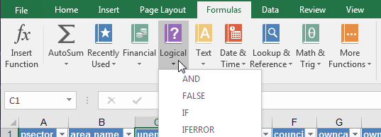

There are drop-down menus here for the various **Function** categories (e.g. **Logical**, **Text**, **Math & Trig**).

### Method 2:

From the **Formula Bar**, click on the **Insert Function fx** button

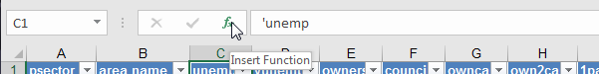

This has three elements.

If you know the name of the function you require, you can search for it. Type in the **Search for a function** box and then press **Go**.

If you know what kind of function you want but can't recall its exact name, look for it by using the **Select a category** drop-down menu.

For each category, a list of **Functions** will appear in the **Select a function** menu; these are the specific functions which you select.

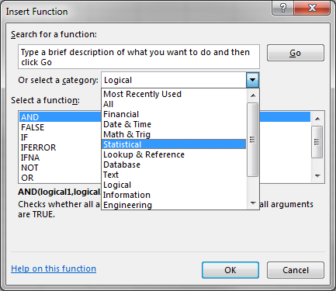For example, under **Statistical** you can find:

**MAX** is used to find the maximum value of a range of cells, e.g. =MAX(A1:A10)

**MIN** is used to find the minimum value of a range of cells, e.g. =MIN(A1:A10)

**AVERAGE** finds the average of values in a range of cells, e.g. =AVERAGE(A1:A10)

**TODAY** can be used to insert today’s date into the current cell, e.g. =TODAY

These are among the most basic statistical functions and more are available as you'll see in the next exercise.

**Note**: in *Excel*, **AVERAGE** gives the *arithmetic mean*, which is the most common kind of average. Other types of average, such as the *Median* or *Mode,* can also be found by *Excel*.

### Task 2.1 How to calculate averages using the statistics function

#### Access the work sheet named **weather**. This gives data on weather conditions by month over a year. You will use functions to calculate average conditions and outliers (highest and lowest figures).

#### Select cell **B16** in the worksheet.

#### Choose the **Formulas** tab then **Insert Function**.

#### Select the **Statistical** function **Average** and the cell range **B3 to B14**. *The selected range will appear in the* ***Number 1*** *box (****B3:B14****).*

#### Click on **OK**.

#### Repeat the above process to enter the **maximum**, **minimum**, **mode** and **median** precipitation for the data into cells **B17** to **B20**. Be careful to select the same data column for each. Highlight cells **B16** **to** **B20**.

#### Use **Autofill** to copy the functions in these cells into the equivalent cells in columns **C** to **E**. Select a cell in this range: note how the function now appears in the **Formula** **bar**.

# Organising data before creating a chart.

## Averages

Firstly, you have to create a chart comparing average (*mean*, *mode* and *median*), BMI and Body fat and separating male and female data. You need to use the Function operation to find averages for the relevant data in the appropriate columns.

### Task 2.2a How to calculate and plot averages in a chart

#### Open the worksheet, **HEM data***.* You will see a sheet of data giving health information of several volunteers: **gender**, **age** and so on including **BMI**.

#### Now sort the data so that all the **male** and all the **female** data are separated from each other.

#### Now, in columns **Q-R** place the headings **Female average BMI** and **Female average Body fat** then calculate the following functions:

##### *Mean* for **BMI** (female); *mode* for **BMI** (female); *median* for **BMI** (female).

##### *Mean* for **% body fat** (female); mode for **% body fat** (female); median for **% body fat** (female).

##### Leave one row space and then repeat the above but this time for the **male** data (with suitable headings for this data).

**NOTE**: what does it mean if you get “#N/A” when you use the Mode function?

### Task 2.2b: How to calculate and plot averages in a chart

#### Use the first set of HEM data averages (mean, mode, median) – for females – to create a simple **Column** chart.

#### Now, with the chart selected, choose **Chart Tools 🡺 Design** then **Select Data**. Now select the male averages data and headings by dragging over it.

#### If you have any problems with the legend text, use **Select Data** and the **Edit** option to correct it.

## How to count the number of individuals that fall under defined categories

Using COUNTIF you can count the numbers of TRUE results we get for each option. BMI can be broken down into 4 simple areas: underweight, normal, overweight and obese.

Use IF/AND statements to find out for each subject (row of data) whether they are underweight, normal, overweight and obese then COUNTIF to count the number of subjects who fall under each category.

**BMI Categories:**

**Underweight: <18.5**; **Normal weight: 18.5-24.9**; **Overweight: 25-29.9; Obesity: >=30**

**You will also use these categories to perform the exercises in Tasks 2.3 & 2.4.**

### Task 2.3 How to divide the data into BMI Categories and count how many individuals are in each

#### Return to the worksheet, **HEM data***.* We don’t have a breakdown of data for underweight, overweight, etc. So, we’ll have to create it. How?

#### Next to the **BMI** columns, put the headings: **underweight**, **normal**, **overweight** and **obese**. (If necessary, insert new columns).

#### Now use an **IF** function (you will have to use **AND** also here where you are testing data in two cells at once – ask your tutor if you’re not sure about this), using a logical test against **BMI**, to fill the columns’ cells. Make the output **TRUE/FALSE**.

#### Now you need figures for each of these: in a free space to the side of the main data, repeat the headings *underweight*, etc. Under these use the **COUNTIF** function to count all the **TRUE** values for each column.

## Information on standard deviation

Standard deviation is a statistical measure used to assess the variation of sample data from the mean. You can easily calculate standard deviation using *Excel*. This application has many functions and formulas available to perform various types of calculations automatically. A *formula to calculate the standard deviation is available.*

When you have several samples in a data set and you plot the mean value, it is expected that you use a statistical measure to investigate the variance from the mean that occurs within that data. You will be expected to display that information by including error bars on the charts that you produce. The statistical test you will be asked to use in Level 1 Biology is Standard Deviation which is calculated using the following formula:

s equals the sum of x minus the mean average, all squared, over n minus 1.

(Where n is the sample size)

Thankfully you do not have to do this by hand – excel has a statistical function that will do this for you.

### Task 2.4 How to add standard deviation to a chart.

#### Open the worksheet, **body mass data***.* First you must calculate the average data then create a column chart of the average body mass for each species.

#### Select cell **E3** in the worksheet.

#### Choose the **Formulas** tab then **Insert Function**.

#### Select the **Statistical** function **Average** and the cell range **B3 to D3**. The selected range will appear in the **Number 1** box (**B3:D3**) and **autofill** into cells **E4 to E7**

#### Repeat the above process to calculate the standard deviation using the **STDDEVA** formula in cell **F3** and **Autofill** into cells **F4 to F7.**

#### Create the column chart by selecting the data (you want to plot the averages only i.e. Column **A** vs column **E** – use the **ctrl** key to select non-contiguous data) then choose Insert column chart. Select the chart and format the data display, if necessary.

#### To add the standard deviation values as error bars, **select the chart** then choose the **layout** tab from the chart tools on the *Excel* ribbon then select the down arrow beside the **Error bars option** on the right-hand side of the ribbon.

#### Select **more error bars**. Tick **custom** and then **Specify Value**. Select the cells that contain the Standard deviation for your data for both the positive and negative error bars **(F3 to F7).** Your error bars should now display on the graph.

#### Ensure you add a **Title** and your axes are correctly labelled.

## Information on Histograms

A histogram is a set of data (often displayed as a simple column chart) that takes a collection of measurements and plots the number of measurements (the frequency) that fall within each of several intervals (bins).

For example, if you had sets of students’ assessment marks and wanted to find out how many students gained marks between 0-9, 10-19, 20-29, etc. you would use a Histogram.

**Excel 2016 now includes histograms as part of the standard suite of charts. If you are using a different version of Excel, you may need to use an add on like this:**

#### choose Options (on the File tab),

#### then Add-Ins.

#### Select Analysis Toolpak and then click the Go button.

The Add-Ins window appears:

#### select Analysis Toolpak here and click OK.

#### On the Data tab you’ll now see Data Analysis (in the Analysis group).

#### Click this and in the window that appears choose Histogram and OK this.

### Task 2.5 How to create a Histogram

#### Return to the worksheet, **HEM data***.*

#### Highlight the data that you wish to include in your Histogram. In this case the % Body Fat

#### From the **Insert** menu, under the **Charts** group click the **Insert Statistical Chart** item Image of the insert statistical chart dropdown icon

#### From the drop-down menu that appears, select **Histogram**

A basic histogram chart will appear.

#### With your histogram chart selected, click the **Format** tab

#### In the combination box at the top of the **Current Selection** group, select **Horizontal Category Axis**

#### In the **Current Selection** group, click **Format Selection**

The **Format Axis** pane will appear on the right of the screen

#### In the **Format Axis** pane, under **Axis Options,** click on the **Axis Options** icon image of the Axis Options icon

#### In the **Axis Options** submenu, set the **Bin width** to 3

#### Format your chart to add a relevant title and styling

### Remember to use the chart checklist (p9)

Other help with charts can be found in Excel*’s* Help menu and via this link: [Create a chart from start to finish](https://goo.gl/Y9bQ8p)

# Information on Integrating *Word* and Excel Files

You are asked to submit word documents as part of the Level 1 Biology coursework (See Appendix I for Why you need Word and how to print from Word). In your HEM lab report you are expected to include tables and charts from your class data.

You do this by copying Excel files into *Word* documents to create an integrated report. If the files are linked any changes made to the spreadsheet will be reflected in the report which can save you time in having to regenerate completely new charts. Both the *Word* and *Excel* files must be saved in the same drive or the linking won’t be possible and for convenience it is best to keep the files in the same folder.

The data table below has been pasted into this document from Excel.

|  |  |  |  |  |  |  |  |
| --- | --- | --- | --- | --- | --- | --- | --- |
| **psector** | **area name** | **unemp** | **yunemp** | **owners** | **council** | **owncar** | **own2car** |
| G1 1 | Central | 7.42 | 5.65 | 71.37 | 9.18 | 48.16 | 5.05 |
| G1 2 | Central | 24.72 | 21.43 | 2.69 | 97.31 | 7.07 | 0.00 |
| G1 4 | Central | 6.78 | 0.00 | 56.52 | 28.26 | 51.06 | 6.38 |
| G1 5 | Central | 43.71 | 27.03 | 19.28 | 75.21 | 12.55 | 0.43 |
| G2 3 | East End | 42.34 | 35.71 | 10.67 | 29.33 | 19.74 | 2.63 |
| G2 4 | East End | 20.00 | 17.95 | 31.15 | 0.00 | 28.57 | 4.76 |
| G2 6 | East End | 27.69 | 57.14 | 29.73 | 13.51 | 38.71 | 0.00 |
| G2 7 | East End | 50.70 | 41.18 | 5.63 | 92.81 | 10.19 | 2.78 |
| G2 8 | East End | 9.86 | 0.00 | 81.48 | 7.41 | 47.17 | 1.89 |

Table 1: data table pasted from Excel

The simplest way to add spreadsheet data to a Word document is to use a straightforward **Copy** and **Paste**.

The table above was pasted into this document from the **postcode** worksheet. It displays in the form of a *Word* table with gridlines and shading added.

## To change how the Excel table displays in Word

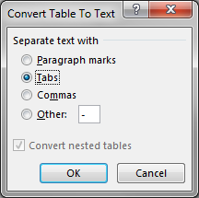You can easily change this by selecting the table and under **Table Tools**, on the **Layout** tab, in the **Data** group, click **Convert to Text**.

In the dialog box that appears, select the data divider option – **Tabs** is most suitable as this will display the data in neat rows and columns (although it will no longer be a *Word* table object).

### Task 2.6: How to copy from Excel and Paste into Word

#### Open a blank *Word* document. Access the *Excel* worksheet, **format work**, and **Copy** table 1 and **Paste** it into this *Word* document. Type a brief sentence or two describing what it shows. Save this document as *link.doc*.

#### Select the data in the Word document and convert it from a table format into plain text separated by tabs. Now move to the top of a new page.

#### Once the table is in word and formatted, right click on the table then choose **insert caption** to allow you to type in the text for your figure legend.

## Information on Paste Special

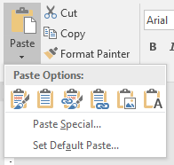When you paste data into a document (that is not just plain text) you are given several **Paste Options**. These appear when you click the down-arrow under the **Paste** button.

You can paste the data in several formats: e.g. as a Picture, Use Destination Styles, Link, Link & Use Destination Styles, or as Keep Text Only.

**Picture** is suitable when you need high-quality printing.

If entered as **Destination Styles**, it will be shown as a table; if you choose **Keep Text Only** it will be shown as plain text separated by tabs.

Selecting a **Link** option means that the data you paste will be linked to the original file.

If the data in the original worksheet is edited and saved, the linked object will automatically be updated when you next open the Word document.

**Note: sometimes one has to close the Excel file before Word will update the link.**

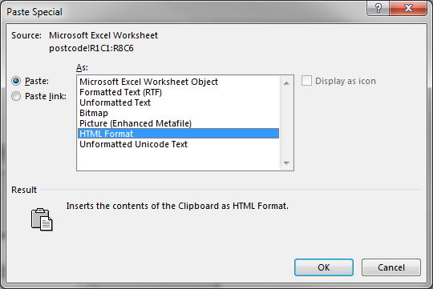Below the icons, whose functions are described above, you will find the **Paste Special** option. This opens the traditional dialog box that contains most of the options just described plus an additional one: **MS Excel Worksheet Object**.

This pastes it into *Word* as a table (or chart) which when double-clicked opens a miniature Excel window in which you can edit the data (and if this includes formula their results will automatically be updated when you change any data they refer to).

### Task 2.7 how to paste a linked file

#### Go to a new page in your *Word* document. Access the worksheet once again. Select the data here and then **Copy** it again.

#### Now, insert it into your *Word* document using **Paste** and then **Link & Use Destination Styles**. a screenshot of the Link & Use Destination Styles icon

#### Place the cursor below the pasted data. Type a brief sentence describing what you have just added.

#### Return to the *Excel* worksheet with the original data (you can do this by right clicking and selecting **Linked Worksheet Object** then **Edit Link**).

#### Change this data here in some small way. Save the worksheet. Now return to Wordand you should see the changes reflected in the worksheet object in Word.

#### Charts too can be copied and pasted into other documents. Go to a worksheet where you have created a chart. Copy this chart.

#### Now using **Paste Special**, paste it into your *Word* document as an **MS Excel Chart Object**. When you double-click on the pasted object, you should see the worksheet for the chart. This will also include the worksheet with the chart data.

# Information on printing in Excel

You may also wish to present larger tables and charts than can be comfortably included on a *Word* page. This will require you to print out directly from the spreadsheet file.

Before printing a worksheet, it is important to check how it looks. This can be done using the **Print** command under the **File** menu.

File menu Print Options Print Preview

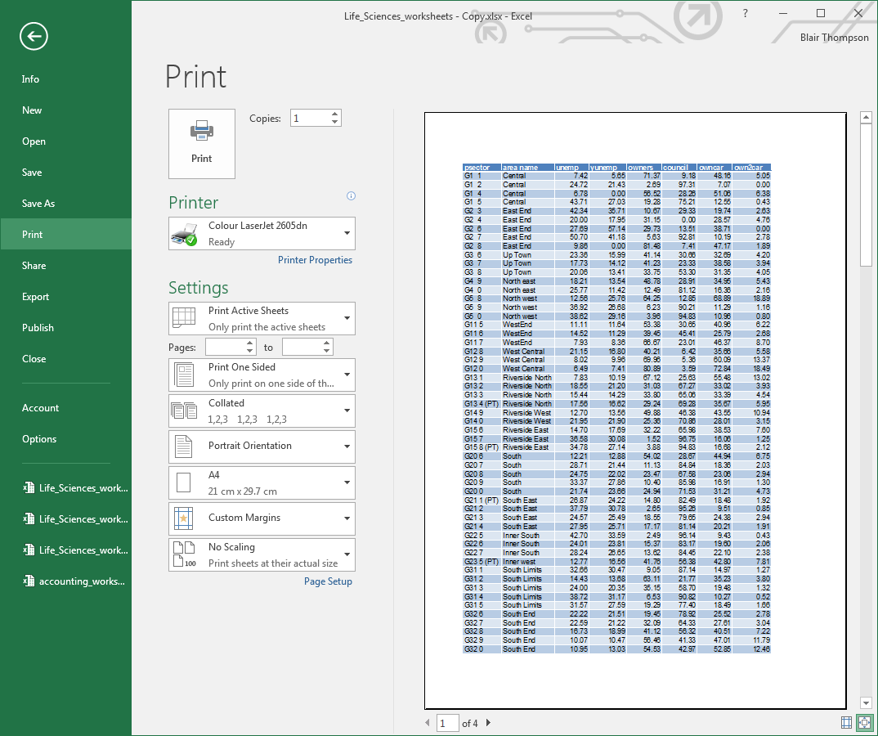

**Page Setup** link (opens dialog box)

If the worksheet is going to take up more than one page, the **Preview** will indicate the number of pages at the bottom left-hand corner of the screen. The *orientation* of the paper can be set to *landscape* or *portrait*.

The fit of the spreadsheet to the page can be set, and margins can be altered. Your tutor will demonstrate these options, which can be accessed by clicking the **Page Setup** link which opens a dialog box.

Each **tab** allows you to select from a choice of printing options:

The default, **Page** option, allows you to select orientation, and adjust the fit of the worksheet so it will fit into a page.

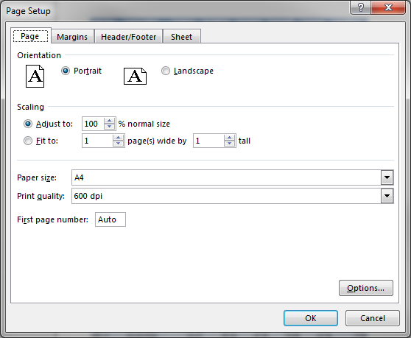sThe **Margins** option allows you to adjust the margins on the worksheet.

The **Header/Footer** option displays a window into which you can type a header and /or a footer, which will be printed out on your spreadsheet.

Click the **Custom Header** or **Custom Footer** button to add text or select options like date/page numbering.

The **Sheet** option allows you to hide/display the gridlines or column and row headings or *change the order in which pages will be printed*.

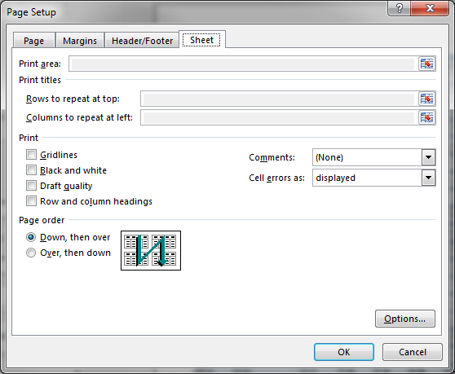Your tutor will show you some of these but spend some time exploring the possibilities for yourself.

If a spreadsheet is too wide to fit across one sheet of **A4** paper in **Portrait** orientation, the **Landscape** option can be selected. The **Scaling** options under the **Page** tab of **Page Setup** can be used to decrease or increase the scale so that more or less data fits on a page.

**NOTE:** the **Print area** and **Print Titles** options are “frozen” in this version of the dialog box and you cannot change it. You can, however, set these options if you open the **Page Setup** dialog box by selecting **Page Layout 🡺 Page Setup** then clicking on the dialog box launcher.

### Task 2.8 how to print from Excel

#### Now access the **printout data** worksheet. You will use this worksheet for the tasks in this section.

#### Open **Page Setup**. Select the **Header/Footer** tab and add the following: (Clicking the **Custom Header**/**Footer** buttons)

#### *A header with your name and student registration number*

#### *A footer with today’s date.*

#### Select the **Page** tab and make sure the orientation is set to **Landscape**. Set the **scaling** to 105%. This makes the area of data fill the page better. If you had more columns of data, you might wish to reduce the scaling.

#### Select **Print Preview** from the **File** menu. Try the following:

#### *Adjust the margins – e.g. the position of the header and footer*

#### Click on the **Page Break** button*.*

You should see at least two breaks – try readjusting the position of these.

#### Now close **Print Preview** and open the **Page Setup** dialog box from **Page Layout 🡺 Page Setup**. (Note: this option is not active if you select **Setup** from **Print Preview**). Select the **Sheet** tab. Now, select a print area by dragging with the mouse. Note how the cell range you have selected appears automatically in the **Print Area** textbox.

#### Now, choose the **Rows to repeat at the top** option and then select the row with the heading names. (Note: this option is not active if you select **Setup** from **Print Preview**).

#### Change the **Page order** from **Page setup** then preview the effect this will have by viewing the **Page Break** preview (you will have to adjust the break on the right-hand side).

#### Make sure you have saved all the work you have been doing this session and close the files and close Excel.

## Pull Printing at the University

When using the University machines, the default printer option you will normally see is **Pull Printing**. This is not a printer per se but a server to which print files are sent when you click the **Print** button.

Your print file is not actually printed until you go to a Pull Printer, log on to it then print your file out. This means you can choose to print from any one of a number of printers or if all are busy, wait to print your document later (avoiding queues).

In the Library and Reading Room Pull Printing printers are available on all floors so you can collect your printouts from any one of a number of printers; see:

[Student Printing](http://goo.gl/W0Vo2U)

# Further Training

If you wish to take your IT Training further, the University offers a wide range of free courses. Check our web pages for more information

[Information Services IT Training](https://www.gla.ac.uk/myglasgow/it/training/)

# Appendix I – Word Processing for lab reports, essays and papers.

We assume that you already possess word processing skills (specifically MS Word). Here we will only deal with why you require word-processing skills and explain how printing works on campus (which is likely to be quite different from what you have experienced before).

## Why you need to be able to use Word:

Throughout your undergraduate study, and further into employment, you will be required to produce and submit written work. This work will take many forms, but all require certain key elements:

##### Clearly formatted writing

##### Concise writing and presentation of text

##### Appropriate use of diagrams, figures, tables, graphs and images

##### Clear citations showing where your information has been sourced from

##### Correctly formatted reference sections

This part of the course will give you experience in formatting and presenting written work. You will have opportunities to practice these skills throughout the Level 1 Biology Course.

You will be required to submit a lab report detailing the experimental methodologies you carried out, the data you collected and any results you have determined form this data. In addition, you will be required to establish the context of your work and clearly show the external research reading you have carried out.

## Required word-processing skills

Please make sure you DO have the required Word skills. You should be able to do the following:

##### know how to use Word to produce formatted documents (different fonts, spacing, paragraph alignment, etc.)

##### know how to add document information, e.g. headers and footers

##### know how to add pagination and adjust pagination

##### know how to use section breaks for different layout, headers and footers and pagination in different sections

##### understand copying text and data between different documents

##### adding tables of contents using heading styles

##### know how to create tables in Word and format them

##### understand the importance of proof reading before printing any documents

If you don’t understand how to do any of the above tasks (or feel you may need a little revision), online guidance is available in the form of Moodles and Video guides.

The following is a Moodle designed for Life Sciences’ students’ revision:

[Life Sciences Moodle revision](http://moodle.gla.ac.uk/course/view.php?id=533)

This Moodle contains material on Excel and EndNote as well as material on Word which is not included in the taught course.

As well as using it for learning about features in Word you can also use it to revise these other topics (it contains demonstrations of topics via illustrations and short videos).

## Printing in Word

Printing facilities are available in campus computer clusters. To print in Word, select **Print** from the **File** tab and the following menu (or a very similar one) will appear. The default print option on campus is **Pull Printing** which will be explained below.

Select pages to print Printer button to start print job Properties link opens printer options

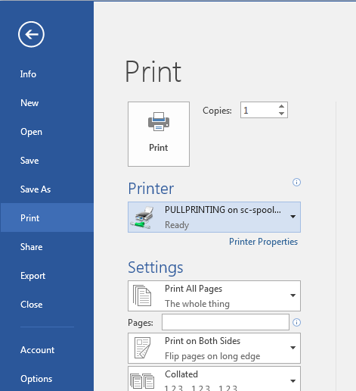

Default for campus printers is to print double sided. Note that for some kinds of course work you are required to print single-sided. Both options are set under **Printer Properties** (and selecting the **Finishing** tab). You can also choose to staple a document if you wish.

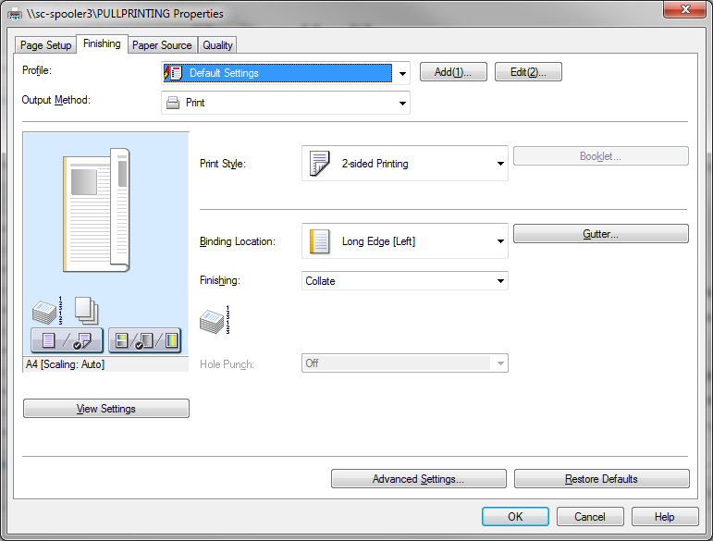

Under **Finishing** you can choose to have your document stapled.

Make sure it is collated whether or not you choose to staple.

Under **Print Style** you can choose 2-sided or single-sided printing.

Two-sided printing is the most economical but for certain documents (e.g. dissertations) you may be required to print single-sided.

Note: some campus printers give the option to print in colour. Be careful if you don’t wish to print in colour as it is more expensive than black and white.

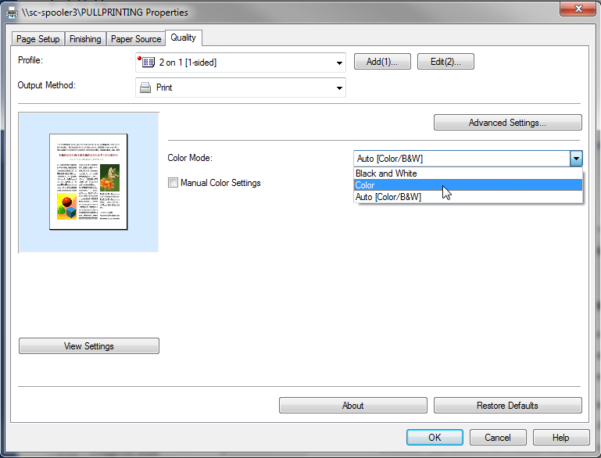

To print in colour, choose Printer Properties and select the Quality tab. Then choose **Color** from the **Color Mode** menu.

Note: if you intend to print, double-sided, a document which includes a cover, insert a blank page after the cover so no text appears on the inside of the cover.

Your print file is not actually printed until you go to a Pull Printer, log on to it then print your file out. This means you can choose to print from one of a number of printers, or if all are busy, wait to print your document later (avoiding queues).

In the Library and Reading Room Pull Printing printers are available on all floors so you can collect your printouts from one of a number of printers

Appendix II – Additional material you may find useful to work through.

# Charts: Category Labels

### Instructions – how to use category Labels with charts

#### Access the worksheet, **Life_data***.*

#### Select the data in columns **A** and **B**, starting with and including the headings **Year** and **Male**.

#### Now click on the **Insert** tab.

#### Select the **Line** chart option and make sure the first chart sub-type is chosen.

#### Something is wrong here. This is because the **Year** data is being treated as if it was the same kind of data as the **Male** life expectancy data, rather than a factor against which that data is measured.

#### Click the **Design** tab on **Chart Tools** and then choose **Select Data**. Click on **Edit** under the **Horizontal (Category) Axis** labels. The **Axis Label** dialog box opens. Select the years (the cells **A10-A19**). Click **OK** to replace theoriginal labels data.

#### Now select **Year** and click the **Remove** button. Click **OK** and then **OK** again.

#### You will see that now the life expectancy data is now being measured against the year, giving us the chart we require.

#### Click **Add**

#### Type **Female** for **Series name** and select **L10-L19** for **Series values** (delete what’s already in the dialog box then select from the cells).

#### Click **OK**

#### Now finish off by adding a **Chart Title** and **Axis Titles** using the **Quick layout** tool found in the **Design** ribbon

#### Save the worksheet.

# Logical Functions

Most functions display a **Function Arguments** dialog boxthat allows you to enter or select the data which the functions will operate on. Some also require you to enter options and conditions that will affect the results.

### One example of this is with the logical functions. Here the dialog box opens to offer you a choice of conditional operators (e.g. AND, OR, IF, etc.).

When **IF** is selected you are then shown a dialogue box into which you enter the logical test and the values resulting depending on whether the condition test returns a **TRUE** or **FALSE** value.

#### First you select the cell you want the result to appear in

#### Call up the **Insert Function** dialog box and choose the **Logical** category

#### In the **Function Arguments** dialog box, enter the logical test (i.e. **If** a cell’s data matches [=] or is greater [>] or less [<] than a particular value).

#### Then enter what result will appear if the test is true (i.e. is equal to the value you are looking for) and also what result will appear if not true.

These are five other logical operators: AND; FALSE; NOT; OR; TRUE. Their main use is as additional operators associated with an IF condition; the most generally useful are AND and OR.

### How to use Logical Functions

#### Open the **weather** worksheet

#### Click on cell **F3**; into this cell we are going to put a conditional formula which will tell us whether a month was on average dry or wet. Choose the **If** conditional function from the **Logical** functions.

#### Into the box **marked Logical_test** we need to put the criteria we wish to use for the answer to be true, in this case **B3>2.5**.

#### Into the **Value_if_true** box we want to type the word “wet”.

#### Into the **Value_if_false** box we need to type “dry”.

#### Fill the formula down column **F** using **AutoFill**. Add a heading (e.g. **Dry/Wet***)* to the top of the column.

#### Put a conditional formula into column **G** to say “sunny” if there were more than **4.5** hours of sunshine and “cloudy” if there were not.

#### Add a heading (e.g. **Sunny/Cloudy***)* to the top of the column. Save the file.

Appendix III – Remote desktop

Access a virtual desktop which gives you access to the same programs, applications and file store as a computer cluster PC (CSCE). You can access the Remote Desktop Service from anywhere that you have access to an internet connection.

This can be very useful when you need to access software that you do not own, especially at times when Computer Clusters are busy (exam times, near dissertation deadlines etc.).

You cannot use Remote Desktop to save or open files stored on the device you use to access this service, but you should be able to print to your local printer. You can only access, save, modify, delete etc. any files on your M or K or OneDrive drives from within the Remote Desktop service.

You cannot add your own programs (for security, stability and licensing reasons).

Use the following link to access the University remote desktop service

[Remote Desktop](https://www.gla.ac.uk/myglasgow/anywhere/remotedesktop/)