|  |
| --- |
| PHYS4066 Analytical Mechanics |
| Course Information Guide 2024-25 |
|  |
|  |



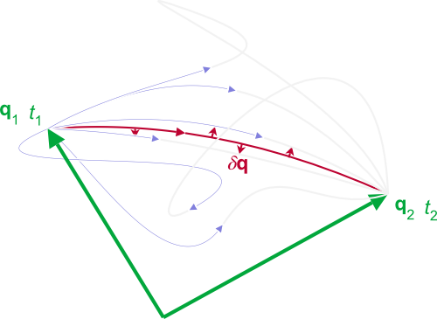

|  |  |  |  |
| --- | --- | --- | --- |
| Lecturer: | [Prof. Jörg Götte](https://www.gla.ac.uk/schools/physics/staff/joerggoette/) | Schedule: | 18 lectures, Wed 11 am, Fri 11 am |
| SCQF Credits: | 10 | ECTS Credits: | 5 |
| Assessment: | Examination (100%) | Co-requisites: | [PHYS4025](http://www.gla.ac.uk/coursecatalogue/course/?code=PHYS4025),[PHYS4011](http://www.gla.ac.uk/coursecatalogue/course/?code=PHYS4011), [PHYS4031](http://www.gla.ac.uk/coursecatalogue/course/?code=PHYS4031) |
| Level: | Honours |  |  |
| Typically Offered: | Semester 1 | Prerequisites: | Physics 2 |

# Course Details

# Course Aims

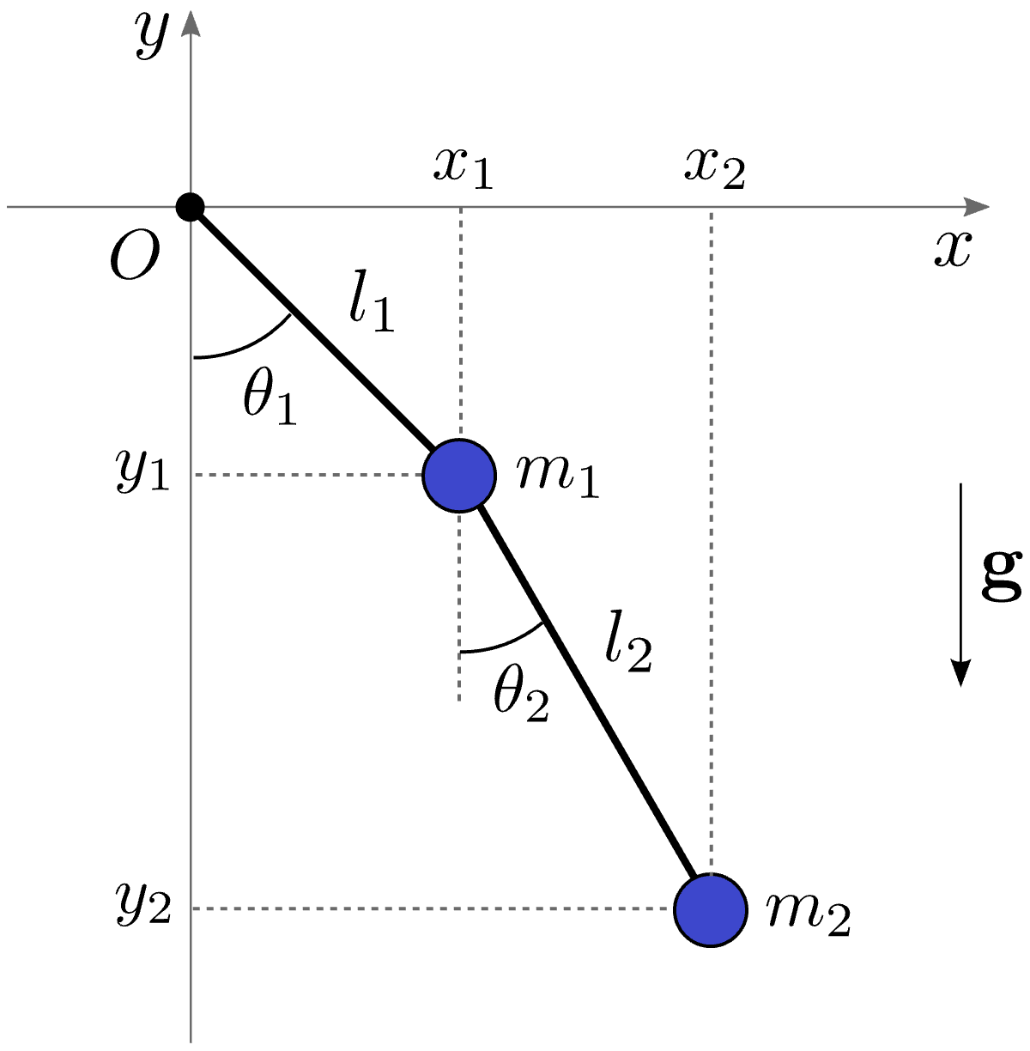This course is compulsory for all BSc (Honours) and MSci students on the Theoretical Physics plan and an elective for BSc (Honours), MSci and the designated degree programme in the School of Physics & Astronomy. It aims to provide students with an opportunity to develop their knowledge and understanding of the key principles and applications of Analytical Mechanics, and their relevance to developments in advanced physical theories. In particular, it will provide a working knowledge of:

* Lagrangian mechanics;

Figure 1: The double pendulum can be solved elegantly with Lagrangian mechanics

* variational principles;
* the principle of least action;
* Hamiltonian mechanics and Hamilton-Jacoby theory;
* phase space dynamics;
* symmetries and Noether’s theorem;

# Intended Learning Outcomes

By the end of the course students will be able to:

* Demonstrate knowledge and a broad understanding of Lagrangian and Hamiltonian mechanics;
* Describe qualitatively and quantitatively process, relationships and techniques relevant to the topics included in the course outline, and apply these techniques to solve general classes of problems;
* Write down and, where appropriate, either prove or explain the underlying basis of physical laws relevant to the course topics, discussing their applications and appreciating their relation to the topics of other courses taken.

# Course Outline

Figure 2: Phase portrait of a pendulum with closed and open paths, separated by a separatrix.

***Revision of Newtonian Mechanics*:** Geometric and kinematic foundations, vector fields and integral curves, differentiable Riemannian manifolds, constrained systems and generalised coodinates, holonomic systems, phase space, Galilean relativity principle, the simple pendulum.

***Lagrangian Mechanics*:** Cardinal equations, holonomic systems with smooth constraints, Euler-Lagrange equation, orbits in a central field, the Kepler problem.

***Symmetry and conservation laws:*** introduction to symmetry and its connection with conservation laws: Noether’s theorem, equilibrium, stability and small oscillations, the Lyapunov exponent, outlook to Lie groups and algebras

***Hamiltonian Mechanics*:** Legendre transformation, the Hamiltonian, Hamilton’s equations, Liouville’s theorem, Poincaré recursion theorem.

***Variational principles*:** Introduction to the variational principle of mechanics, the Euler equations for stationary functionals, Hamilton’s variational principle: Lagrangian and Hamiltonian form; the principle of the stationary action, the Jacobi metric

***Canonical formalism of mechanics*:** Symplectic structure of the Hamiltonian phase space, canonical transformations, the Poincaré-Cartan integral invariant and the Lie condition, generating functions, Poisson brackets

***Hamilton-Jacobi theory:*** Integrability, the Hamilton-Jacobi equations, integrable systems with one degree of freedom: action angle variables.

# Further Information

Further information can be found on the course Moodle page

and also using the links below:

* [Course specification](http://www.gla.ac.uk/coursecatalogue/course/?code=PHYS4030)
* [Reading list](http://readinglists.glasgow.ac.uk/courses/phys4030.html)