School of Infection & Immunity
Preferred Email Signatures

To add our new and updated recommended email signature, please follow this eight-step guide:

- Open your email account using the Outlook app

- Click the ‘home’ tab at the top left of the page

- Click ‘New Email’

- Click ‘signature’

- From the drop down menu, click ‘signatures…’

- Click ‘New’ from the four grey buttons

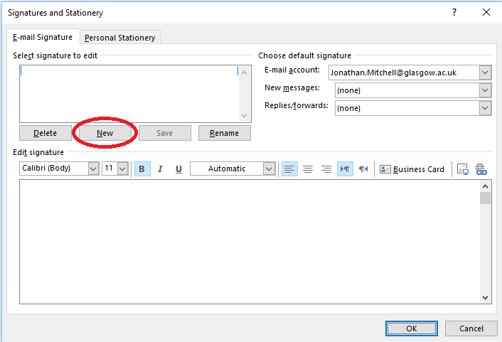

- Copy and paste the text and images from one of the signature variants (see a-f) and paste into the empty signature box:
You must copy the signature directly from this document
You must right click and use ‘copy’ and ‘paste’ and not ‘Ctrl v’ and ‘Ctrl C’

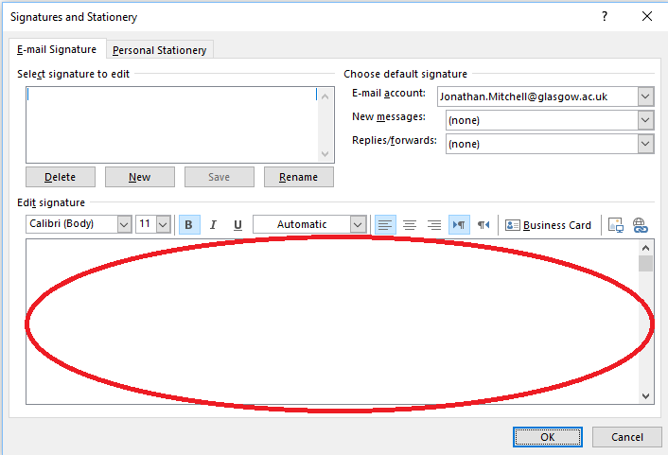

You must click on the second paste option icon ‘Keep Source Formatting’

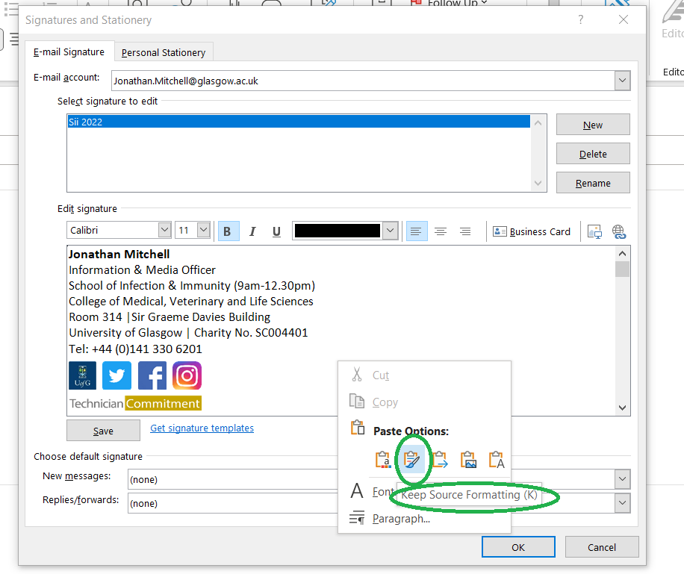

a) Original
b) With flexible working hours note
c) CVR*
d) WCIP**
e) AntiVec
f) Mental Health First Aider
g) Flow Cytometry Core Facility
h) Plain text
i) Professional Services Team

a)

Jonathan Mitchell
Information & Media Officer
School of Infection & Immunity (9am-12.30pm)
College of Medical, Veterinary and Life Sciences
Room 314 |Sir Graeme Davies Building
University of Glasgow | Charity No. SC004401
Tel: +44 (0)141 330 6201

b)

Jonathan Mitchell
Information & Media Officer
School of Infection & Immunity (9am-12.30pm)
College of Medical, Veterinary and Life Sciences
Room 314 |Sir Graeme Davies Building
University of Glasgow | Charity No. SC004401
Tel: +44 (0)141 330 6201

The School of Infection & Immunity encourages flexible working,
so this email may have been sent outside normal working hours.
A response is not expected until you return to work.

c) *The CVR also has their own email signature document due an agreement between the MRC and UofG. Staff should also refer to this.

Forename Surname (preferred pronouns)
Job Title
MRC-University of Glasgow Centre for Virus Research
forename.surname@glasgow.ac.uk
+44 (0)7XX XXX XXXX | +44 (0)141 3XX XXXX

d) ** The WCIP has rebranded as the Centre for Parasitology. This signature will be updated when new logos are available.

Jonathan Mitchell
Information & Media Officer
School of Infection & Immunity (9am-12.30pm)
College of Medical, Veterinary and Life Sciences
Room 314 |Sir Graeme Davies Building
University of Glasgow | Charity No. SC004401
Tel: +44 (0)141 330 6201

e)

Jonathan Mitchell
Information & Media Officer
School of Infection & Immunity (9am-12.30pm)
College of Medical, Veterinary and Life Sciences
Room 314 |Sir Graeme Davies Building
University of Glasgow | Charity No. SC004401
Tel: +44 (0)141 330 6201

f)

Jonathan Mitchell
Information & Media Officer
School of Infection & Immunity (9am-12.30pm)
College of Medical, Veterinary and Life Sciences
Room 314 |Sir Graeme Davies Building
University of Glasgow | Charity No. SC004401
Tel: +44 (0)141 330 6201

g)

Jonathan Mitchell
Information & Media Officer
School of Infection & Immunity (9am-12.30pm)
College of Medical, Veterinary and Life Sciences
Room 314 |Sir Graeme Davies Building
University of Glasgow | Charity No. SC004401
Tel: +44 (0)141 330 6201

h)

Jonathan Mitchell
Information & Media Officer
School of Infection & Immunity (9am-12.30pm)
College of Medical, Veterinary and Life Sciences
Room 314 |Sir Graeme Davies Building
University of Glasgow | Charity No. SC004401
Tel: +44 (0)141 330 6201

i)

Jonathan Mitchell
Administrative Assistant
School of Infection & Immunity
College of Medical, Veterinary and Life Sciences
Room 415 |Sir Graeme Davies Building
University of Glasgow | Charity No. SC004401

- Personalise with your own contact details, and then click ‘OK’

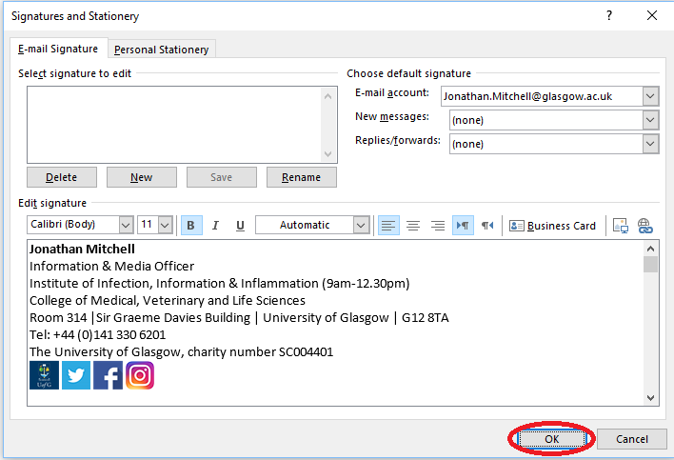

If you have any problems or questions, please don’t hesitate to contact me by emailing jonathan.mitchell@glasgow.ac.uk.

