Shows the University of Glasgow marque along with Equality and Diversity logo

# **Staff Equality Monitoring Report 2017-18**

# **Executive Summary**

This is the seventh annual staff equality monitoring report produced by the Equality and Diversity Unit, and follows largely the same format as the previous reports, allowing comparison between years. This report supports the University’s obligations to publish annual staff equality monitoring data as part of the Public Sector Equality Duty under the Equality Act 2010.

The publishing cycle reflects the previous academic cycle (August 2017 –July 2018).

The report shows the following important changes:

* The percentage of women at level 10 has increased by 1.1% from 2016-17, making a total of 28.2%.
* 4% of University staff have declared a disability. This is a rise of 0.8% since 2015-16.
* There has been an increase in staff declaring they are Lesbian, Gay or Bisexual from 2.6% in 2015-16 to 3.2% in 2017-18.
* 7.5% of staff have declared they are Black, Asian or Minority Ethnic (BAME).
* There has been a 0.5% decrease in Non-UK staff from 2016-17.
* The percentage of staff stating they are Christian (all denominations) has risen from 9.3% in 2014-15 to 14.6% in 2017-18.
* Disability declaration rates for Level 10 have increased by 0.3% to 2.7%.
* The College of Arts has seen an increase in BAME staff of 0.7%.
* In Academic Promotions for 2017-18 women and men were equally successful. It is noteworthy that this includes promotion to Reader where women were less successful in 2016-17.

The data highlights challenges; these include:

* There has been a decrease in BAME Level 10 staff by 0.8%.
* The Operational job family has an older profile; this should be noted when considering succession planning.
* Application and Successful appointments for Black, Asian and Minority Ethnic (BAME) staff continues to have large variabilities.
* The Regarding process highlights some gender concerns as men are more successful than women. Further investigation will be required to understand this.

The Equality and Diversity Strategy Committee identified in 2017 that the data set for the protected characteristic Sexual Orientation was sufficient to consider this at the same level of detail as age, Disability, Ethnicity and Sex. This report therefore includes a detailed section on Sexual Orientation for the first time.

# **Introduction**

The Staff Equality Monitoring Report allows the University to have a standard base for all staff equality information across the organisation. This report meets one of the University’s obligations under the Public Sector Equality Duty.

The aim of this report is to provide transparent data for all functions in the institution to use when equality information is required, such as when conducting Equality Impact Assessments.

Structure

This report has been structured to provide a ‘Whole University’ overview by all the main protected characteristics plus full/part time working, and maternity leave followed by specific sections on age, disability, ethnicity, sex and sexual orientation, with a breakdown of data by the following:

* College
* Level 10 staff
* Job Family Profiles
* Grade
* Full/Part Time
* Contract Type
* Nationality
* Recruitment – by all applicants and successful applicants

We have not provided a further breakdown beyond ‘Whole University’ on data for religion and belief as the proportion of staff answering these questions is too small to give meaningful information.

Further information is then been provided, by sex, on:

* Academic Promotions
* Regrading for Professional & Support Staff
* Equal Pay – Gender Pay Gap

Notes and definitions

This 2017-18 report is based on a census date of 6 August 2018, unless otherwise stated. Percentages have been used, as there are some instances where numbers are very small and using actual numbers carries a risk of identifying individual staff. Overall figures for each of the sections have been provided in Tables 1-6 below.

Whole University - Total head count is **7655** (up 127 on last year). This is the head count for all staff in the University, with those on multiple contracts only counted once. The three previous year’s total headcount figures were 6865 (2014-15), 7020 (2015-16) and 7528 (2016-17).

College/University Services Split

When using the term ‘By College’ this includes University Services as a College.

| Table 1 - College | #2017 | #2018 | %2018 |
| --- | --- | --- | --- |
| Arts | 535 | 606 | 8% |
| MVLS | 2271 | 2268 | 30% |
| Science and Engineering | 1499 | 1531 | 20% |
| Social Science | 862 | 929 | 12% |
| University Services | 2361 | 2321 | 30% |

Job Family Profile

Some members of the Senior Management Group (SMG) are classed as ‘Research & Teaching’ or ‘Clinical’ under the Job Family profile. For reporting purposes, these have been moved into SMG and the original Job Family figures amended accordingly.

| Table 2 - Job Family | # | % |
| --- | --- | --- |
| Clinical | 275 | 4% |
| Management, Professional and Administrative (MPA) | 2659 | 35% |
| Operational | 851 | 11% |
| Research & Teaching | 3227 | 42% |
| SMG | 14 | 0% |
| Technical & Related | 629 | 8% |

By Full/Part Time

All staff who work less than one FTE are considered Part Time.

| Table 3 - Full Time / Part Time | # | % |
| --- | --- | --- |
| Full Time = FTE 1.0 | 5055 | 66% |
| Part Time = FTE anything < 1.0 | 2600 | 34% |

By Contract Type

The contract types are as follows;

**F** = Fixed term as per FT & OE Contract policy

**O** = Open ended with funding end date

**P** = Open ended + Permanent in Temporary Fixed Term Appointment

**S** = Fixed term - SOSR e.g. Maternity leave cover

| Table 4 - Contract Type | # | % |
| --- | --- | --- |
| F = (F) Fixed term | 1260 | 16% |
| O = (O) Open ended with funding end date | 1453 | 19% |
| P = (P) Open ended + (C) Permanent in Temporary Fixed Term Appointment  (such as Principal/Vice Principal/Head of College roles etc.) | 4816 | 63% |
| S = (S) Fixed term - SOSR e.g. Maternity leave cover | 126 | 2% |

Grade Grouping

| Table 5 - Grade Grouping | # | % |
| --- | --- | --- |
| Grade 1 | 369 | 5% |
| Grade 2 | 346 | 5% |
| Grade 3 | 307 | 4% |
| Grade 4 | 472 | 6% |
| Grade 5 | 1057 | 14% |
| Grade 6 | 1274 | 17% |
| Grade 7 | 1405 | 18% |
| Grade 8 | 929 | 12% |
| Grade 9 | 635 | 8% |
| Level 10 (see Table 6 for definition) | 546 | 7% |
| Clinical | 272 | 4% |
| Other[1] | 43 | 1% |

| Table 6 - Level 10 staff  (based on Actual Grade Description) | # | % |
| --- | --- | --- |
| Professor | 482 | 88% |
| Senior Administrative Group | 50 | 9% |
| Senior Management Group (SMG) | 14 | 3% |

Age

Two charts are provided for the whole University age data, using 5-year groupings and then 10-year age groupings. For all subsequent charts, the age data is provided using the 10-year age groupings only.

Disability

Two charts have been provided for the whole University disability data, whether staff have stated they have a disability, and then by impairment category. For all subsequent charts, the disability data is only provided by whether staff have stated they have a disability or not.

Ethnicity

Two charts are provided for the whole University ethnicity data. For all subsequent charts, all ethnic minority categories have been combined into Black, Asian or Minority Ethnic (BAME). The nomenclature Black, Asian and Minority Ethnic (BAME) was introduced in the 2016-17 report as this best reflects the local population.

Maternity

This outlines the percentages of who returned to work within the reporting period, the percentage still on leave and due to return, those whose contract ended within the period and those who resigned.

Nationality

This is based on information provided by staff about their right to work in the UK. For the purpose of this report we have used the following categories: UK, EU/EEA and International.

Sexual Orientation

For the purposes of this report, the sexual orientation categories of Lesbian, Gay and Bisexual have been combined and shown as LGB. The whole University data shows the full breakdown, including where information has not been declared. For all subsequent charts, only declared sexual orientation or ‘prefer not to say’ data is provided. This is the first time the University has reported this level of information. Future reports will allow more detailed analysis as the University builds trend data on this community of staff.

Recruitment - Applications and Successful Applicants

The census date for applicants and successful applicants was 01 August 2017 – 31 July 2018 and based on the date the post was first advertised. The information excludes direct appointments and those who withdrew prior to an offer decision or during the application process. Data from 651 applications is missing due to GDPR and IGrasp issues relating to archiving.

Academic Promotions and Professional & Support Staff Regarding

The promotion data is only provided by sex as further disaggregation carries a risk of identifying individual staff.

Pay Gap Information

In accordance with the Public Sector Equality Duties, the Gender Pay Gap and Equal Pay information for Disability and Ethnicity are provided in line with our legislative requirements in a separate report.

# **Whole University Profile**

Age 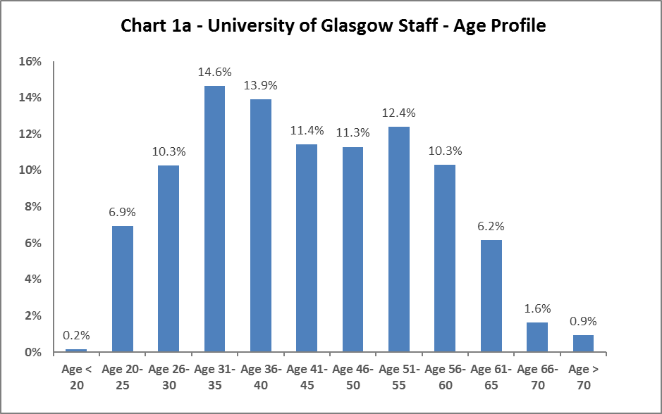

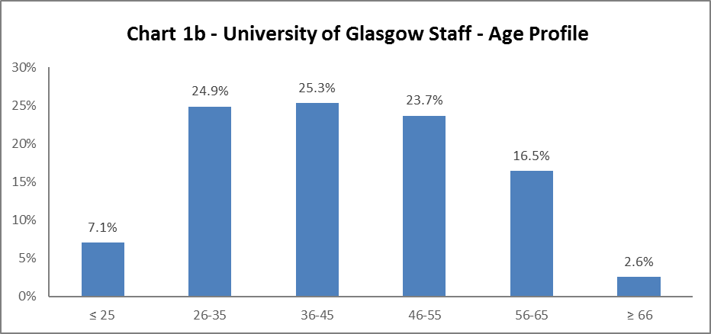

The University's age profile follows more or less a bell curve, as shown in Charts 1a and 1b above. The age profile has remained similar since 2011-12. There has been a slight dip (0.7%) from age range 26-35, and a rise (0.6%) in age range 36-45 from 2016-17, however all other age ranges have only had marginal increases or decreases.

Disability

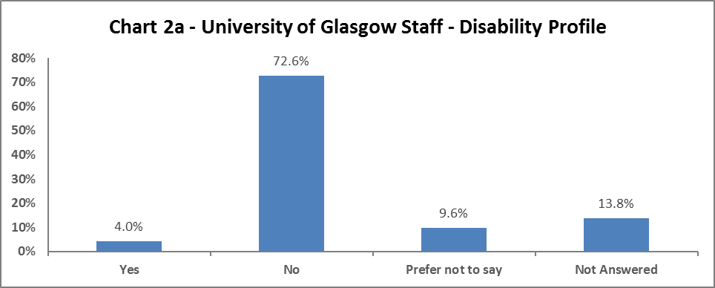

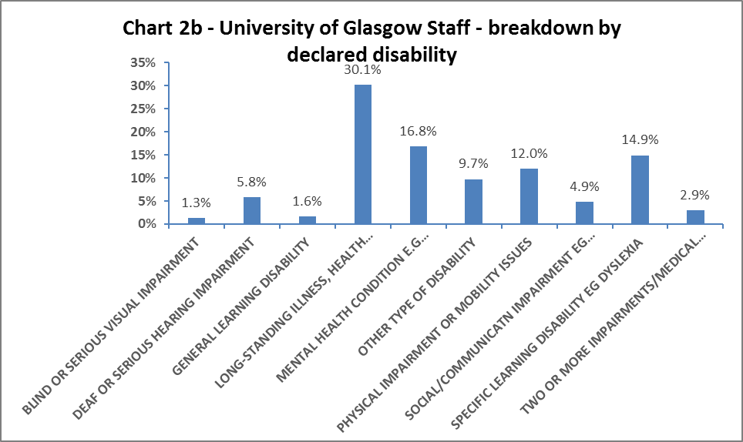

Chart 2a above shows 4% of University staff has declared a disability. This is a rise of 0.3% since 2016-17. Staff stating ‘No’ continues to drop, although this is by a small margin (0.4%). The ‘Prefer not to say’ category has also dropped by 1.1% from 2016-17. There continues to be a rise in the ‘Not answered’ category by 1.2%.

When considering impairment type, in Chart 2b, there has been an increase in staff stating they have a General Learning Disability (by 0.6%) and a Mental Health condition (0.9%) since 2016-17. The other impairment types have only seen minor increases or decreases in the last year.

Marital Status

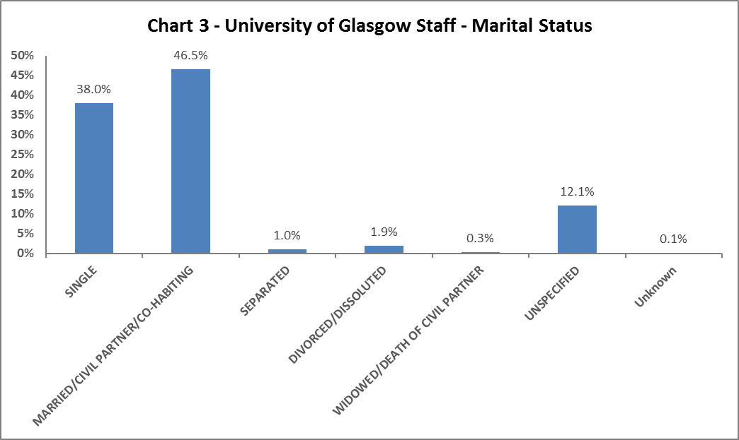

Chart 3 shows a rise in single staff in the last four years (from 31.5% to 38%) and a drop in Married/Civil Partnership/Co-habiting staff (from 52.1% to 46.5%).

Full Time/Part Time

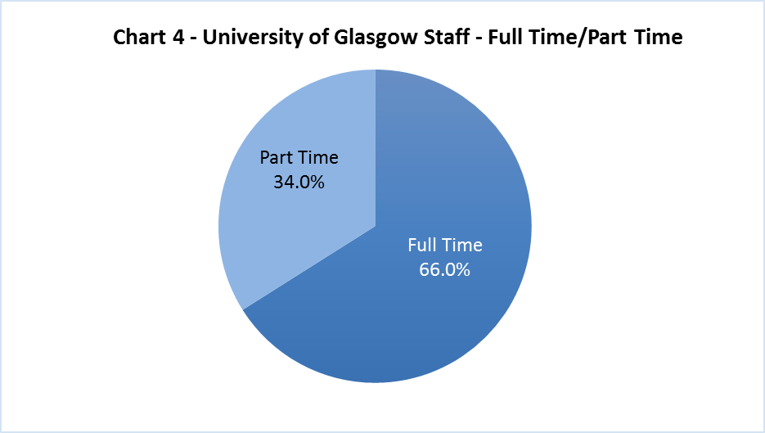

Two thirds of University staff work full time and one third works part time.

Nationality

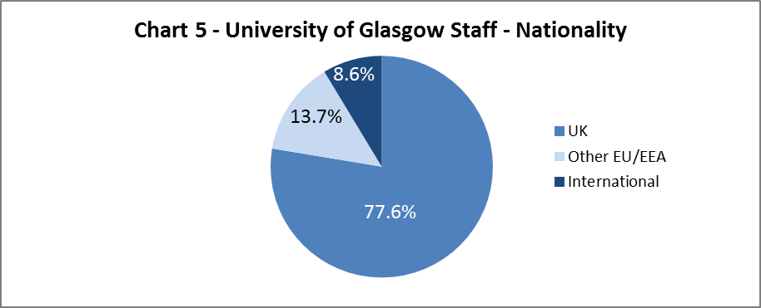

13.7% of staff come from other EU/EEA countries and 8.6% from elsewhere overseas. 77.6% of staff in 2017-18 are from the UK. The percentage of Non-UK staff has drop slightly from 2016-17 from 22.8% to 22.3%.

Ethnicity

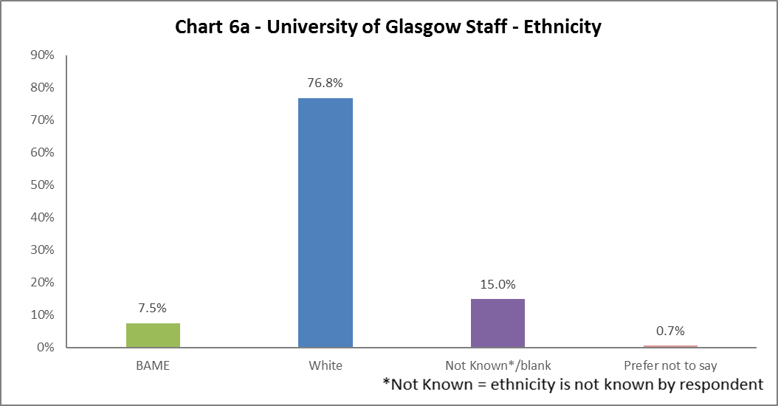

Chart 6a shows 7.5% of University staff are from a Black, Asian or Minority Ethnic background (up from 5.3% in 2011-12); this is higher than the Scottish national average from the 2011 census (4%), but lower than the Glasgow City average from the same census (11.6%). The full ethnic breakdown is provided for information in Chart 6b below.

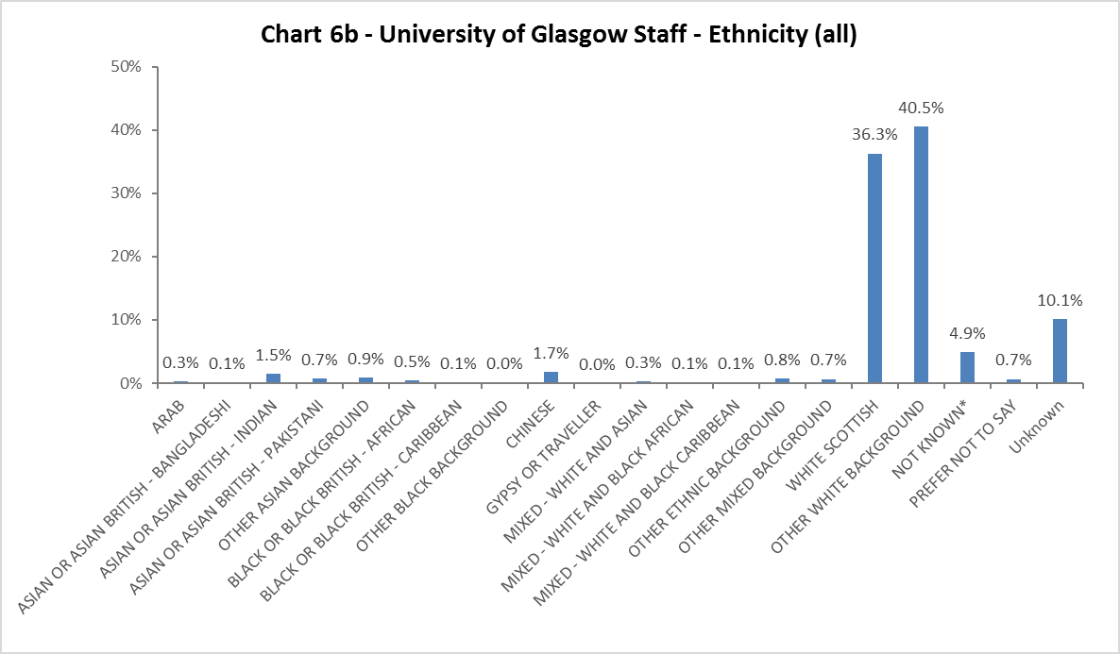

Religion and Belief

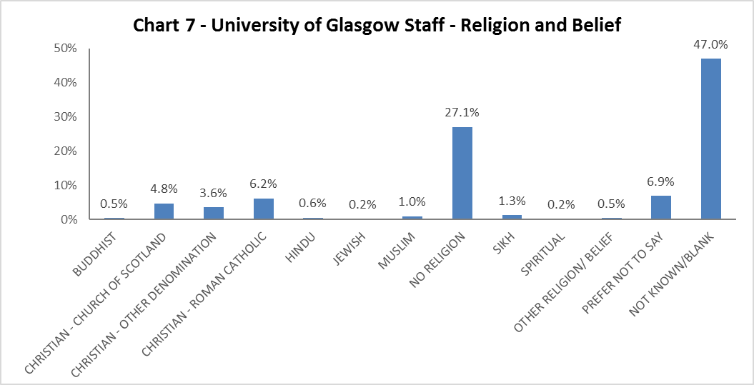

2017-18 sees a rise in the percentage of staff stating they are Christian (all denominations) from 9.3% in 2014-15 to 14.6%.

Sex

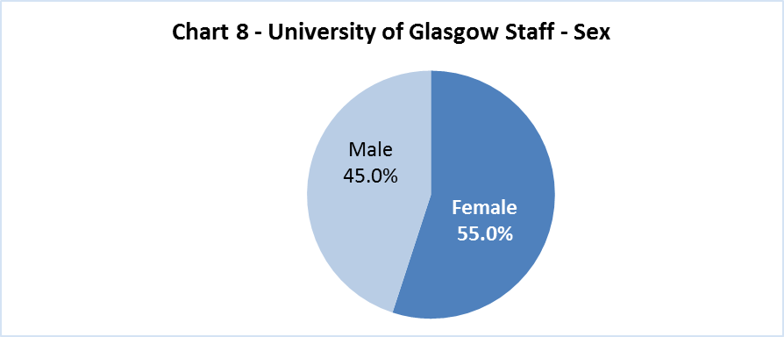

We have seen little fluctuation in the gender makeup of the University’s workforce since 2011.

Sexual Orientation

2017-18 has seen a 0.1% increase in staff declaring they are Lesbian, Gay or Bisexual. There has been a 0.8% increase in staff stating ‘Prefer not to say’ from 2016-17.

Maternity Leave

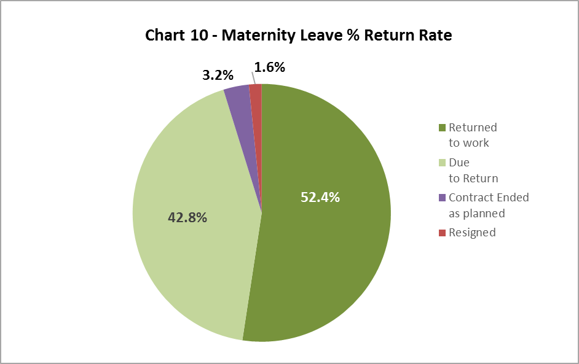

52.4% staff returned during the year (compared to 46.9% in 2016-17), and 42.8& are due to return. 3.2% of staff contracts ended as planned, compared to 4.7% in 2016-17. 1.6% of staff resigned, compared to 0.8% in 2016-17, however this is a very small increase in terms of numbers.

# **Profile by Age**

By College

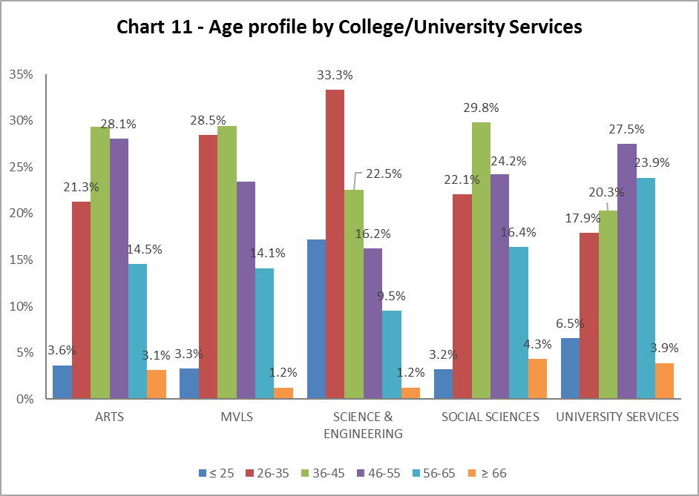

| Table 7 | ARTS | MVLS | SCIENCE & ENGINEERING | SOCIAL SCIENCES | UNIVERSITY SERVICES |
| --- | --- | --- | --- | --- | --- |
| Age Range | % | % | % | % | % |
| ≤ 25 | 3.6 | 3.3 | 17.2 | 3.2 | 6.5 |
| 26-35 | 21.3 | 28.5 | 33.3 | 22.1 | 17.9 |
| 36-45 | 29.4 | 29.4 | 22.5 | 29.8 | 20.3 |
| 46-55 | 28.1 | 23.5 | 16.2 | 24.2 | 27.5 |
| 56-65 | 14.5 | 14.1 | 9.5 | 16.4 | 23.9 |
| ≥ 66 | 3.1 | 1.2 | 1.2 | 4.3 | 3.9 |

Chart 11 above allows a quick visualisation of the distribution of ages in each College/US which can be compared with the Whole University distribution in Chart 1. Table 7 above gives the relevant percentages. The only College/US outlier from previous years is Science and Engineering which has a spike in 26-35 age range compared to other Colleges. University Services continues to have an older demographic of staff when compared to the Colleges.

By Level 10 staff

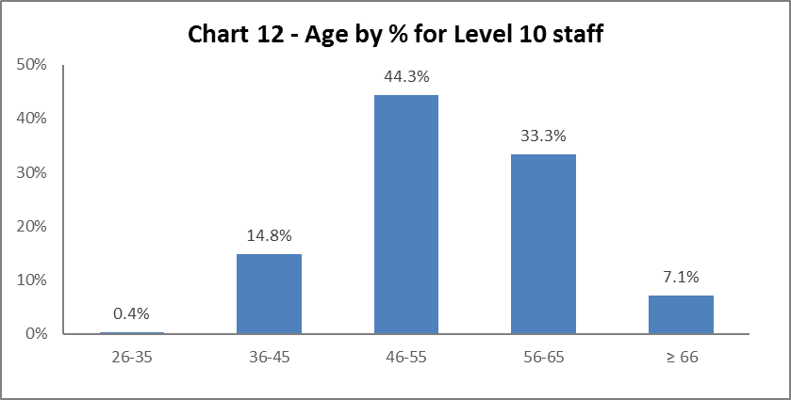

Chart 12 above shows the majority of Level 10 staff are aged 46 or over; there has been a marked increase in level 10 staff who are 66 or over (from 5.9% in 2016-17 to 7.1% in 2017-18).

By Job Family Profile

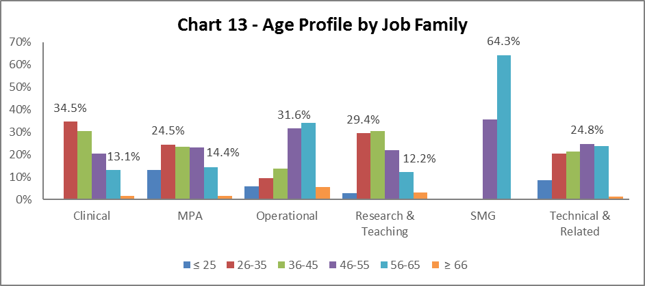

| Table 8 | Clinical | MPA | Operational | Research & Teaching | SMG | Technical & Related |
| --- | --- | --- | --- | --- | --- | --- |
| Age Range | % | % | % | % | % | % |
| Age ≤25 | 0.0 | 13.1 | 5.8 | 2.9 | 0.0 | 8.4 |
| Age 26-35 | 34.5 | 24.5 | 9.4 | 29.4 | 0.0 | 20.5 |
| Age 36-45 | 30.5 | 23.4 | 13.6 | 30.5 | 0.0 | 21.3 |
| Age 46-55 | 20.4 | 23.2 | 31.6 | 22.0 | 35.7 | 24.8 |
| Age 56-65 | 13.1 | 14.4 | 34.0 | 12.2 | 64.3 | 23.7 |
| Age ≥66 | 1.5 | 1.4 | 5.6 | 3.0 | 0.0 | 1.3 |

Chart 13 above outlines the age distribution by job family. The age profile by family reflects previous years. The MPA staff profile is most similar to the University average (Chart 1), whilst Research & Teaching staff have a slightly younger profile. Operational and Technical & Related staff have an older profile, and specifically for Operational job family this should be noted when considering succession planning. The numbers of Clinical staff are quite low, so it is difficult to draw conclusions. Table 8 above gives the relevant percentage figures which are very similar to those seen in previous years.

By Grade

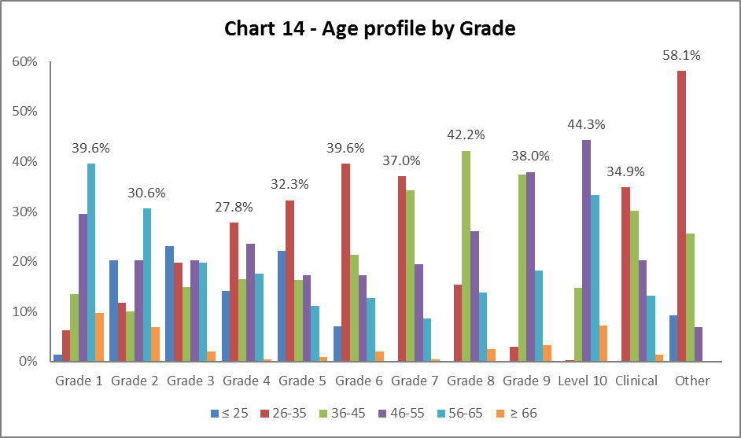

| Table 9 | Grade 1 | | Grade 2 | | Grade 3 | | Grade 4 | | Grade 5 | | Grade 6 | | Grade 7 | | Grade 8 | | Grade 9 | | Level 10 | | Clinical | | Other |
| --- | --- | --- | --- | --- | --- | --- | --- | --- | --- | --- | --- | --- | --- | --- | --- | --- | --- | --- | --- | --- | --- | --- | --- |
| Age Range | **%** | **%** | | **%** | | **%** | | **%** | | **%** | | **%** | | **%** | | **%** | | **%** | | **%** | | **%** | |
| Age ≤ 25 | 1.4 | 20.2 | | 23.1 | | 14.2 | | 22.1 | | 7.0 | | 0.1 | | 0.0 | | 0.0 | | 0.0 | | 0.0 | | 9.3 | |
| Age 26-35 | 6.2 | 11.8 | | 19.9 | | 27.8 | | 32.3 | | 39.6 | | 37.0 | | 15.4 | | 3.0 | | 0.4 | | 34.9 | | 58.1 | |
| Age 36-45 | 13.6 | 10.1 | | 15.0 | | 16.5 | | 16.4 | | 21.4 | | 34.2 | | 42.2 | | 37.5 | | 14.8 | | 30.1 | | 25.6 | |
| Age 46-55 | 29.5 | 20.2 | | 20.2 | | 23.5 | | 17.2 | | 17.3 | | 19.5 | | 26.2 | | 38.0 | | 44.3 | | 20.2 | | 7.0 | |
| Age 56-65 | 39.6 | 30.6 | | 19.9 | | 17.6 | | 11.2 | | 12.7 | | 8.7 | | 13.8 | | 18.3 | | 33.3 | | 13.2 | | 0.0 | |
| Age ≥ 66 | 9.8 | 6.9 | | 2.0 | | 0.4 | | 0.9 | | 2.0 | | 0.4 | | 2.5 | | 3.3 | | 7.1 | | 1.5 | | 0.0 | |

Chart 14 and Table 9 show the general profile for age range reflects the norm and has not changed significantly since reporting started. However, there are spikes in Grades 1 and 2 for staff who are aged 50 years or over, which is possibly linked to the job family profiles. There is a significant rise in age range 26-35 from Grade 6, where the Research and Teaching job family starts. This profile is similar to previous reported years.

By Full/Part Time

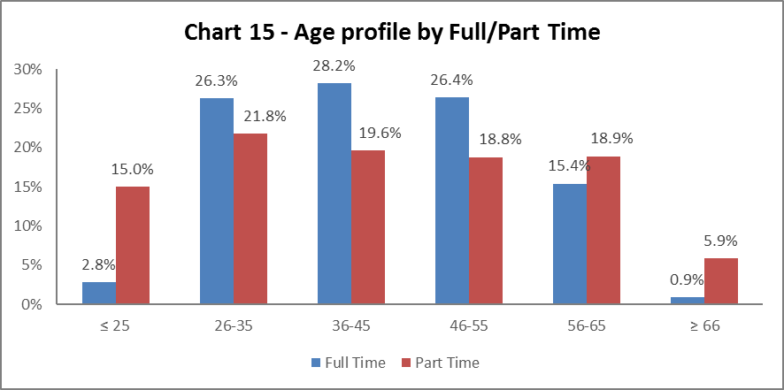

Chart 15 shows the part time staff age profile. The 2017-18 data reflects the previous year, with staff under 25 and over 56 more likely to work part time than full time.

By Contract Type

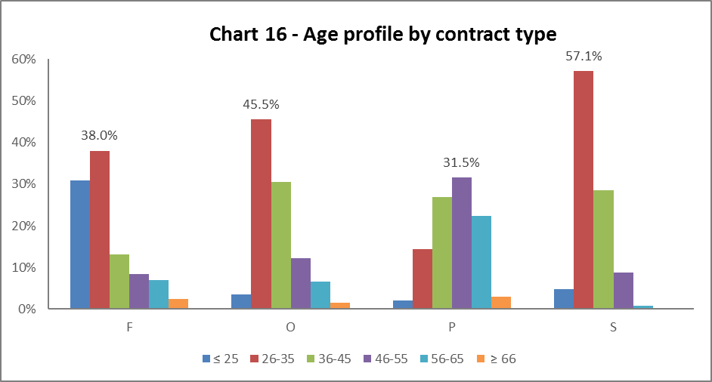

**Key:**F = Fixed term as per FT & OE Contract policy  
O = Open ended with funding end date  
P = Open ended (‘Permanent’) + Perm in Temp Fixed Term Appointment (HoC/Principal/VP role)  
S = Fixed term - SOSR e.g. Maternity leave cover

| Table 10 | F | O | P | S |
| --- | --- | --- | --- | --- |
| Age Range | % | % | % | % |
| Age ≤25 | 31.0 | 3.5 | 2.0 | 4.8 |
| Age 26-35 | 38.0 | 45.5 | 14.4 | 57.1 |
| Age 36-45 | 13.2 | 30.6 | 26.8 | 28.6 |
| Age 46-55 | 8.4 | 12.3 | 31.5 | 8.7 |
| Age 56-65 | 7.0 | 6.6 | 22.3 | 0.8 |
| Age ≥66 | 2.5 | 1.6 | 2.9 | 0.0 |

Chart 16 above shows that Open ended with Funding End Date and both types of Fixed Term workers are generally younger (under 35). Staff on Open ended contracts (code P) tend to be slightly older compared to the University profile. The Fixed term contracts (code S) are relative few in number, hence the spike in age range 26-35 years, which reflects previous years.

By Nationality

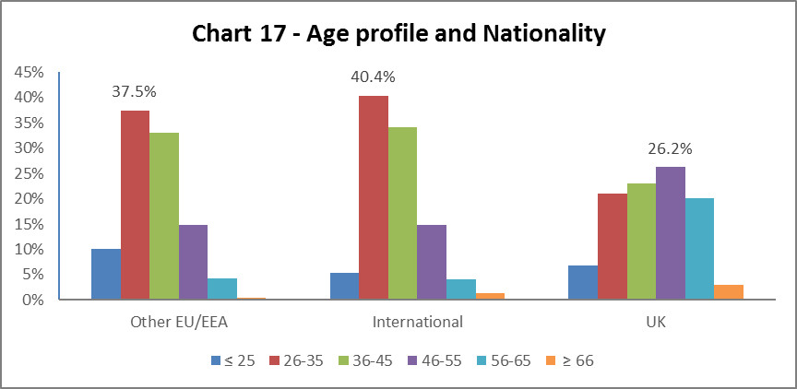

Chart 17 tells us a higher percentage of our EU/EEA and International staff are younger than our UK staff, this reflects the last three years data.

Recruitment – by Applications and Successful Applicants

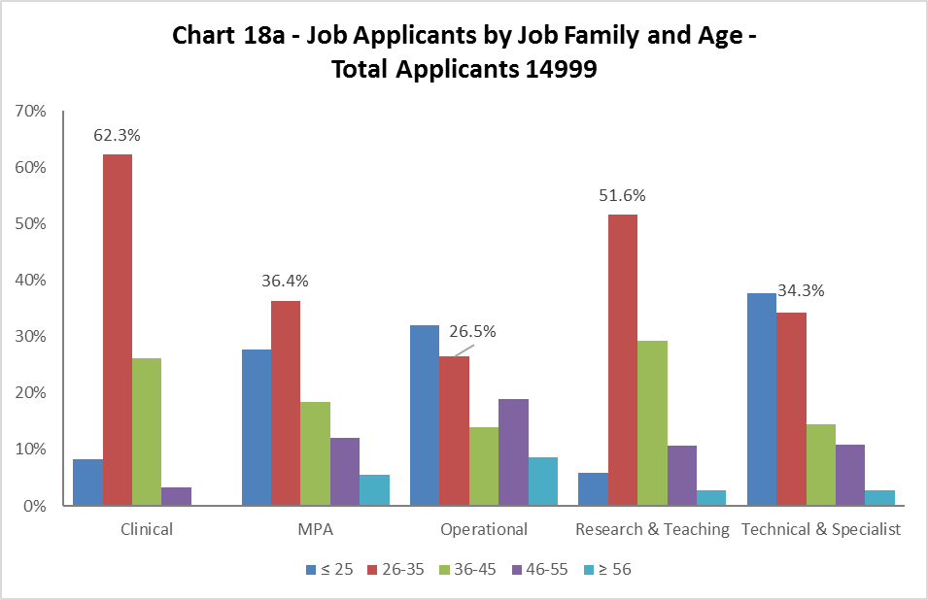

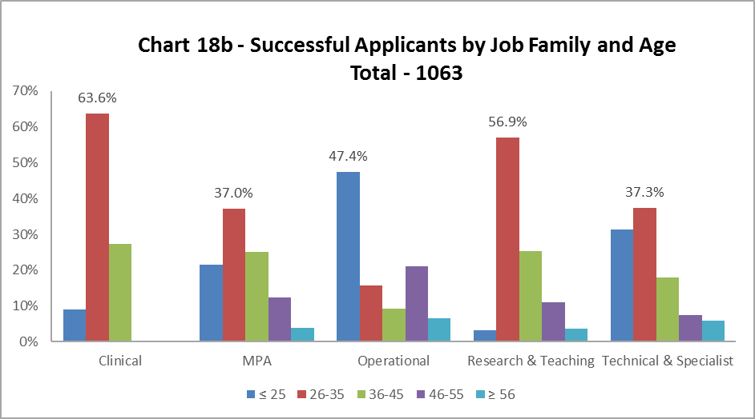

As in previous years, Charts 18a and 18b show the age of applicants are generally reflective of the appointments. The proportion of under 25 year olds successful applicants in Operational job family is significantly higher than the applicant pool.

# **Profile by Disability**

By College

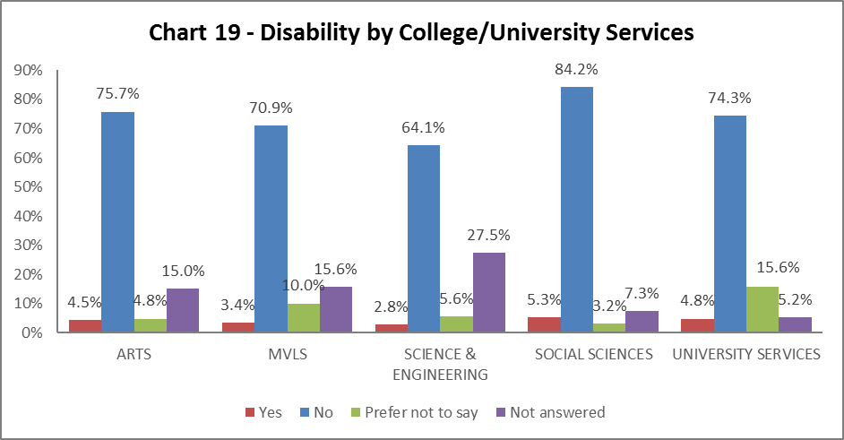

Chart 19 shows where our Disabled staff are in College/US. There has been a slight increase in staff with disabilities in all areas, except Arts which remains static. Science & Engineering has the lowest percentage of disabled staff (2.8%), however also has the highest percentage of Not answered responses. Social Sciences has a highest percentage of disabled staff.

By Level 10 staff

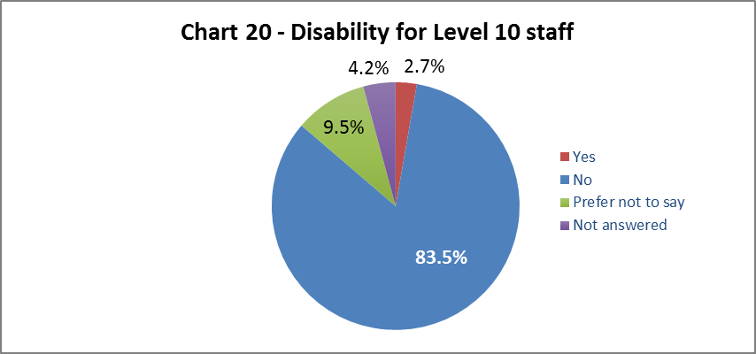

Chart 20 shows 2.7% of senior staff have declared a disability; this is a 0.3% increase from 2016-17, and lower than the University wide figures.

By Job Family Profile

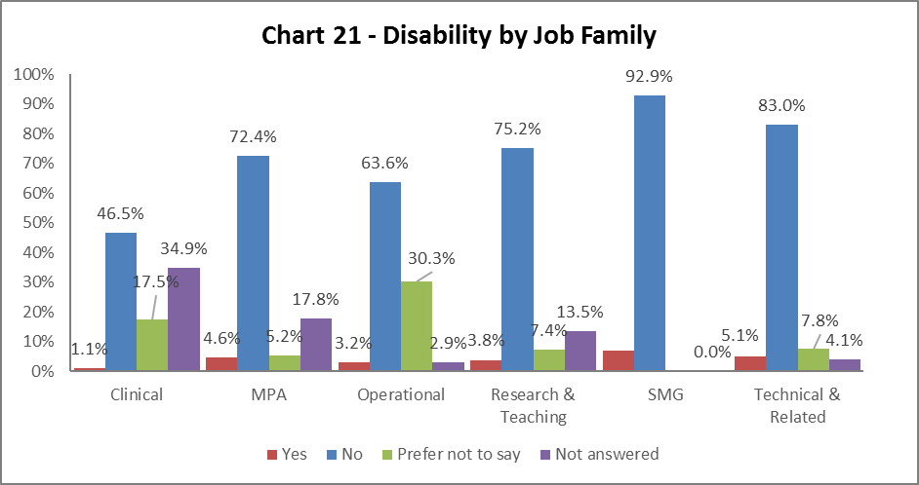

Chart 21 shows Technical and Related staff have a higher disability declaration rate than all other job families, this is a change from previous year. However all job families have seen an increase in declaration rates compared to 2016-17. There continues to be an increase in staff having not answered across most job families.

By Grade

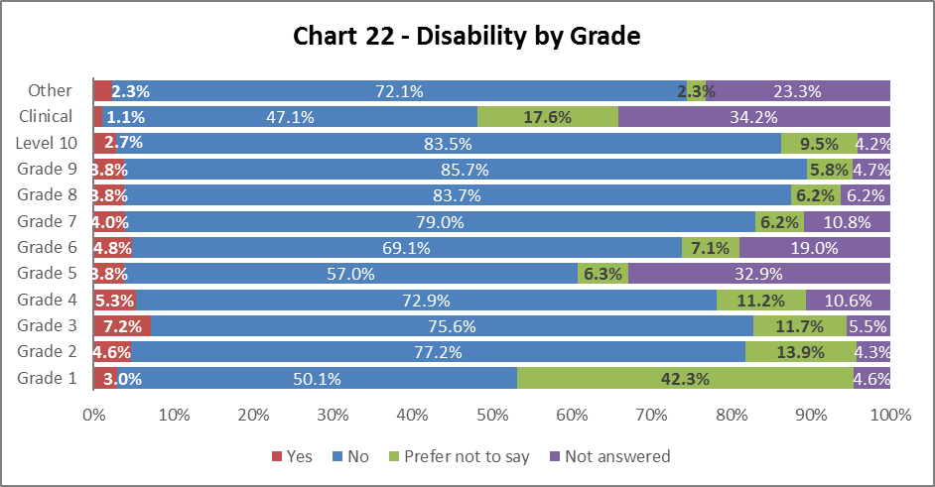

Chart 22 shows disability declaration rates by grade. There has generally been an increase in declarations in grades 1-5, and a slight decrease in grade 6-9. There has been a sharp increase in grade 5 staff not answering this question, but a drop in grade 4 staff not answering this question.

By Full/Part Time

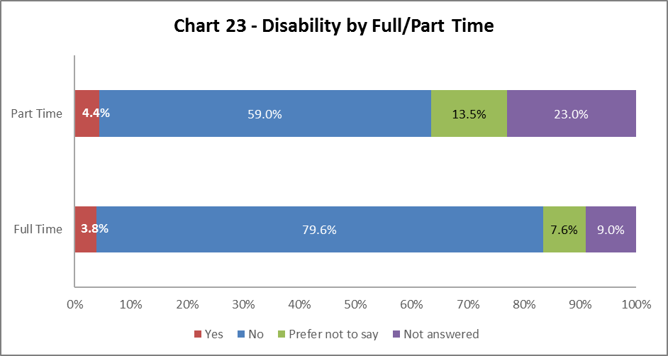

Staff with a disability are more likely to work part time, as shown in Chart 23.

By Contract Type

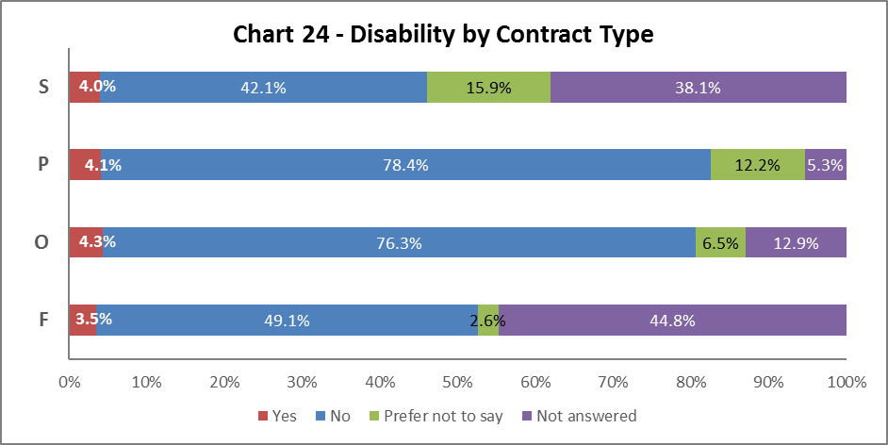

Chart 24 above shows Disabled staff are most likely to have an Open-ended with funding end date (code O) contract, which reflects 2016-17. However, has been a rise in Disabled staff with Open-ended (code P) from 3.3% in 2015-16 to 4.1% in 2017-18.

By Nationality

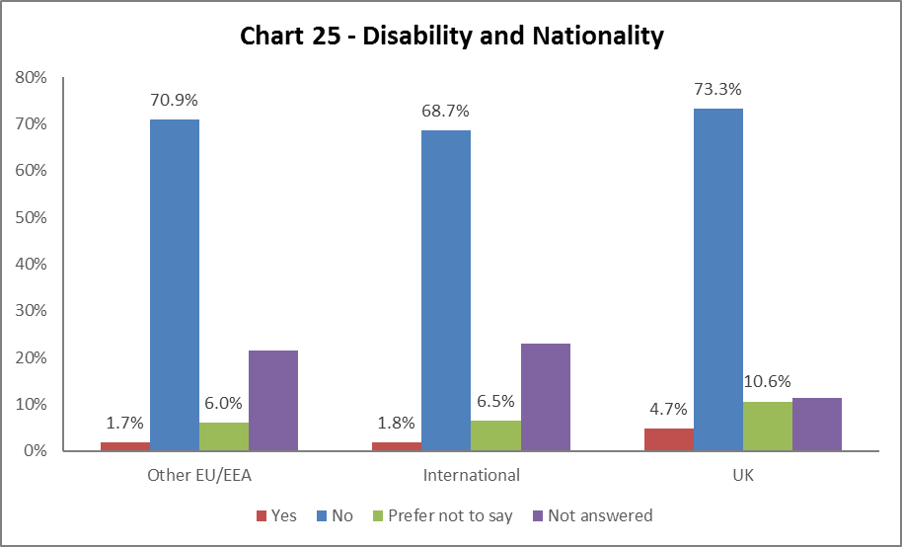  
  
Chart 25 indicates a higher percentage of staff from the UK have declared a disability, this is a rise of 0.3% from 2016-17. The EU/EEA and International staff declaration rates have marginal increases of 0.3% in both categories.

Recruitment – by Applications and Successful Applicants

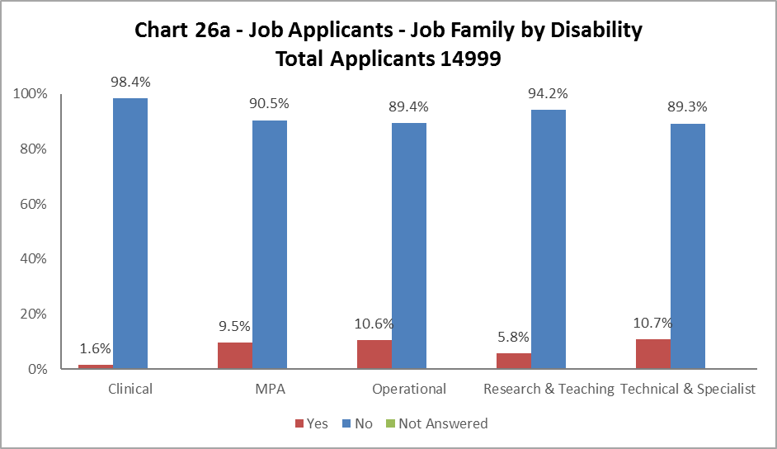

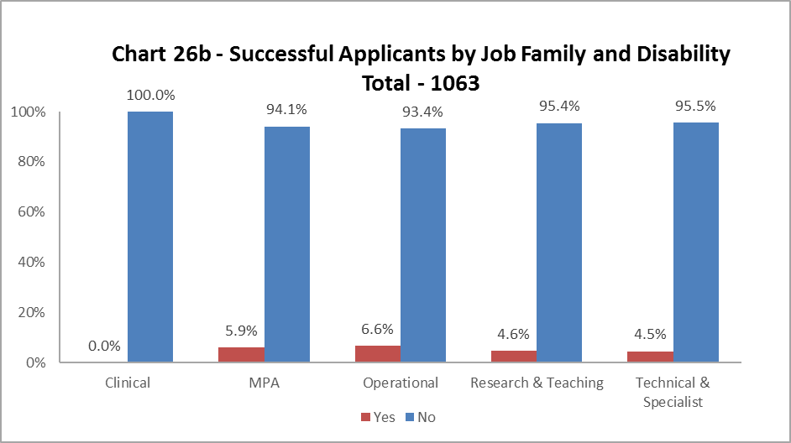

Charts 26a and 26b show that across all job families had more Disabled applicants than were successfully appointed. The percentage decrease ranged from over 6% in Technical and Related to just over 1% in Research and Teaching. The Clinical job family did not appoint any Disabled applicants.

# **Profile by Ethnicity**

By College

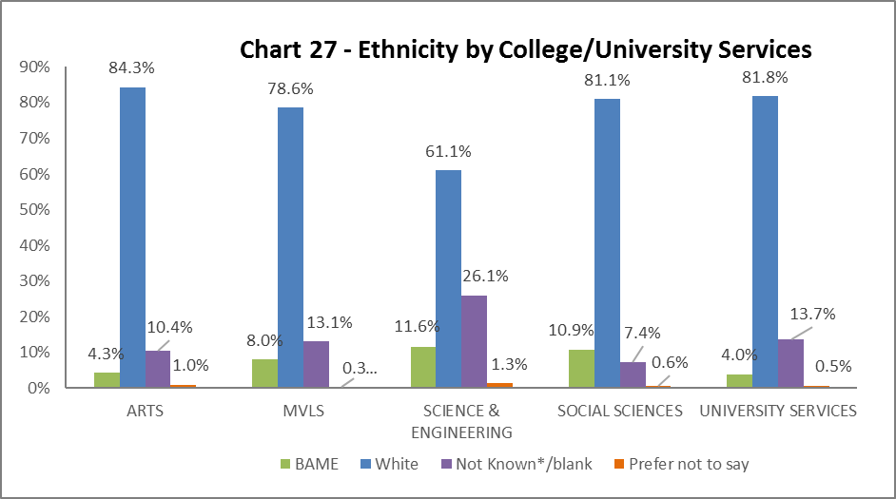

Chart 27 shows the breakdown of BAME staff in College/US. There has been a marked increase in the percentage of BAME staff in Arts, rising from 3.6% in 2016-27 to 4.3% in 2017-18; Science and Engineering have also had a slight increase by 0.3% from last year. All other Colleges/US have seen a slight decrease. Science and Engineering continue to have very high ‘Not known/Info refused/Blank’ rates.

By Level 10 Staff

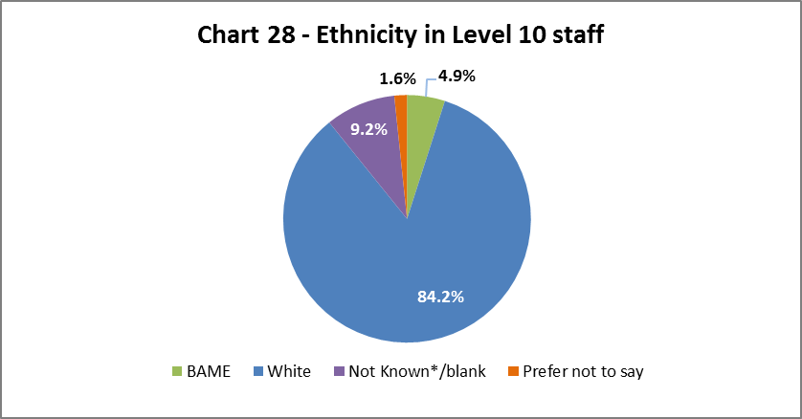

Chart 28 above show the percentage of BAME staff at level 10 to be 4.9%, this is a decrease of 0.8% from last year. This is the first time we have had a decrease in BAME staff at this level.

By Job Family Profile

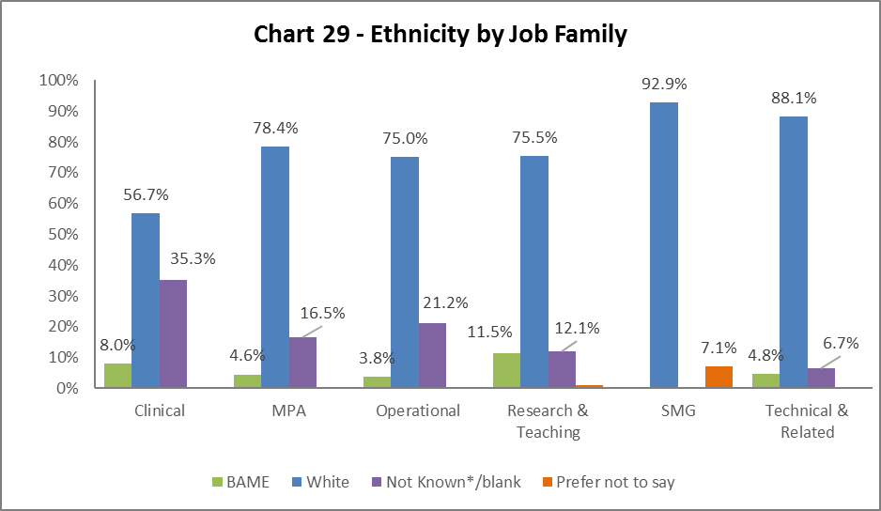

Chart 29 shows the highest proportion of BAME staff is in Research & Teaching (11.5%), a 0.2% increase from 2016-17. Technical and Related job family has been 0.9% increase since 2016-17. The percentage of BAME staff in the Clinical and Operational job families has dropped from last year by 1.1% and 0.3% respectively.

By Grade

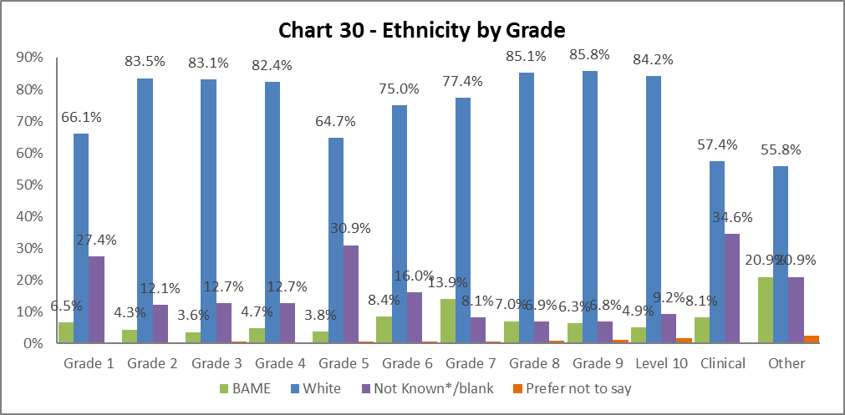

Chart 30 above shows the grade and ethnicities of staff. Most grades show an increase in BAME staff (grades 1, 3, 6, 10 being the exceptions). Grade 7 continues to have the highest percentage of BAME, with an increase of 1.1% from 2016-17.

By Full/Part Time

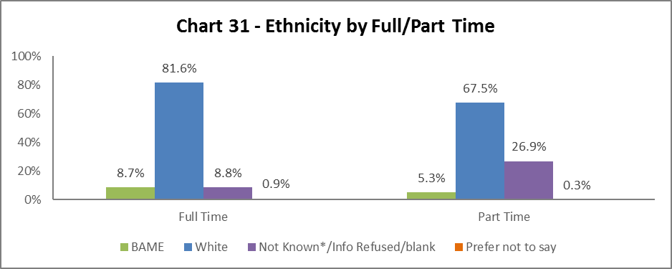

There are fewer BAME part time staff than full time, reflecting previous year’s data. The percentages are marginally higher than last year.

By Contract Type

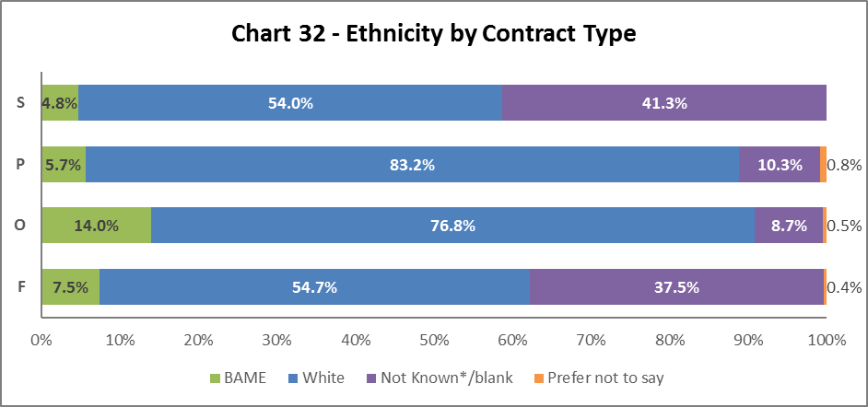

Chart 32 indicates the highest proportion of BAME staff are on Open-ended with funding end date (code O) contracts. All contract types have seen a marginal increase in the percentages of BAME staff compared to last year.

By Nationality

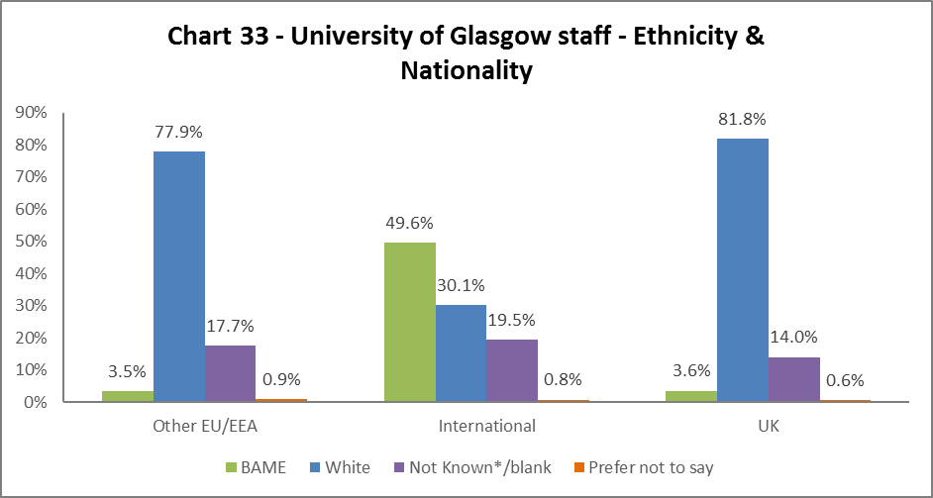

Chart 33 outlines that of our international staff 49.6% are BAME, 3.5% of our EU/EEA staff are BAME and 3.6% of our UK staff are BAME. This shows a 1.8% increases in BAME International and 0.7% increase in BAME EU/EEA staff, and a 0.2% increase for UK BAME staff.

Recruitment – by Applications and Successful Applicants

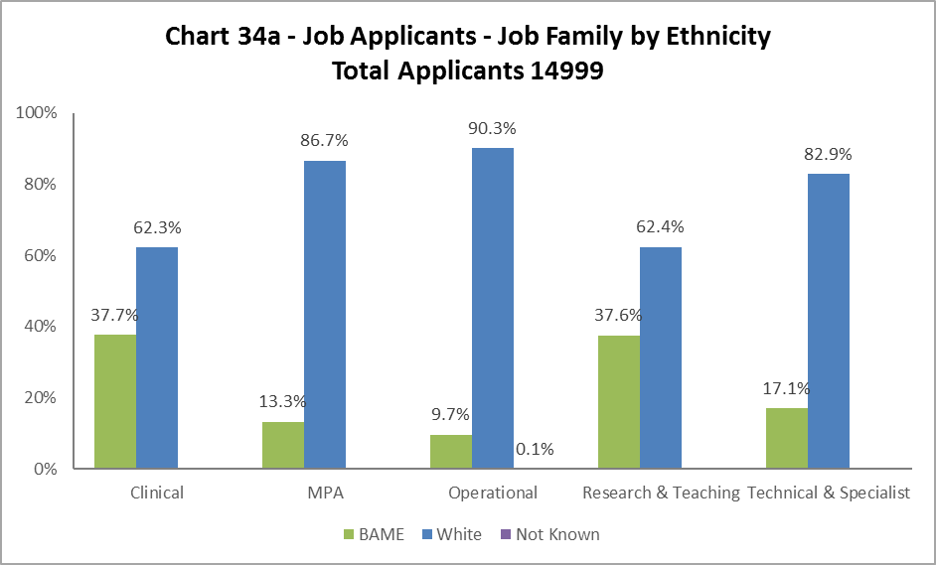

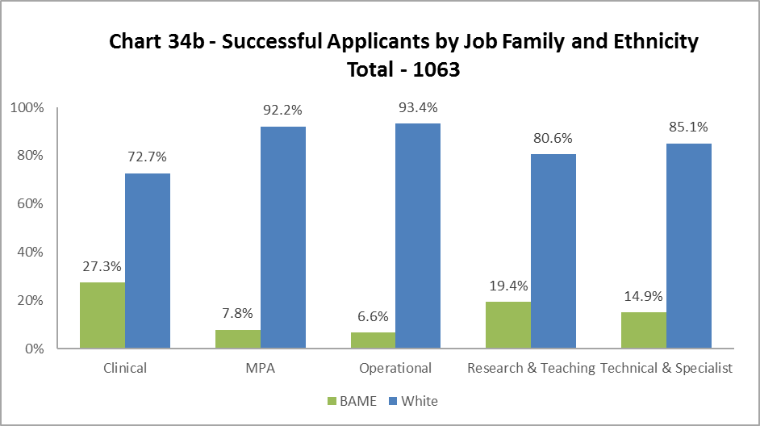

The data, as illustrated by Chart 34a and 34b, shows BAME staff are proportionally less likely to be appointed in all job family profiles. The highest differences are in Research & Teaching job families, where the drop is 18.2%. This trend has been evident for a number of years and requires further investigation. There has been a marked increase in the success rate of BAME applicants to the Technical and Related job family, compared to 2016-17.

# **Profile by Sex**

By College

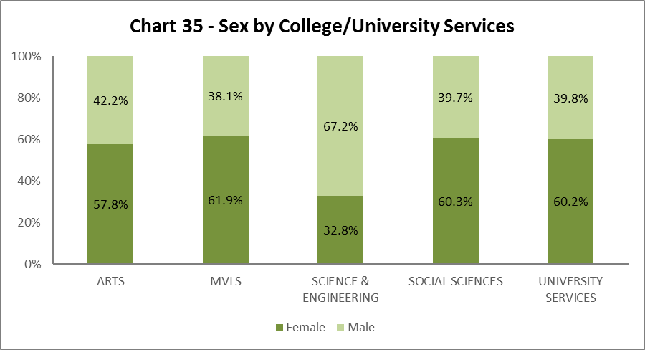

Chart 35 shows the gender split by College/US. All areas, except MVLS, have had marginal increases in female staff. MVLS has had a marginal increase in male staff.

By Level 10 Staff

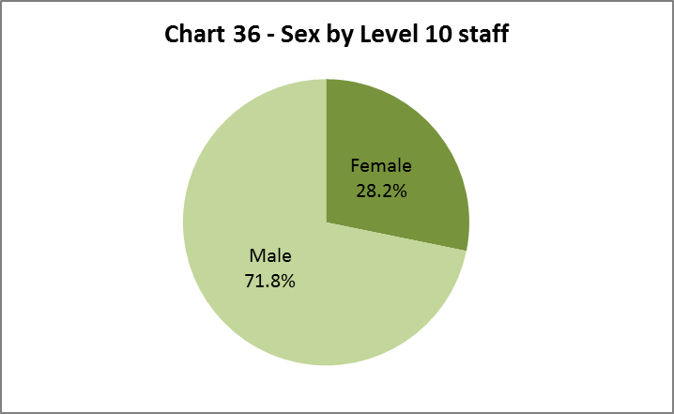

Chart 36 illustrates that 28.2% of senior staff are female. This is an increase of 1.1% from 2016-17, and brings us closer to our KPI, of 33% by 2020.

By Job Family Profile

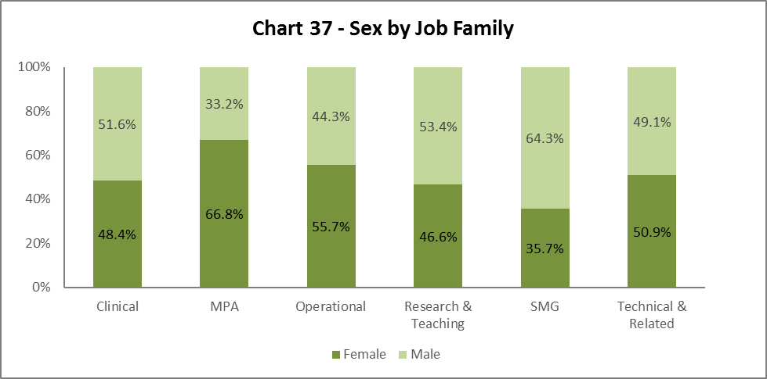

Chart 37 shows an increase in women in all job families, with the exception of Clinical staff who have had a 0.1% decrease. There has been a notable rise in female representation on SMG by 12.6%.

By Grade

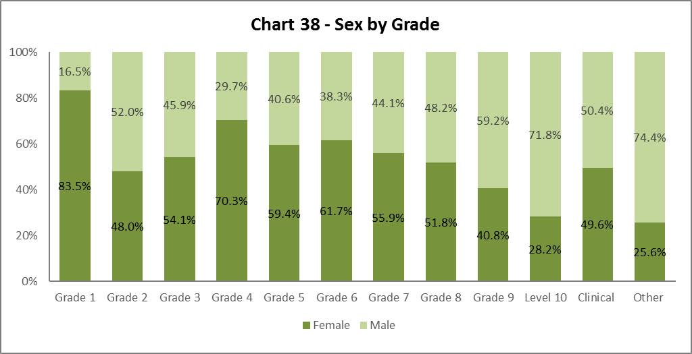

Chart 38 shows a similar pattern to previous years (with the exception of Grades 2 and 3, where there is almost s 50:50 split of men and women) as we climb the grades, the percentage of male staff increases and female staff declines. It noted that there has been an increase females in Grades 4 by 6.6% from 2016-17.

By Full/Part Time

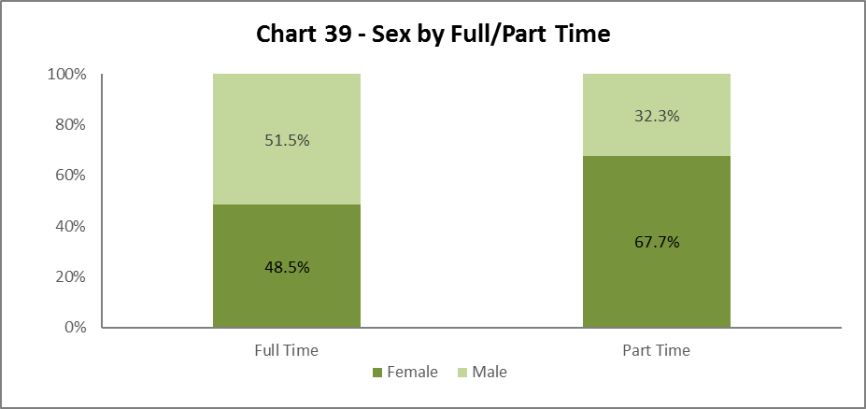

Chart 39 illustrates the sex breakdown of Full and Part Time staff. Approximately two thirds of all Part Time staff are female.

By Contract Type

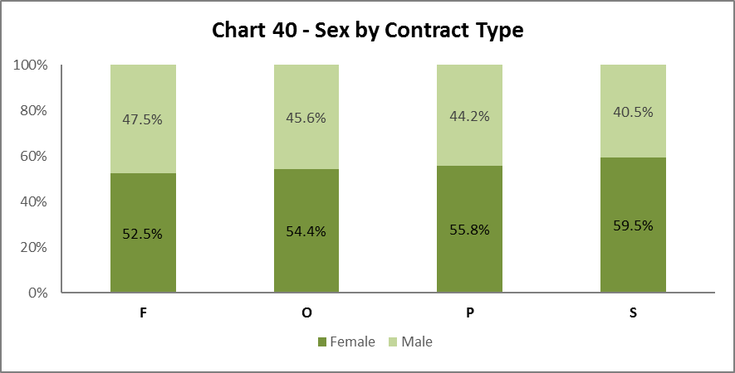

Chart 40 shows women are more likely to hold an Open-ended contract (code P), this mirrors the data from 2016-17.

By Nationality

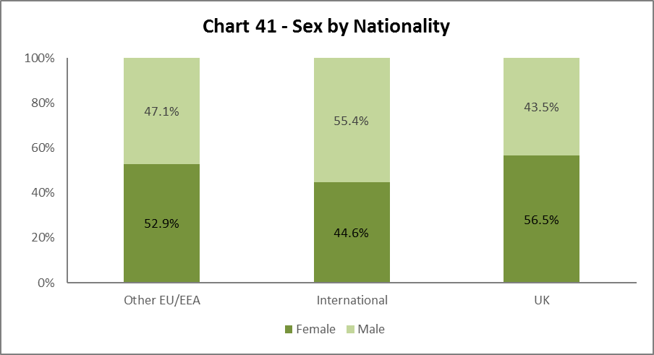

Chart 41 shows women and men are fairly equally represented from EU/EEA, we have slightly more men who are International and slightly more women from the UK, this reflects the data from 2016-17.

Recruitment – by Applications and Successful Applicants

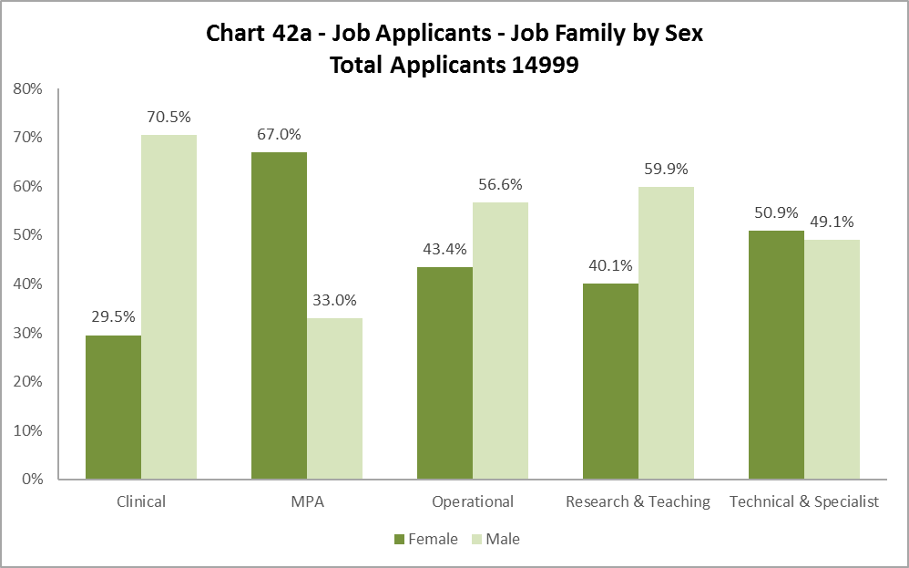

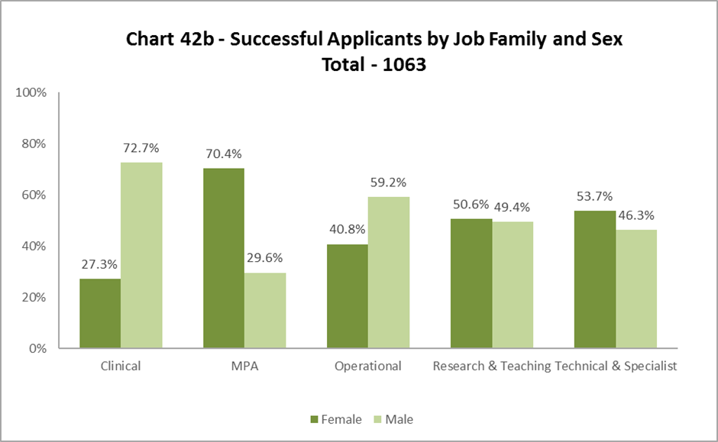

All job families, the sex of applicants reflects those who are successful applicants, with the exception of Research and Teaching, where women are more successful than men in proportion to applications.

# **Profile by Sexual Orientation**

By College

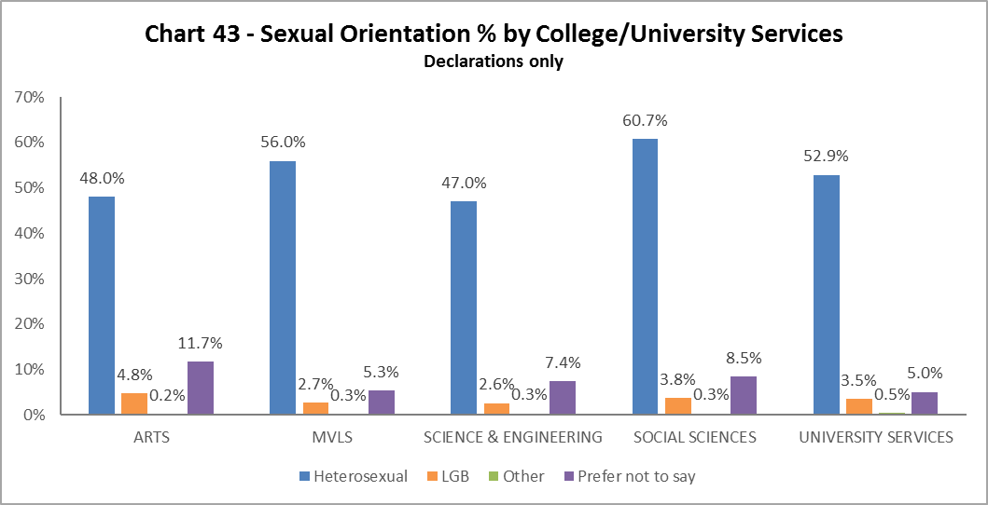

Arts have the highest proportion of LBG staff compared to other Colleges/US, and Science and Engineering has the smallest proportion.

By Level 10 Staff

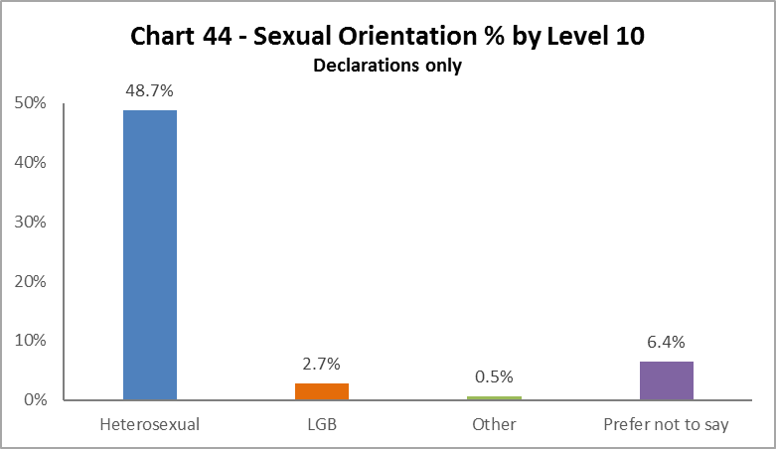

2.7% of level 10 staff identify as LGB.

By Job Family

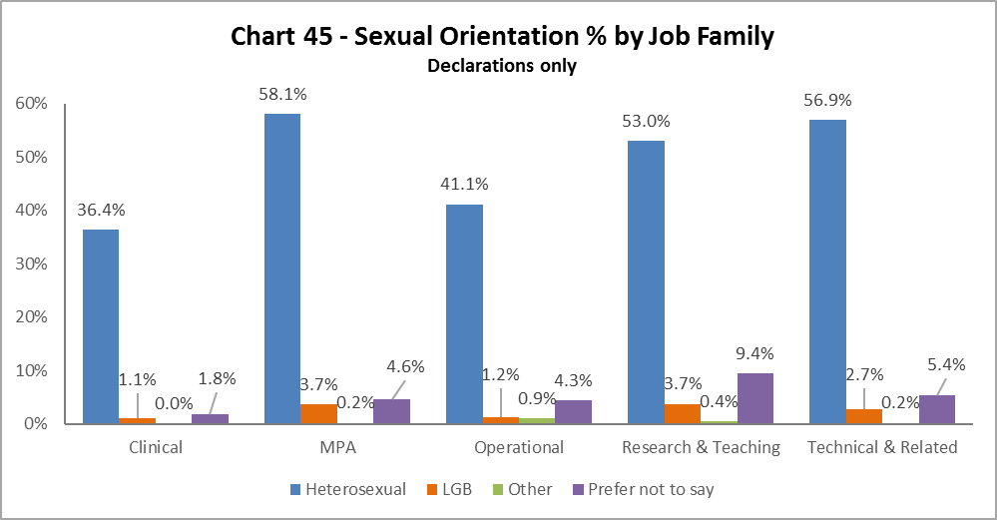

The highest proportion of LGB staff (3.7%) are in MPA and Research and Teaching job families.

By Grade

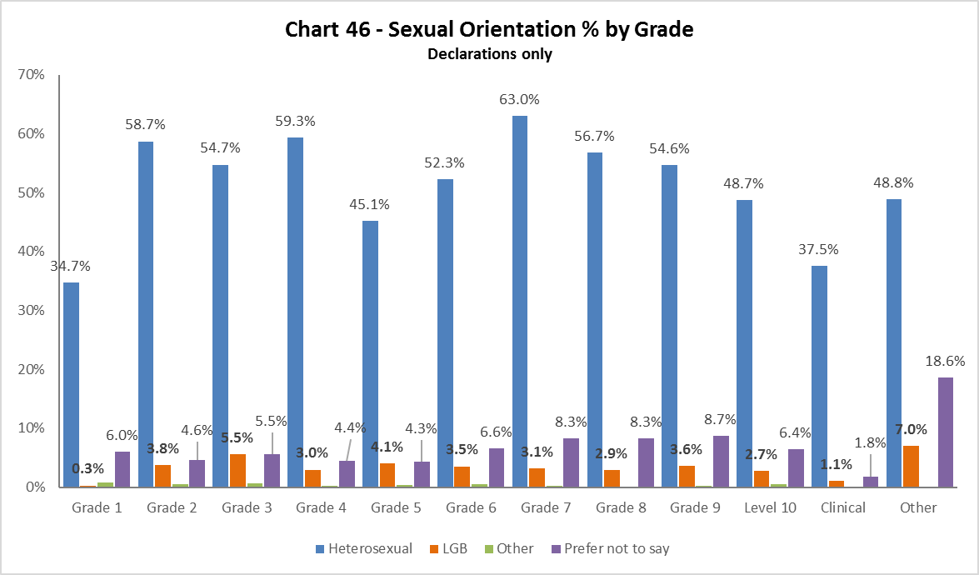

LGB staff are even spread across the grades, with the highest proportion in Grade 5. There are no LGB in Grade 1.

By Full/Part Time

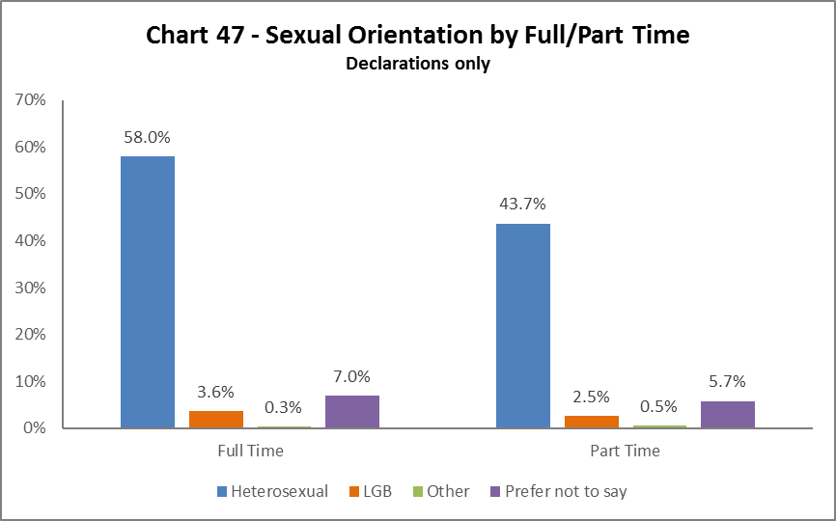

Most LGB staff work full time.

By Contrast Type

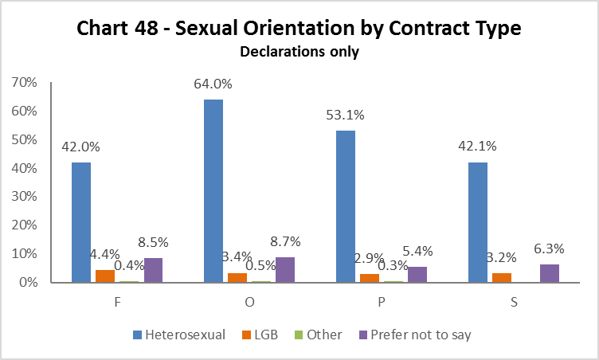

The highest proportion of LGB staff have Fixed term (code F) contracts, and the lowest proportion are on Open Ended (code P) contracts.

By Nationality

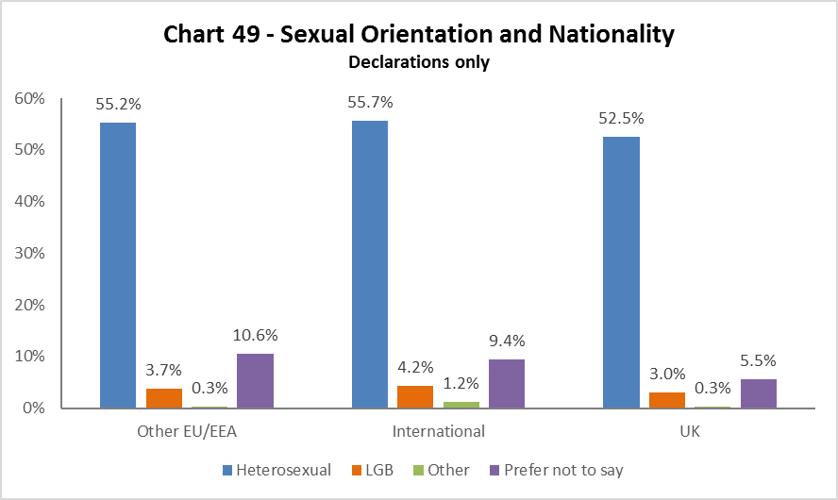

The highest proportion of LGB staff are International at 4.2%, 3.7% are EU/EEA and 3% are from the UK.

Recruitment – by Applications and Successful Applicants

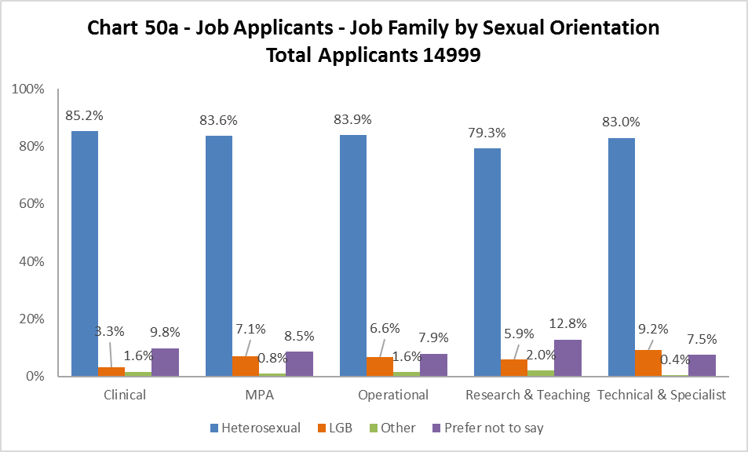

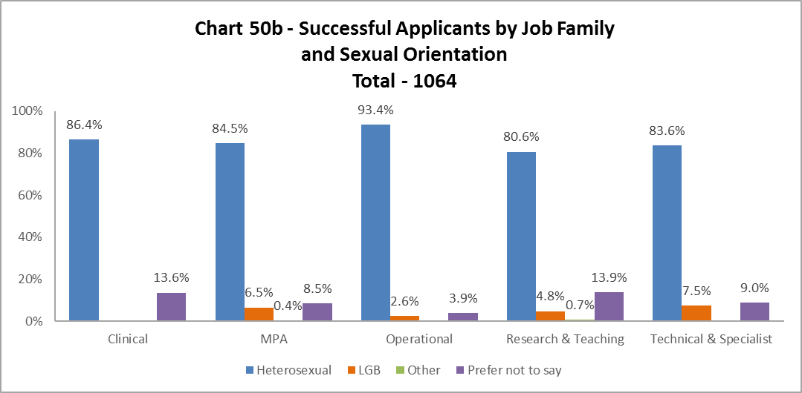

The percentages declaring sexual orientation at application are fairly high, including those from LGB orientations. The conversion rate to successful applicants for LGB not too dissimilar to the applicant rate, with the exception of Clinical and Operational job families.

# **Academic Promotions**

|  |  |  |  |  |  |  |
| --- | --- | --- | --- | --- | --- | --- |
| **Table 11 - Academic Promotions 2018 - R&T and Clinical Job Families Only** | | | | | | |
| **Grade Applied**  **For** |  | **Female** | | **Male** | | **Overall** |
| **No.** | **%** | **No.** | **%** | **No.** |
| **GRADE 7** | Apps | 14 | 45% | 17 | 55% | 31 |
| Successful | 13 | 45% | 16 | 55% | 29 |
| **Promoted (%)** | **93%** | | **94%** | | **94%** |
| **GRADE 8** | Apps | 35 | 49% | 36 | 51% | 71 |
| Successful | 33 | 49% | 34 | 51% | 67 |
| **Promoted (%)** | **94%** | | **94%** | | **94%** |
| **GRADE 9** | Apps | 24 | 38% | 39 | 62% | 63 |
| Successful | 19 | 52% | 30 | 61% | 49 |
| **Promoted (%)** | **79%** | | **77%** | | **78%** |
| **READER** | Apps | 5 | 50% | 5 | 50% | 10 |
| Successful | 5 | 50% | 5 | 50% | 10 |
| **Promoted (%)** | **100%** | | **100%** | | **100%** |
| **CLINICAL** | Apps | 0 | 0% | 1 | 100% | 1 |
| Successful | 0 | 0% | 0 | 0% | 0 |
| **Promoted (%)** | **0%** | | **0%** | | **0%** |
| **PROFESSOR** | Apps | 13 | 42% | 18 | 58% | 31 |
| Successful | 11 | 42% | 15 | 58% | 26 |
| **Promoted (%)** | **85%** | | **83%** | | **84%** |

Table 11 provides information about the Academic Promotions 2017-18 process by gender. Women and men were equally successful, in general across all grades.

In contrast to 2016-17, all applications to Reader for women and men were successful.

As noted in previous years, although women continue to be successful at many grades the numbers applying is lower compared to their male counterparts.

# **Regrading for Professional & Support Staff**

|  |  |  |  |  |  |  |
| --- | --- | --- | --- | --- | --- | --- |
| **Table 12 - Regrading 2017-18 - Professional and Support Staff by Grade** | | | | | | |
| Grade Applied  For |  | **Female** | | **Male** | | **Overall** |
| **No.** | **%** | **No.** | **%** | **No.** |
| **GRADE 1-5** | Apps | 12 | 75% | 4 | 25% | 16 |
| Successful | 9 | 69% | 4 | 33% | 13 |
| **Promoted (%)** | **75%** | | **100%** | | **81%** |
| **GRADE 6-9** | Apps | 31 | 76% | 10 | 24% | 41 |
| Successful | 17 | 71% | 7 | 29% | 24 |
| **Promoted (%)** | **55%** | | **70%** | | **59%** |

|  |  |  |  |  |  |  |
| --- | --- | --- | --- | --- | --- | --- |
| **Table 13 - Regrading 2017-18 - Professional and Support Staff by Job Family** | | | | | | |
| Job Family |  | **Female** | | **Male** | | **Overall** |
| **No.** | **%** | **No.** | **%** | **No.** |
| **MPA** | Apps | 28 | 88% | 4 | 13% | 32 |
| Successful | 14 | 81% | 3 | 19% | 17 |
| **Promoted (%)** | **50%** | | **75%** | | **53%** |
| **OPS** | Apps | 1 | 100% | 0 | 0% | 1 |
| Successful | 1 | 100% | 0 | 0% | 1 |
| **Promoted (%)** | **100%** | | **0%** | | **100%** |
| **TECH & SPEC** | Apps | 14 | 58% | 10 | 42% | 24 |
| Successful | 11 | 58% | 8 | 42% | 19 |
| **Promoted (%)** | **79%** | | **80%** | | **79%** |

OVERALL SUCCESS RATE = 37 / 57 = 65%

Table 12 above shows in all Grades men are more likely than women to be successful in the regrading process. Further investigation would be required to understand why this is the case.

Table 13 shows the same pattern as Table 12, with men more likely to be successful at regrading in all job families compared to women. Further investigation would be required to understand why this is the case.

# **Equal Pay**

The University has a duty to publish pay gap information by 30th April every two years under Regulation 7 of the Equality Act 2010 (Specific Duties) (Scotland) Regulations 2012). This is due to be published by the legislative deadline of April 2019.

Our Gender Pay Gap was calculated at 17.9%.  This is the percentage difference between men’s average hourly pay and women’s average hourly pay (excluding overtime). The University recognises the gender pay gap is significant and has established a Gender Pay Working Group which report to Human Resources Committee to address this.

**END.**

1. As with last year MRC staff have been removed from this category and reallocated to the relevant grade based on salary scales.