

Staff Equality Monitoring Report 2018-19

# Executive Summary

This is the eighth annual staff equality monitoring report produced by the Equality and Diversity Unit, and follows largely the same format as the previous reports to allow comparison between years. This report supports the University’s obligations to publish annual staff equality monitoring data as part of the Public Sector Equality Duty (PSED) under the Equality Act 2010.

The publishing cycle reflects the previous academic cycle (August 2018 –July 2019).

The report shows the following important changes:

* The percentage of Females at Grade 10 has increased by 2.6% from 2017-18, making a total of 30.8%.
* The percentage of Females in the Senior Management Group (SMG) has increased to 53.3%, this is an increase of 17.6% from 2017-18.
* 4.4% of University staff have declared a disability. This is a rise of 0.4% from 2017-18.
* The percentage of staff declaring a Mental Health Condition has increased by 4.7% since 2017-18; to 21.5%.
* There has been an increase in non-UK staff by 2.6% to 24.9% - one quarter of our staffing population.
* There has been an increase in staff declaring they are Lesbian, Gay or Bisexual from 2.6% in 2015-16 to 3.9% in 2018-19.
* 8.7% of staff have declared they are Black, Asian or Minority Ethnic (BAME), and increase of 1.2% from 2017-18.
* Disability declaration rates for Grade 10 have increased by 0.3% to 3%.

The data highlights a number of challenges; these include:

* The University continues to have low response rates for a range of protected characteristics, which makes reporting and checking progress a challenge.
* The BAME UK staff population has grown to 4%, which is comparable with 2011 census data for the Scottish BAME working age population (ages 16-74) of 3.9%[1] but is still significantly lower than Glasgow City’s total BAME population of 11.6%.
* The Operational job family has an older profile, this should be noted when considering succession planning.
* Application and Successful appointments for BAME staff continue to have large variabilities; although it should be noted the Research and Teaching disparity has reduced to below 10%.
* The Regrading process highlights some gender concerns as Males are more successful than Females – further investigation will be required to understand this.

# Introduction

The Staff Equality Monitoring Report allows the University to have a standard base for all staff equality information across the organisation. This report meets one of the University’s obligations under the Public Sector Equality Duty (PSED).

The aim of this report is to provide transparent data for all functions in the institution to use when equality information is required, such as when conducting Equality Impact Assessments (EIA).

# Structure

This report has been structured to provide a ‘Whole University’ overview by all the main protected characteristics plus full/part time working, and maternity leave followed by specific sections on age, disability, ethnicity, sex and sexual orientation with a breakdown of data by the following:

* College
* Grade 10 staff
* Job Family Profiles
* Grade
* Full/Part Time
* Contract Type
* Nationality
* Recruitment – by all applicants and successful applicants

We have not provided a further breakdown beyond ‘Whole University’ on data for religion and belief as the proportion of staff answering these questions is too small to give meaningful information.

Further information has then been provided, by sex, on:

* Academic Promotions
* Regrading for Professional & Support Staff
* Equal Pay – Gender Pay Gap

# Notes and definitions

This 2018-19 report is based on a census date of 9 August 2019, unless otherwise stated. Percentages have been used, as there are some instances where numbers are very small and using actual numbers carries a risk of identifying individual staff. Overall proportions for each of the sections have been provided in Tables 1-6 below.

Whole University - Total head count is **8198** (up 543 on last year). This is the head count for all staff in the University; with those on multiple contracts only counted once. The three previous year’s total headcount figures were 7020 (2015-16), 7528 (2016-17) and 7655 (2017-18).

College/University Services Split

When using the term ‘By College’ this includes University Services as a College.

|  |  |  |  |
| --- | --- | --- | --- |
| Table 1 - College | %2016-17 | %2017-18 | %2018-19 |
| Arts | 7% | 8% | **8%** |
| MVLS | 30% | 30% | **28.5%** |
| Science and Engineering | 20% | 20% | **20%** |
| Social Sciences | 11.5% | 12% | **14.5%** |
| University Services | 31.5% | 30% | **29%** |

Job Family Profile

Some members of the Senior Management Group (SMG) are classed as ‘Research & Teaching’ or ‘Clinical’ under the Job Family profile. For reporting purposes these have been moved into SMG, and the original Job Family figures have been amended accordingly.

|  |  |
| --- | --- |
| Table 2 - Job Family | % |
| Clinical | 3.3% |
| Management, Professional and Administrative (MPA) | 32.6% |
| Operational | 10.1% |
| Research & Teaching | 45.4% |
| SMG | 0.2% |
| Technical & Related | 8.4% |

By Full/Part Time

All staff who work less than one FTE are considered Part Time.

|  |  |
| --- | --- |
| Table 3 - Full Time / Part Time | % |
| Full Time = FTE 1.0 | 64.5% |
| Part Time = FTE - 0 + anything < 1.0 | 35.5% |

By Contract Type

The contract types are as follows;

**F** = Fixed term as per FT & OE Contract policy

**O** = Open ended with funding end date

**P** = Open ended + Permanent in Temporary Fixed Term Appointment

**S** = Fixed term - SOSR e.g. Maternity leave cover

|  |  |
| --- | --- |
| Table 4 - Contract Type | % |
| F = (F) Fixed term | 20.2% |
| O = (O) Open ended with funding end date | 18.0% |
| P = (P) Open ended + (C) Permanent in Temporary Fixed Term Appointment  (Head of College/Principal/Vice Principal roles etc.) | 60.4% |
| S = (S) Fixed term - SOSR e.g. Maternity leave cover | 1.3% |

Grade Grouping

|  |  |  |  |
| --- | --- | --- | --- |
| Table 5 - Grade Grouping | |  | % |
| Grade 1 |  |  | 4.4% |
| Grade 2 |  |  | 4.0% |
| Grade 3 |  |  | 4.0% |
| Grade 4 |  |  | 5.8% |
| Grade 5 |  |  | 13.9% |
| Grade 6 |  |  | 18.5% |
| Grade 7 |  |  | 17.8% |
| Grade 8 |  |  | 12.9% |
| Grade 9 |  |  | 7.9% |
| Grade 10 (see Table 6 for definition) | | | 7.0% |
| Clinical |  | | 3.3% |
| Other[2] |  | | 0.5% |

|  |  |
| --- | --- |
| Table 6 – Grade 10 staff  (based on Actual Grade Description) | % |
| Professor | 88% |
| Senior Administrative Group | 9.4% |
| Senior Management Group (SMG) | 2.6% |

Age

Two charts are provided for the whole University age data, using 5-year groupings and then 10-year age groupings. For all subsequent charts, the age data is provided using the 10-year age groupings only.

Disability

Two charts have been provided for the whole University disability data, whether staff have stated they have a disability, and then by impairment category. For all subsequent charts the disability data is only provided by whether staff have stated they have a disability or not.

Ethnicity

Two charts have been provided for the whole University ethnicity data. For all subsequent charts all ethnic minority categories have been combined into Black, Asian or Minority Ethnic (BAME). The nomenclature Black, Asian and Minority Ethnic (BAME) was introduced in the 2016-17 report as this best reflects the local population.

Maternity

This outlines the percentage who returned to work within the reporting period, the percentage still on leave and due to return, those whose contract ended within the period and those who resigned.

Nationality

This is based on information provided by staff about their right to work in the UK. For the purpose of this report we have used the following categories: UK, EU/EEA and International.

Sexual Orientation

For the purposes of this report, the sexual orientation categories of Lesbian, Gay and Bisexual have been combined and shown as LGB. The whole University data shows the full breakdown, including where information has not been declared. For all subsequent charts, only declared sexual orientation or ‘prefer not to say’ data is provided. This is only the second time the University has reported this level of information. Future reports will allow more detailed analysis as the University builds trend data on this community of staff.

Recruitment - Applications and Successful Applicants

The census date for applicants and successful applicants was 01 August 2018 – 31 July 2019 and based on the date the post was first advertised. The information excludes direct appointments and those who withdrew prior to an offer decision or during the application process. The protected characteristic information of 611 applicants has been archived due to GDPR requirements; these individuals have been excluded from the information provided. None of these applicants were hired.

Academic Promotions and Professional & Support Staff Regarding

The data for promotion is only provided by sex as further disaggregation carries a risk of identifying individual staff.

Pay Gap Information

In accordance with the Public Sector Equality Duties, the Gender Pay Gap and Equal Pay information for Disability and Ethnicity are provided in line with our legislative requirements in a separate report.

# Whole University Profile

## Age

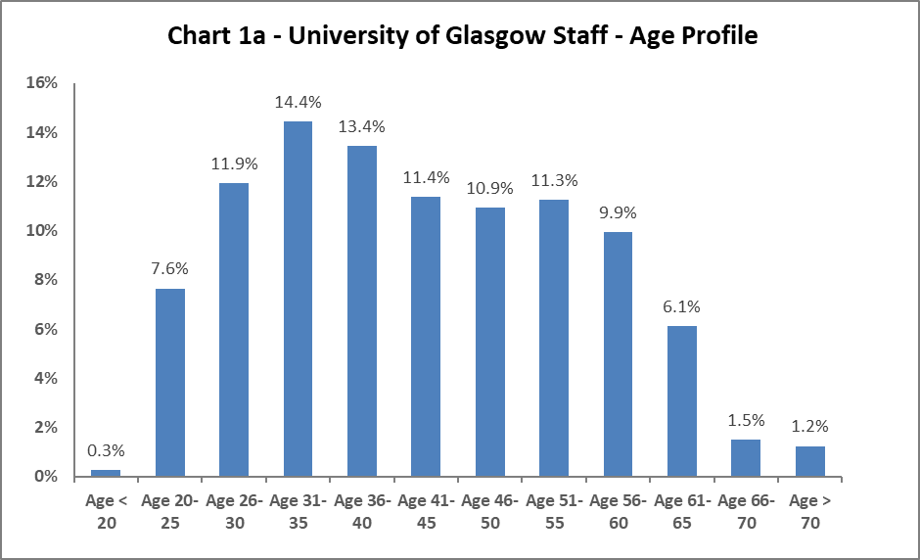

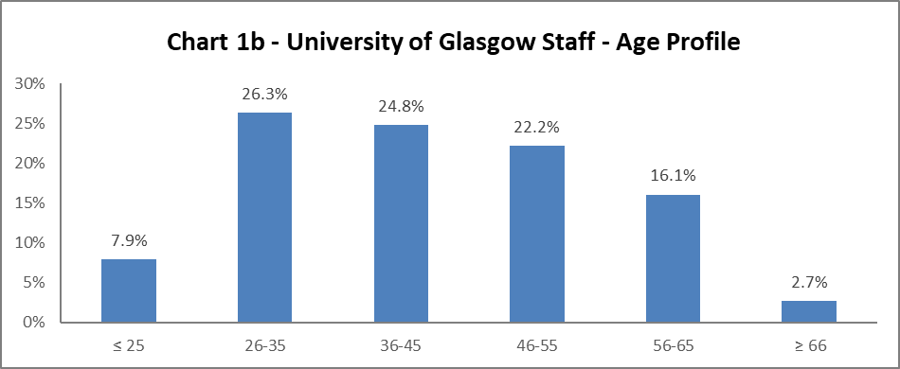

The University's age profile follows more or less a bell curve, as shown in Charts 1a and 1b above. The age profile has remained similar since 2011-12. There has been an increase in 26-35, and 36-45 year olds from 2017-18 of 1.4% and 0.5% respectively, and a drop in 46-55 year olds of 1.5%. All other age ranges have only had marginal increases or decreases.

## Disability

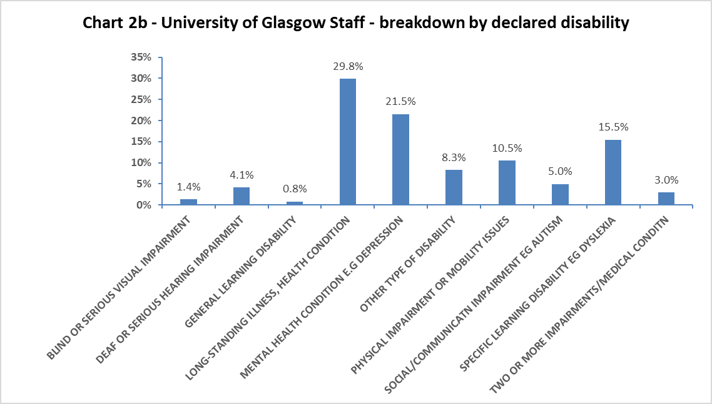

Chart 2a above shows 4.4% of University staff has declared a disability, this is an increase from

2017-18 of 0.4% and a rise of 0.6% since 2016-17. Staff stating ‘Prefer not to say’ category has also dropped by 1.4% from 2017-18. The ‘Not answered’ category has remained static.

When considering impairment type, in Chart 2b, the largest cohort of staff has a longstanding illness or health condition. There has been an large increase in staff declaring they have a mental health condition, with an increase of 4.7% since 2017-18. Additionally, there has been an increase of 1.5% in staff stating they have a physical impairment or mobility issue.

## Marital Status

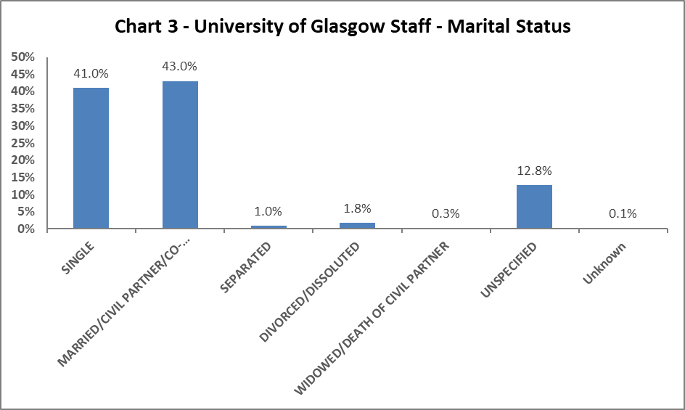

Chart 3 shows single staff represent 41.0% of the staff population. This has risen steadily from 31.5% in 2013-14, with a corresponding drop (from 52.1% to 43%) in Married/Civil Partnership/Co-habiting staff.

## Full Time/Part Time

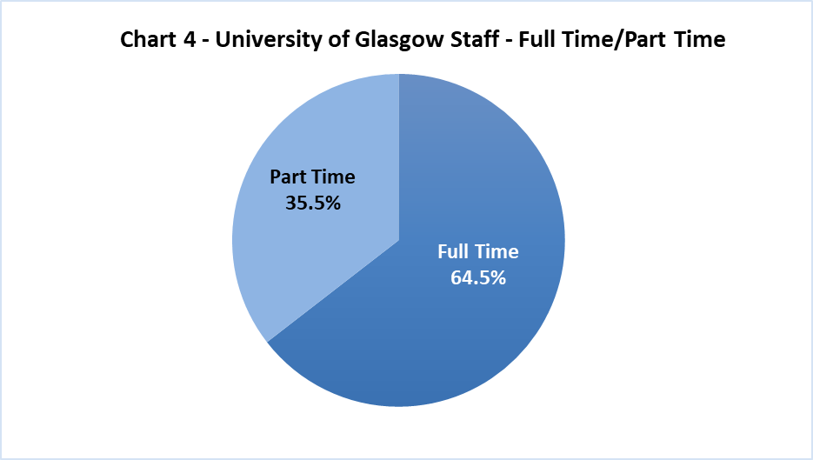

Chart 4 shows, as in previous years, approximately two thirds of University staff working full time and one third working part time. The Part Time figure has increased from 1.5% from 2017-18

## Nationality

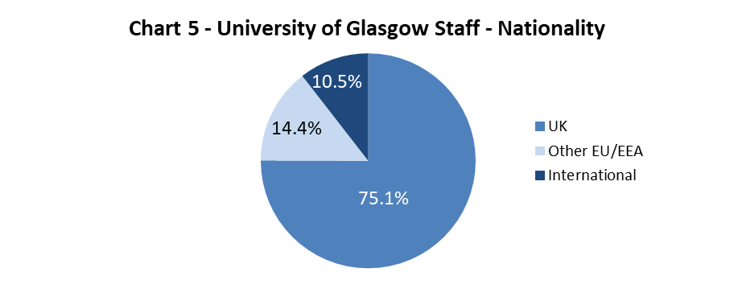

The data shows a slight increase in staff from outside the UK, by 0.7% for EU/EEA and 1.9% in International staff. Overall this is an increase in non-UK by 2.6% to 24.9% from last year and over 5% since first reported in 2014-15.

## Ethnicity

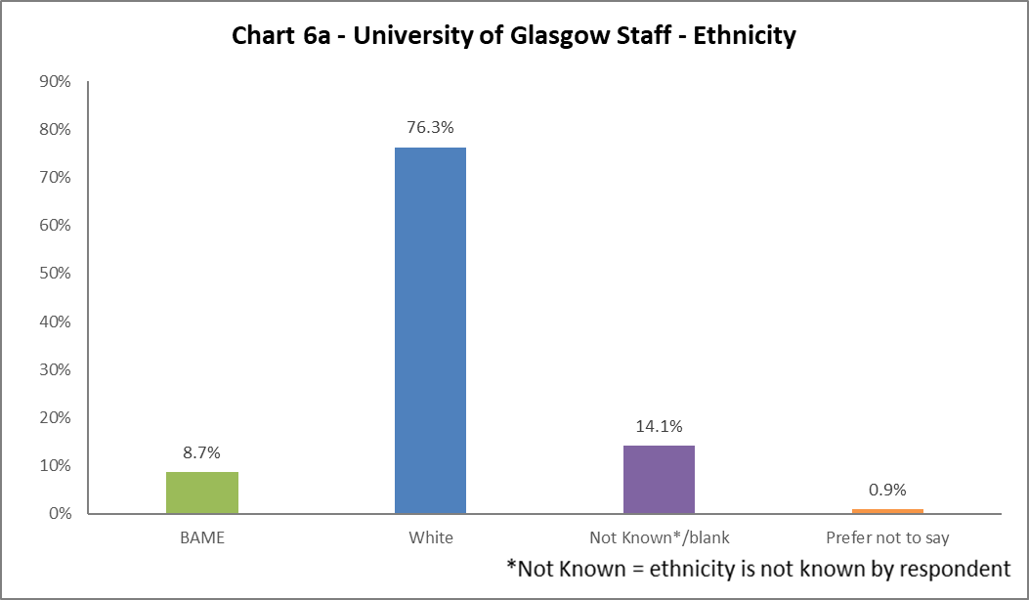

Chart 6a shows 8.7% of University staff are from a Black, Asian or Minority Ethnic (BAME) background, an increase of 1.2% from 2017-18 and 2.3% from 2031-14. 8.7% is higher than the Scottish national average from the 2011 census (4%) and is comparable with the Scottish BAME working age population (ages 16-74) of 3.9% but remains lower than the Glasgow City BAME population from the same census (11.6%). The full ethnic breakdown is provided for information in Chart 6b below.

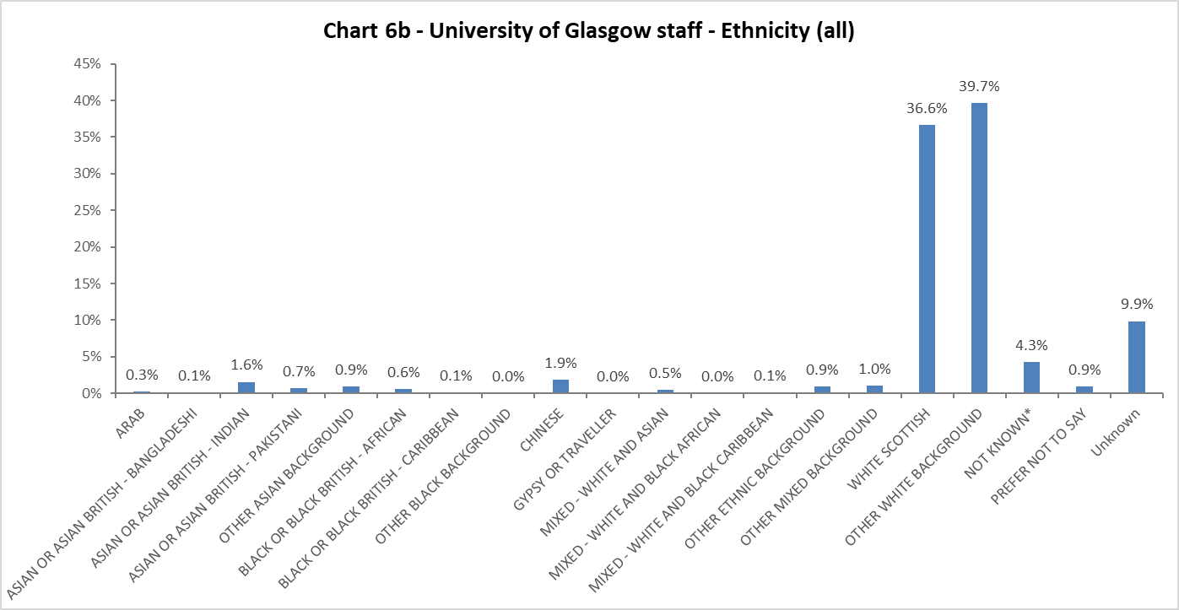

## Religion and Belief

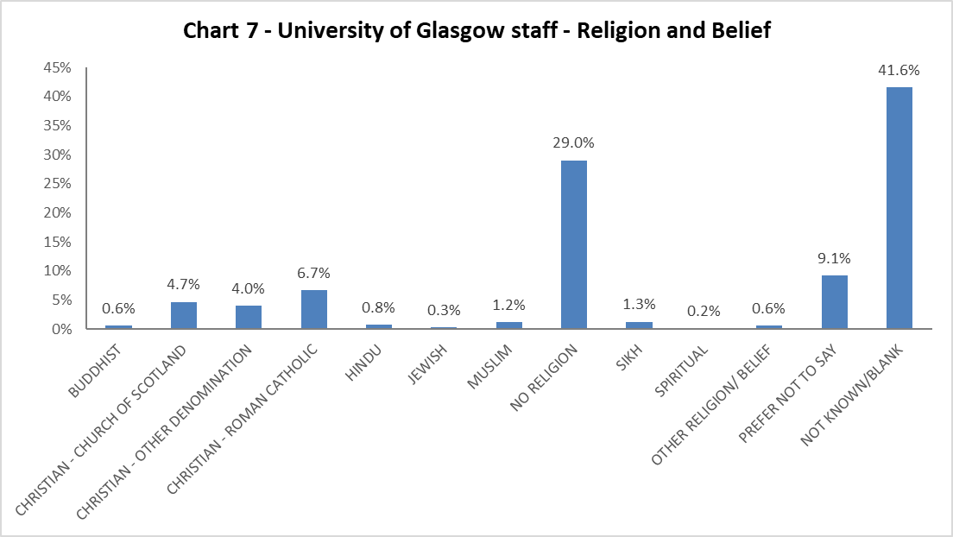

The largest component of staff continues to state they have no religion – up by 1.9% from 2017-18. There has been a slight rise in staff stating they are Christian by 0.8%, Hindu 0.2%, and Muslim 0.2% and Buddhist and Jewish by 0.1% since 2017-18.

## Sex

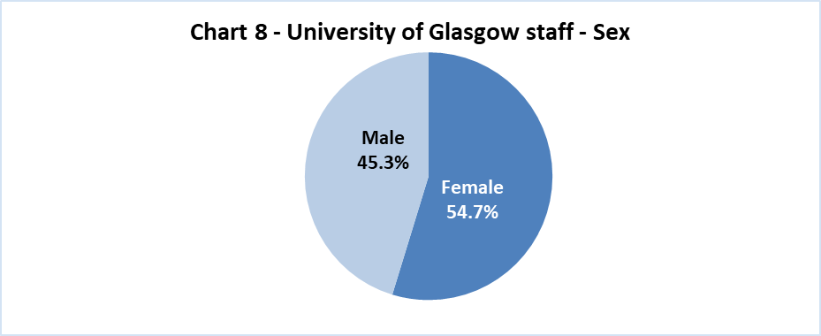

We have seen little fluctuation in the Male/Female makeup of the University’s workforce since 2011.

## Sexual Orientation

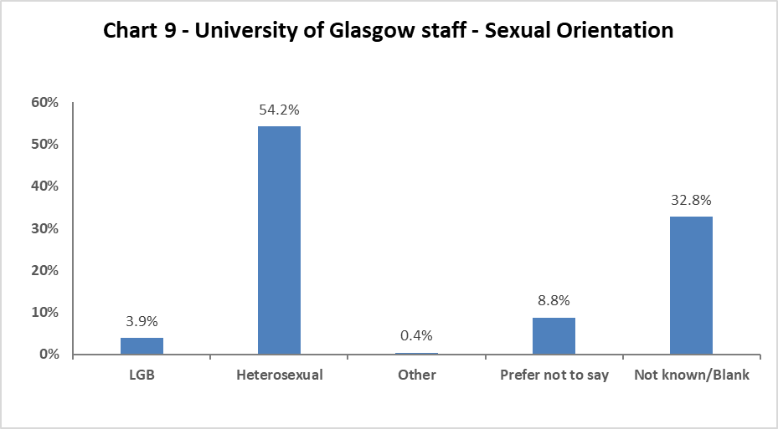

2018-19 has seen a 0.7% increase in staff declaring they are Lesbian, Gay or Bisexual. There has been a 2.3% increase in staff stating ‘Prefer not to say’ from 2017-18.

## Maternity Leave

55.9% staff returned during the year (compared to 52.4% in 2017-18), and 38% are due to return. 4.1% of staff contracts ended as planned, compared to 3.2% in 2017-18 and 4.7% in 2016-17. 2% of staff resigned, this shows a growing increase from 1.6% in 2017-18 and 0.8% in 2016-17, however in terms of numbers this is a very small increase.

# Profile by Age

## By College

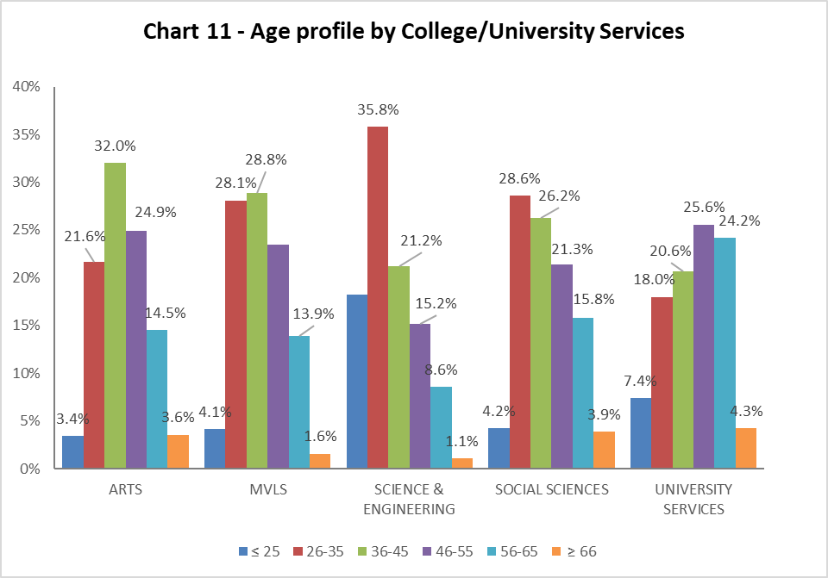

|  |  |  |  |  |  |
| --- | --- | --- | --- | --- | --- |
| Table 7 | ARTS | MVLS | SCIENCE & ENGINEERING | SOCIAL SCIENCES | UNIVERSITY SERVICES |
| Age Range | % | % | % | % | % |
| ≤ 25 | 3.4 | 4.1 | 18.2 | 4.2 | 7.4 |
| 26-35 | 21.6 | 28.1 | 35.8 | 28.6 | 18.0 |
| 36-45 | 32.0 | 28.8 | 21.2 | 26.2 | 20.6 |
| 46-55 | 24.9 | 23.5 | 15.2 | 21.3 | 25.6 |
| 56-65 | 14.5 | 13.9 | 8.6 | 15.8 | 24.2 |
| ≥ 66 | 3.6 | 1.6 | 1.1 | 3.9 | 4.3 |

Chart 11 above allows a quick visualisation of the distribution of ages in each College/US which can be compared with the Whole University distribution in Chart 1. Table 7 above gives the relevant percentages. The College of Arts has seen a 2.6% increase in 36-45 year olds and a decrease of 3.2% in 46-55 year olds. College of Social Science has also seen fluctuation with an increase in 26-35 year olds of 6.5%, and a decrease in 36-45 years by 3.6%. Reflecting all reports, US has an older workforce than any of the Colleges.

## By Grade 10 staff

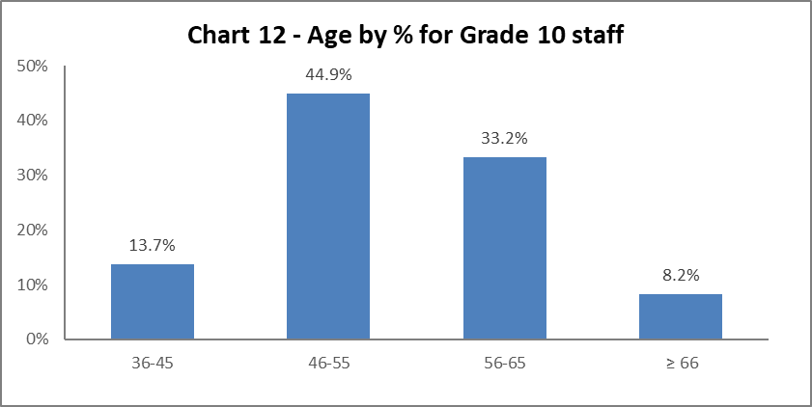

Chart 12 above shows the majority of Grade 10 staff are aged 46 or over. There continues to be an increase in Grade 10 staff who are 66 or over (from 5.9% in 2016-17 to 8.2% in 2018-19).

## By Job Family Profile

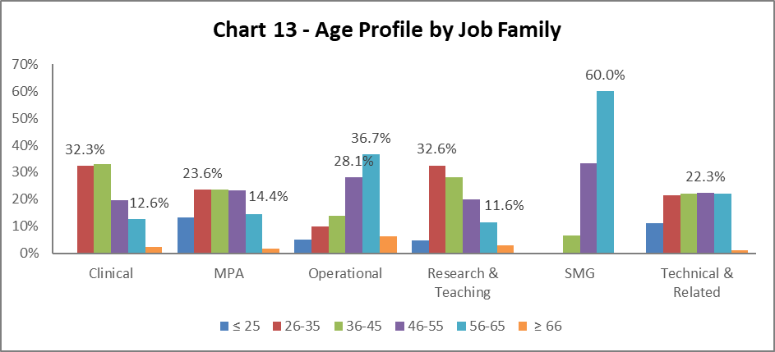

|  |  |  |  |  |  |  |  |
| --- | --- | --- | --- | --- | --- | --- | --- |
| Table 8 | Clinical | MPA | Operational | | Research & Teaching | SMG | Technical & Related |
| Age Range | % | % | | % | % | % | % |
| Age ≤25 | 0.0 | 13.3 | | 4.9 | 4.7 | 0.0 | 11.2 |
| Age 26-35 | 32.3 | 23.6 | | 10.0 | 32.6 | 0.0 | 21.4 |
| Age 36-45 | 33.1 | 23.6 | | 13.9 | 28.1 | 6.7 | 22.0 |
| Age 46-55 | 19.7 | 23.4 | | 28.1 | 20.1 | 33.3 | 22.3 |
| Age 56-65 | 12.6 | 14.4 | | 36.7 | 11.6 | 60.0 | 22.1 |
| Age ≥66 | 2.2 | 1.7 | | 6.4 | 3.0 | 0.0 | 1.0 |

Chart 13 above outlines the age distribution by job family. The age profile by job family reflects previous years. The MPA staff profile is most similar to the University average (Chart 1), whilst Research & Teaching staff have a slightly younger profile. Operational job family continues to have an older age profile, and this should be noted when considering succession planning. Table 8 above gives the relevant percentage figures which are very similar to those seen in previous years.

## By Grade

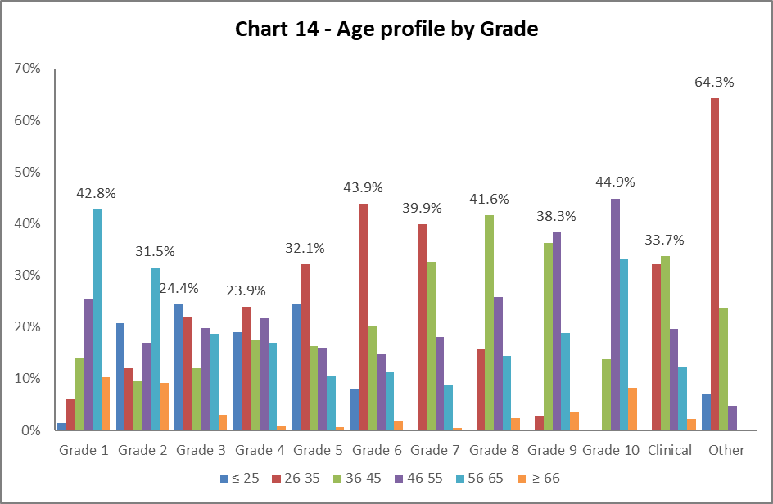

|  |  |  |  |  |  |  |  |  |  |  |  |  |  |  |  |  |  |  |  |  |  |  |  |  |
| --- | --- | --- | --- | --- | --- | --- | --- | --- | --- | --- | --- | --- | --- | --- | --- | --- | --- | --- | --- | --- | --- | --- | --- | --- |
| Table 9 | Grade 1 | | Grade 2 | | Grade 3 | | Grade 4 | | Grade 5 | | Grade 6 | | Grade 7 | | Grade 8 | | Grade 9 | | Grade 10 | | Clinical | | Other | |
| Age Range | % | % | | % | | % | | % | | % | | % | | % | | % | | % | | % | | % | |
| Age ≤ 25 | 1.4 | 20.7 | | 24.4 | | 19.0 | | 24.4 | | 8.1 | | 0.1 | | 0.0 | | 0.0 | | 0.0 | | 0.0 | | 7.1 | |
| Age 26-35 | 6.1 | 12.0 | | 22.0 | | 23.9 | | 32.1 | | 43.9 | | 39.9 | | 15.8 | | 2.9 | | 0.0 | | 32.2 | | 64.3 | |
| Age 36-45 | 14.2 | 9.6 | | 12.0 | | 17.5 | | 16.3 | | 20.3 | | 32.7 | | 41.6 | | 36.3 | | 13.7 | | 33.7 | | 23.8 | |
| Age 46-55 | 25.3 | 17.0 | | 19.9 | | 21.8 | | 16.0 | | 14.7 | | 18.1 | | 25.8 | | 38.3 | | 44.9 | | 19.6 | | 4.8 | |
| Age 56-65 | 42.8 | 31.5 | | 18.7 | | 16.9 | | 10.6 | | 11.3 | | 8.7 | | 14.4 | | 18.9 | | 33.2 | | 12.2 | | 0.0 | |
| Age ≥ 66 | 10.3 | 9.3 | | 3.0 | | 0.8 | | 0.6 | | 1.7 | | 0.5 | | 2.5 | | 3.5 | | 8.2 | | 2.2 | | 0.0 | |

Chart 14 and Table 9 show the general profile for age range reflects the norm and has not changed significantly since reporting started. However, there are spikes in Grades 1 and 2 in age range 56-65, Grade 1 has increased by 3.2% and Grade 2 by 0.9% since 2017-18. There is a significant rise in age range 26-35 from Grade 6; where the Research and Teaching job family starts. This profile is similar to previous reports.

## By Full/Part Time

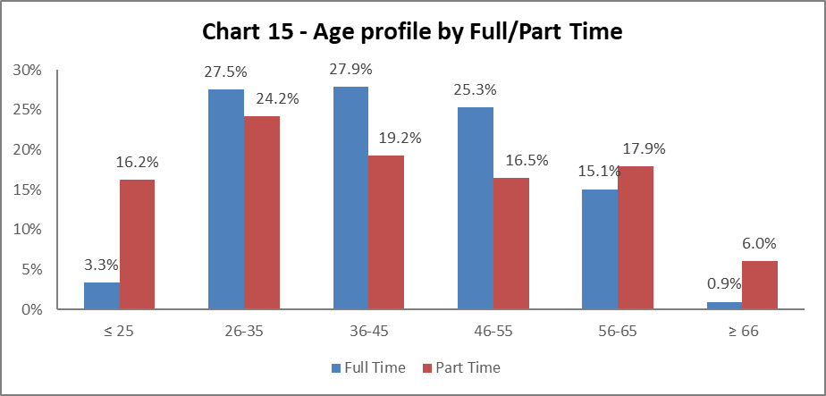

Chart 15 shows the part time staff age profile. The 2018-19 data reflects previous years, with staff under 25 and over 56 more likely to work part time.

## By Contract Type

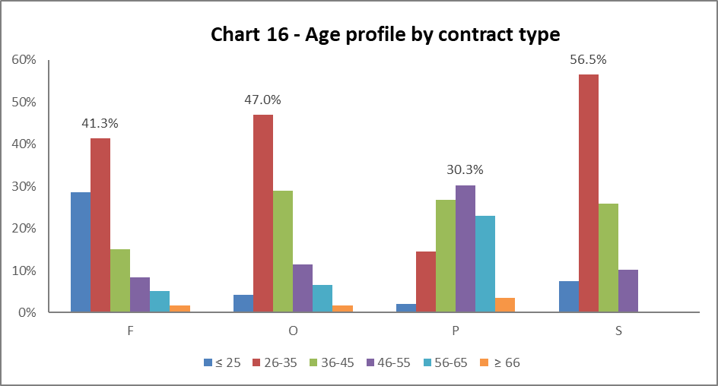

|  |
| --- |
| Key |
| F = Fixed term as per FT & OE Contract policy |
| O = Open ended with funding end date |
| P = Open ended (‘Permanent’) **+** Perm in Temp Fixed Term Appointment (HoC/Principal/VP role) |
| S = Fixed term - SOSR e.g. Maternity leave cover |

|  |  |  |  |  |
| --- | --- | --- | --- | --- |
| Table 10 | F | O | P | S |
| Age Range | % | % | % | % |
| Age ≤25 | 28.5 | 4.3 | 2.1 | 7.4 |
| Age 26-35 | 41.3 | 47.0 | 14.5 | 56.5 |
| Age 36-45 | 15.0 | 28.9 | 26.8 | 25.9 |
| Age 46-55 | 8.3 | 11.5 | 30.3 | 10.2 |
| Age 56-65 | 5.1 | 6.6 | 22.9 | 0.0 |
| Age ≥66 | 1.7 | 1.8 | 3.4 | 0.0 |

Chart 16 above shows that Open ended with Funding End Date (code O) and both types of Fixed Term (F & S) workers are generally younger (under 35). The percentage of staff on (code O) and (code F) contracts in the 26-35 age range has increased from 2017-18 by 1.5% and 3.3% respectively. Staff on Open ended contracts (code P) tend to be slightly older compared to the University profile. The Fixed term contracts (code S) are relative few in number, hence the spike in age range 26-35 years, which reflects previous years.

## By Nationality

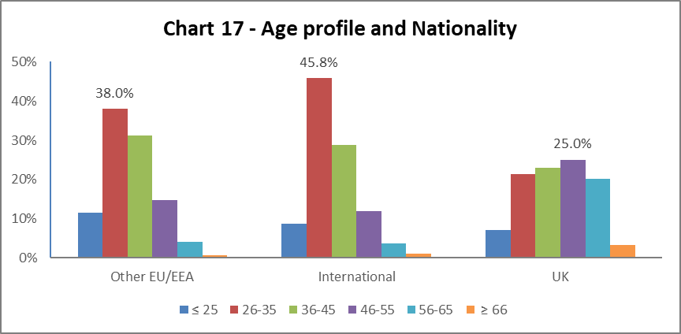

Chart 17 tells us a higher percentage of our EU/EEA and International staff are younger than our UK staff, this reflects the last three years data.

## Recruitment – by Applications and Successful Applicants

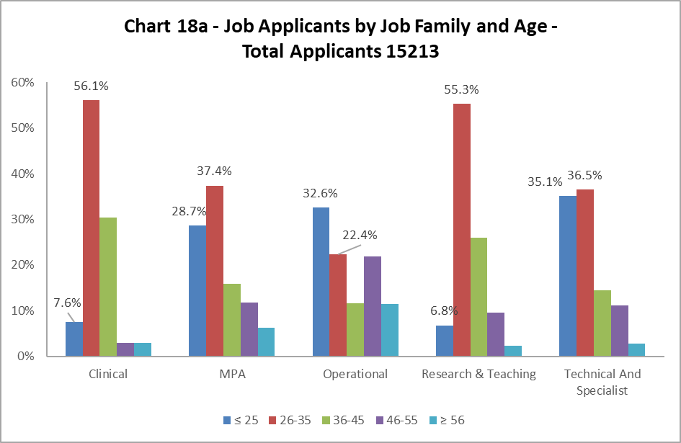

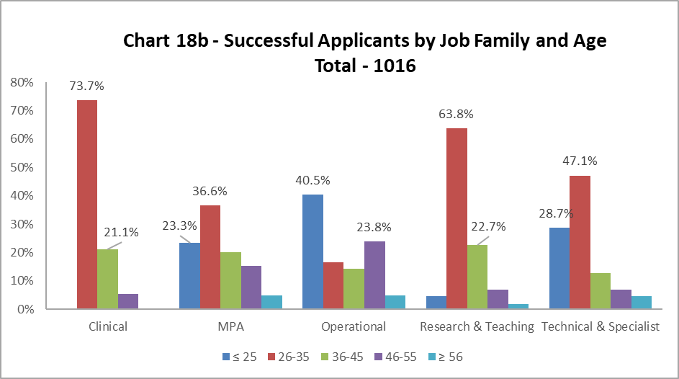

As in previous years, Charts 18a and 18b show the age of applicants are generally reflective of the appointments. The proportion of under 26-year olds successful applicants in Operational job family is higher than the applicant pool. Whilst the Technical and Specialist job family has a lower proportion of successful applicants in the under 26 age category.

# Profile by Disability

## By College

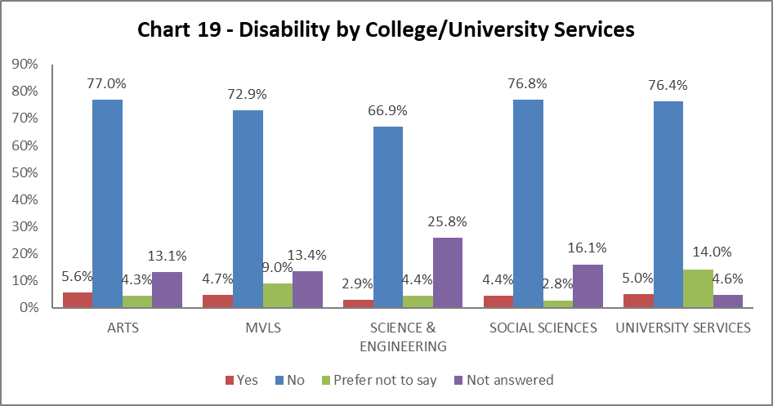

Chart 19 shows the percentage of Disabled staff within College/US. There has been a slight increase in staff with disabilities in most areas, the exception being Social Sciences where there has been a drop of 0.9%. Science & Engineering has the lowest percentage of disabled staff (2.9%), however also has the highest percentage of ‘Not answered’ responses. Arts has the highest percentage of disabled staff, an increase of 1.1% from 2017-18.

## By Grade 10 staff

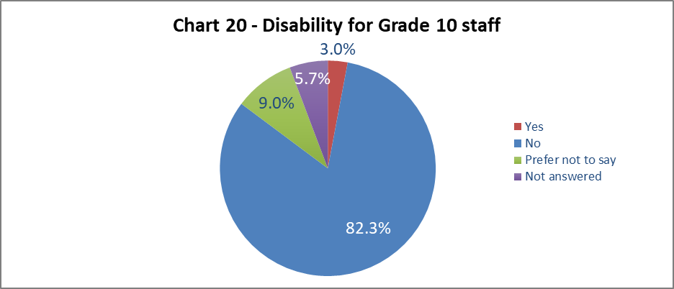

Chart 20 shows 3% of senior staff have declared a disability; this is a 0.3% increase from 2017-18, and lower than the University wide figures.

## By Job Family Profile

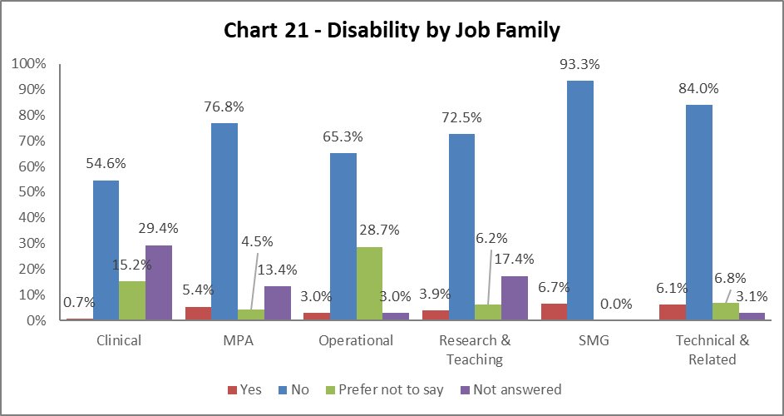

Chart 21 shows most job families have seen an increase in declaration rates compared to 2017-18, notably in Technical and Related by 1%, and MPA by 0.8%. There has been a decrease in most job families of those who have not answered the question, except for Research and Teaching, where there has been a 3.9% increase.

## By Grade

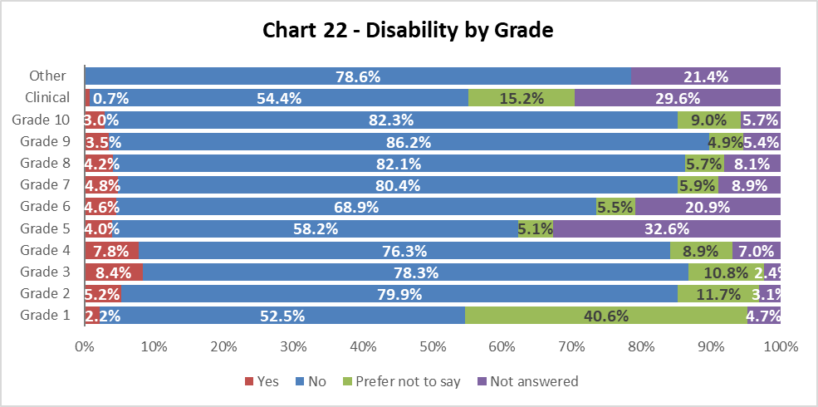

Chart 22 shows disability declaration rates by Grade. There has generally been an increase in declarations in most grades – notably by grades 3 and 4, by 1.2% and 2.5% respectively. There are significant proportion of staff who have not responded to this information or choose the Prefer not to say option – most notably in Grade 1, 2 and Clinical staff.

## By Full/Part Time

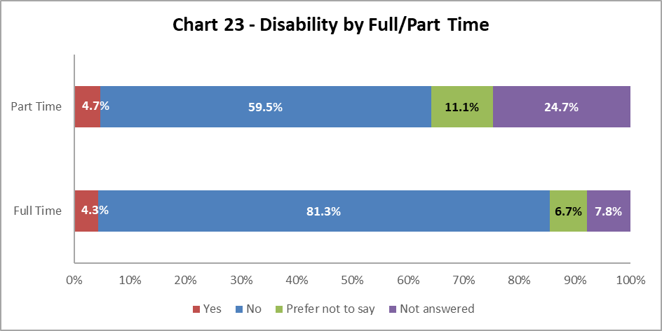

Chart 23 shows staff with a disability are more likely to work part time. There has been a slight increase on previous years in both part time and full time staff with a Disability.

## By Contract Type

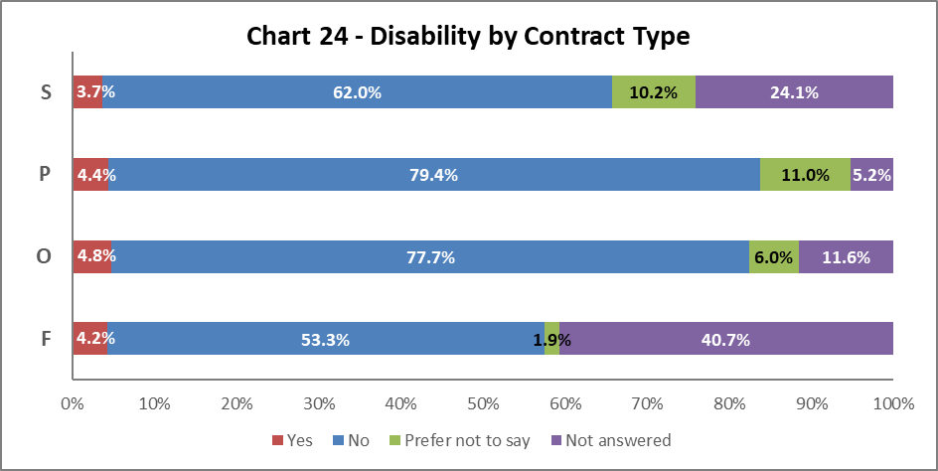

Chart 24 above shows Disabled staff are most likely to have an Open-ended with funding end date (code O) contract, which reflects the last two years. In general, there has been an increase in Disabled staff in all contract types. However, has been a rise in Disabled staff with Open-ended (code P) from 3.3% in 2015-16, 4.1% in 2017-18, and now 4.4% in 2018-19.

## By Nationality

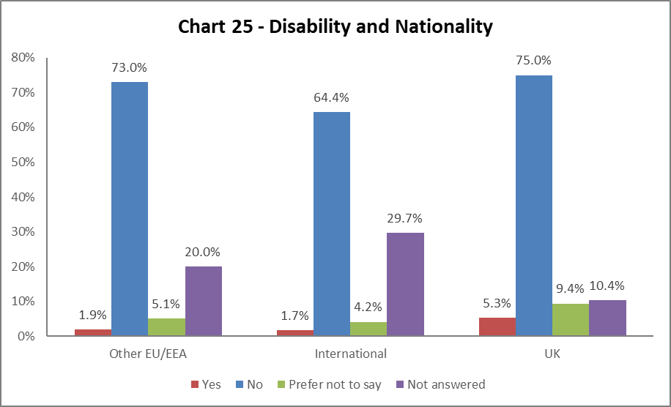

Chart 25 indicates a higher percentage of staff from the UK have declared a disability. This is a rise of 0.6% from 2017-18. The EU/EEA and International staff declaration rates have remained static.

## Recruitment – by Applications and Successful Applicants

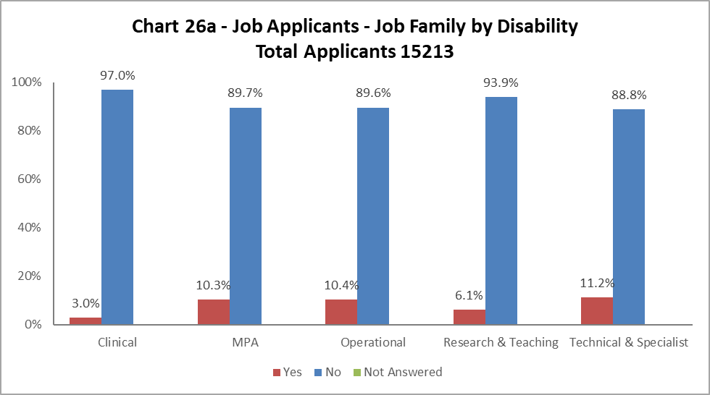

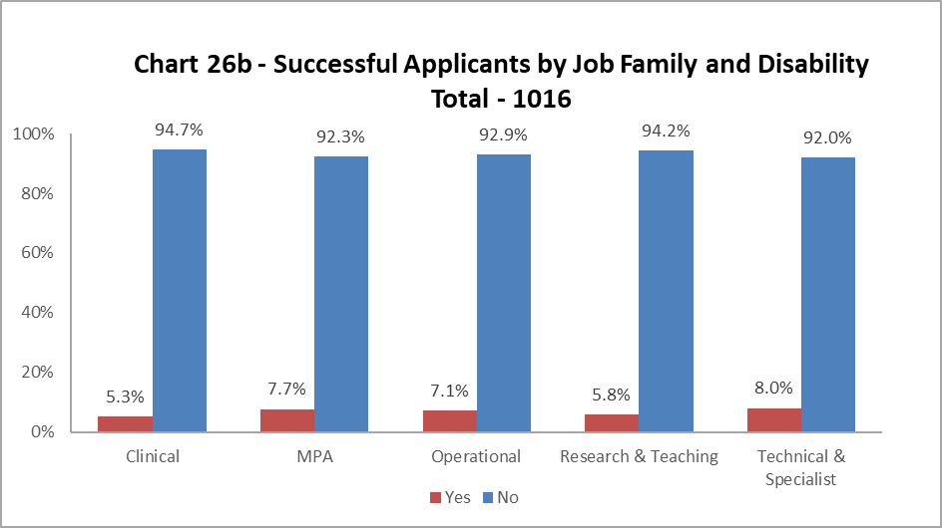

Charts 26a and 26b show that across most job families had more Disabled applicants than were successfully appointed, the exception was Clinical where there was a 2.3% increase in Disabled successful appointments. For the other job families, the percentage decrease was approximately 3%, except in Research and Teaching which was just 0.3%.

# Profile by Ethnicity

## By College

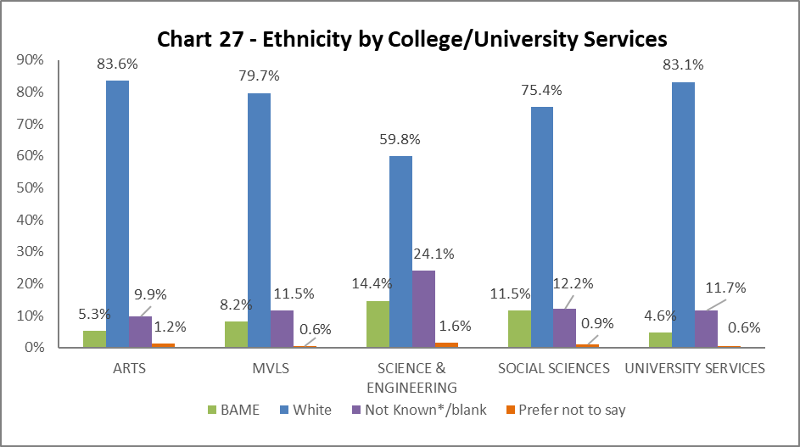

Chart 27 shows the breakdown of BAME staff in College/US. There has been a marked increase in the percentage of BAME staff in Arts, rising from 3.6% in 2016-27 and 4.3% in 2017-18 to 5.3% in 2018-19. Science and Engineering has seen a sizeable 2.8% increase from last year. All other Colleges/US have seen a slight decrease. Science and Engineering continue to have very high ‘Not known/Blank’ rates.

## By Grade 10 Staff

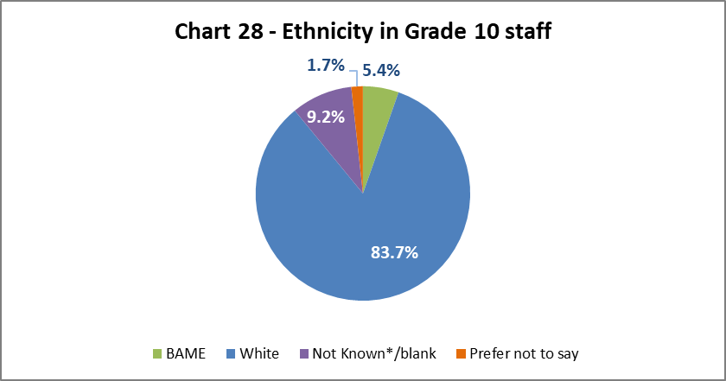

Chart 28 above show the percentage of BAME staff at Grade 10 to be 5.4%, this is an increase of 0.5% from 2017-18, however lower than the 2016-17 high of 5.7%.

## By Job Family Profile

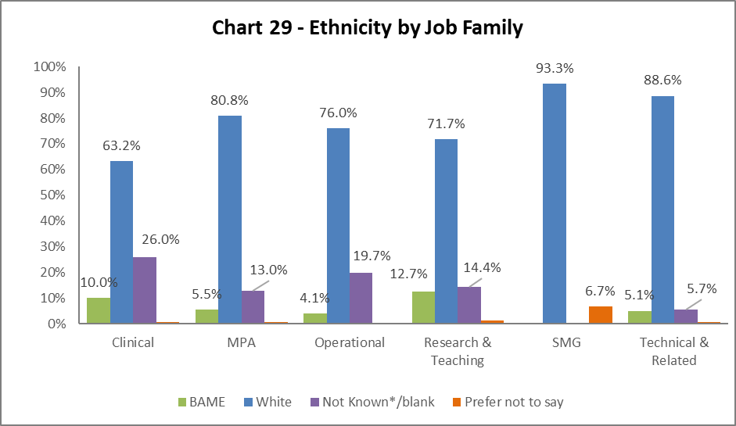

Chart 29 shows the highest proportion of BAME staff are in Research & Teaching roles, at 12.7%, a 1.2% increase from 2017-18. All job families show an increase in BAME staff, except for SMG which remains static.

## By Grade

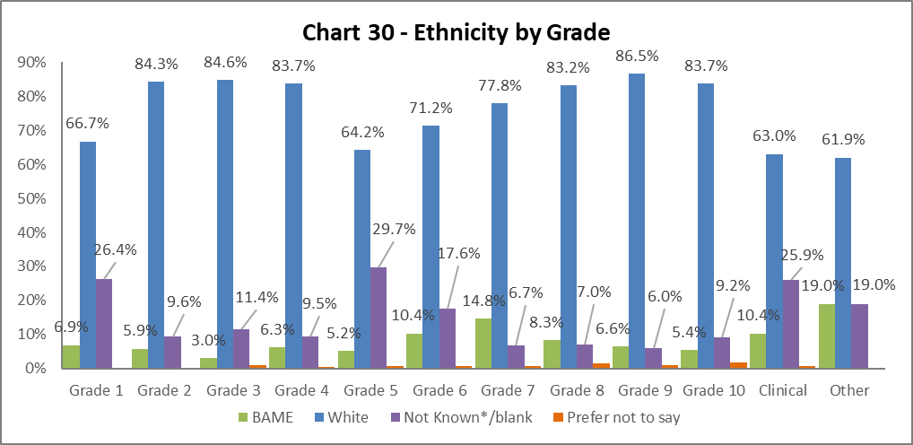

Chart 30 above shows the grade and ethnicities of staff. Most grades show an increase in BAME staff, except Grades 3 which has dropped by 0.6%. Grade 7 continues to have the highest percentage of BAME, with a further increase of 0.9% from 2017-18.

## By Full/Part Time

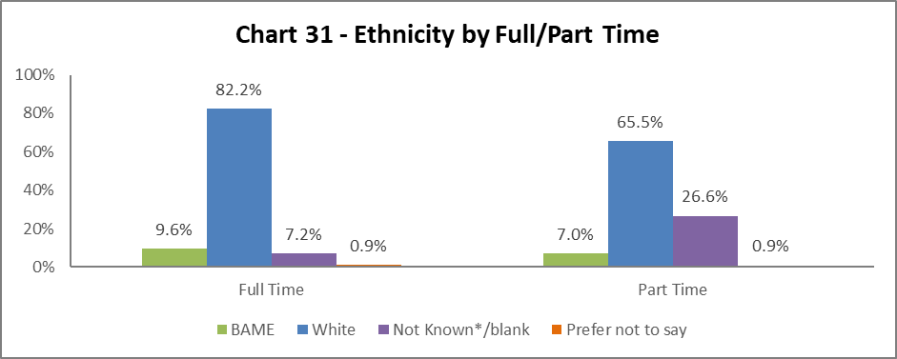

There has been an increase in BAME full time and part time staff since 2017-18 by 0.9% and 1.7% respectively. More BAME staff work full time than part time, reflecting previous years.

## By Contract Type

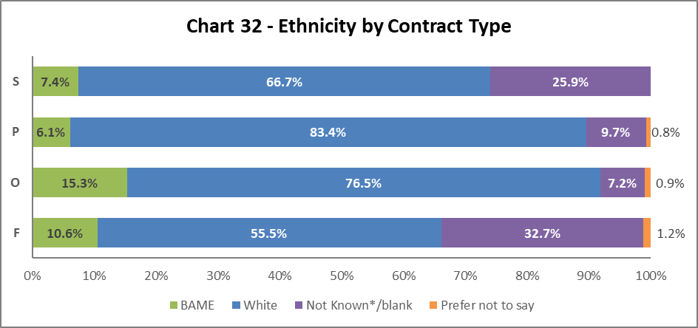

Chart 32 indicates the highest proportion of BAME staff are on Open-ended with funding end date (code O) contracts, an increase of 1.3% from 2017-18. All contract types have seen an increase in the percentages of BAME staff compared to last year.

## By Nationality

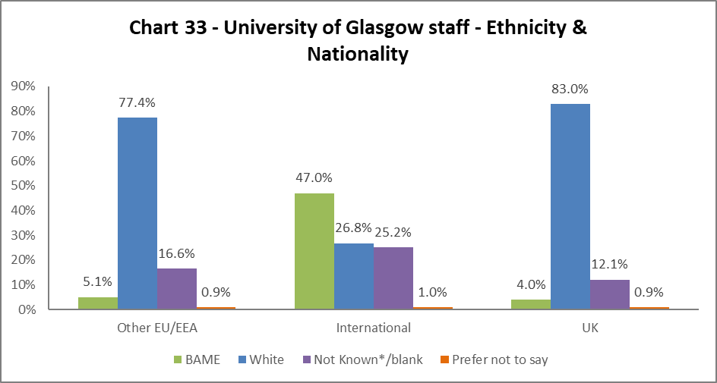

Chart 33 outlines that of our International staff 47% are from a BAME background, 5.1% of our EU/EEA staff are BAME, compared with 4% UK staff reported as BAME. These represent a 2.6% decrease in BAME International staff, a 1.6% increase in BAME EU/EEA staff, and a 0.4% increase for UK BAME staff from the last report.

## Recruitment – by Applications and Successful Applicants

**Image of a graph showing the Ethnicity Profile of Applicants to jobs at the University of Glasgow.  The Clinical Job Family received the highest percentage of applicants from a 'BAME' background at 43.9%. 40.1% of applicants to Research & Teaching jobs.  Roles within the MPA and Operational job families receive the lowest percentage of 'BAME' applicants at 13.5% and 11.7% respectively. 
**

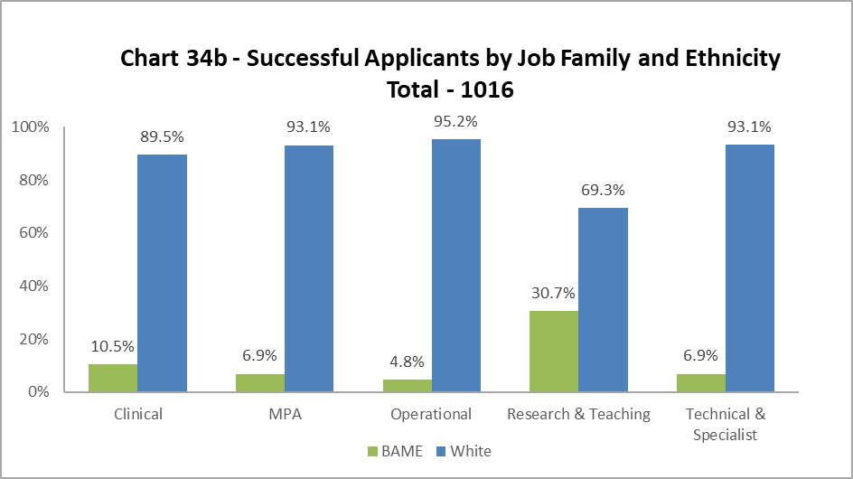

The data, as illustrated by Chart 34a and 34b, shows BAME staff are proportionally less likely to be appointed in all job family profiles. The greatest difference is seen in the Clinical job family, where the drop between applications and successful applicants is over 30% - it should be noted there will be a relatively low number of jobs advertised in this job family. In previous years the drop between applications and successful applicants in the Research & Teaching job families was considerable; this year it was 9.4%. In a change from last year, which saw just a 2.2% drop, the Technical and Related job family saw a drop of 12.1% in the proportion of BAME applications and successful applicants.

# Profile by Sex

## By College

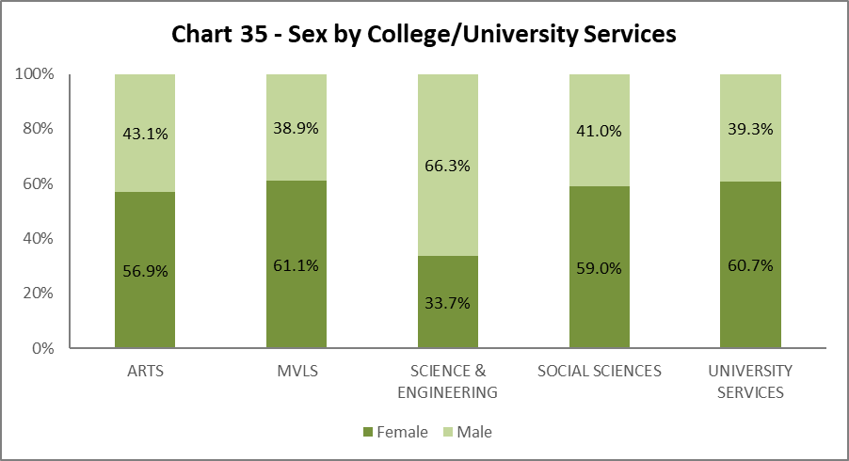

Chart 35 shows the split by Sex in College/US. All areas have a slight increase in Males, except for Science and Engineering who have had a 0.9% increase in Females.

## By Grade 10 Staff

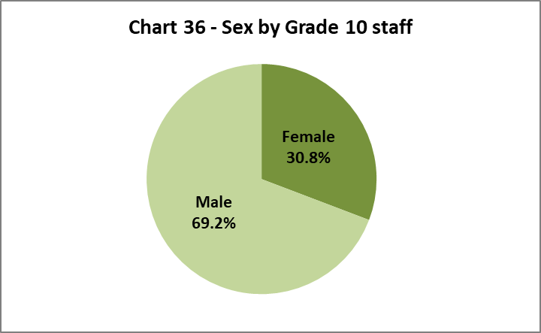

Chart 36 illustrates that 30.8% of senior staff are Female. This is an increase of 2.6% from 2017-18 and brings us closer to our Key Performance Indicator (KPI), of 33%[3] by 2020.

## By Job Family Profile

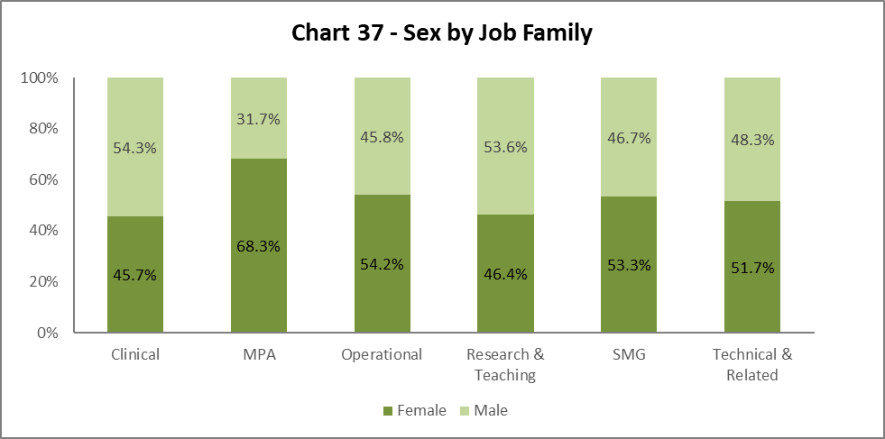

Chart 37 shows an increase in Females in SMG to 53.3%, an increase of 17.6% from 2017-18 - a significant milestone for the University. There has also been a decrease in Males in the MPA job family by 1.5%.

## By Grade

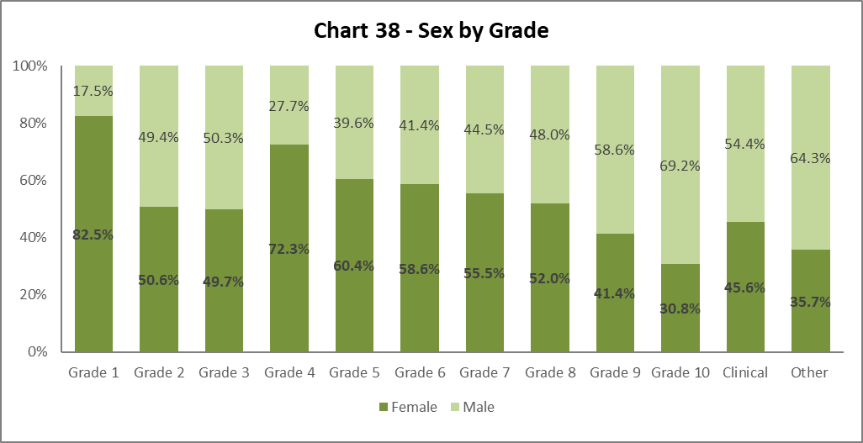

Chart 38 shows a similar pattern to previous years (with the exception of Grades 2 and 3, where there are almost 50:50 splits) as we climb the grades, the percentage of Male staff increases, and Female staff declines. The percentage of Females in Grade 4 continues to grow, by 2% since 2017-18 and from 63.7% in 2016-17.

## By Full/Part Time

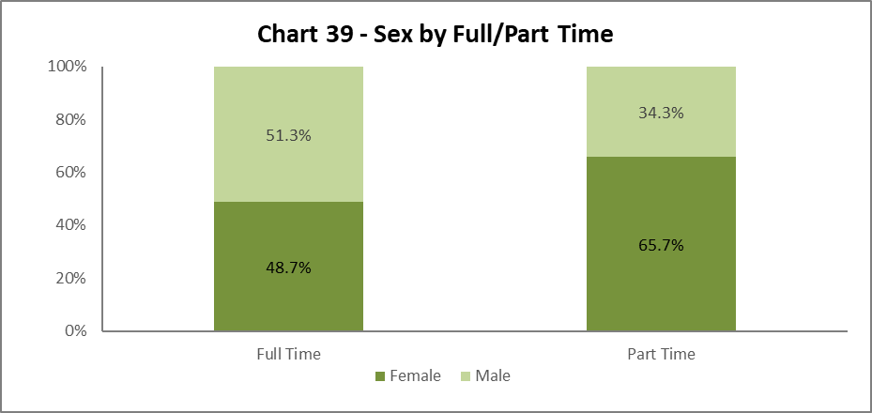

Chart 39 illustrates the breakdown by Sex of Full and Part Time staff. Approximately two thirds of all Part Time staff are Female, however the percentage of Males working part time has increased by 2% since 2017-18.

## By Contract Type

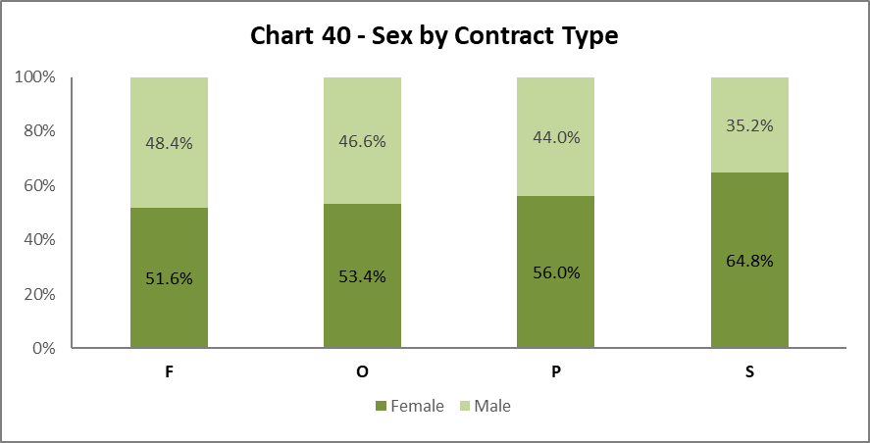

Chart 40 shows Females are more likely to hold an Open-ended contract (code P), this mirrors the data from 2017-18.

## By Nationality

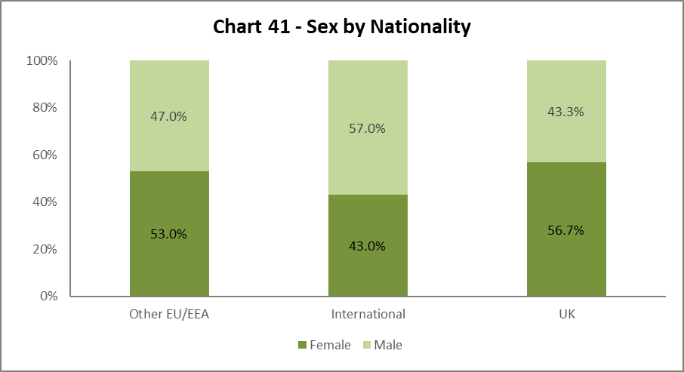  
  
Chart 41 shows Females and Males are fairly equally represented from EU/EEA. We have a higher proportion of Male International staff. Whilst for our UK staff the proportions are reversed, with nearly 57% Female staff. This profiles reflects the previous four reports.

## Recruitment – by Applications and Successful Applicants

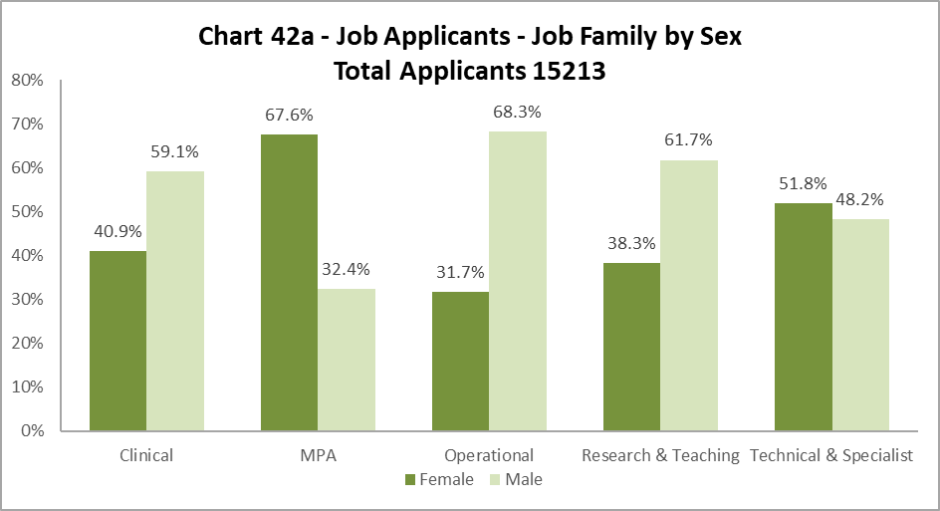

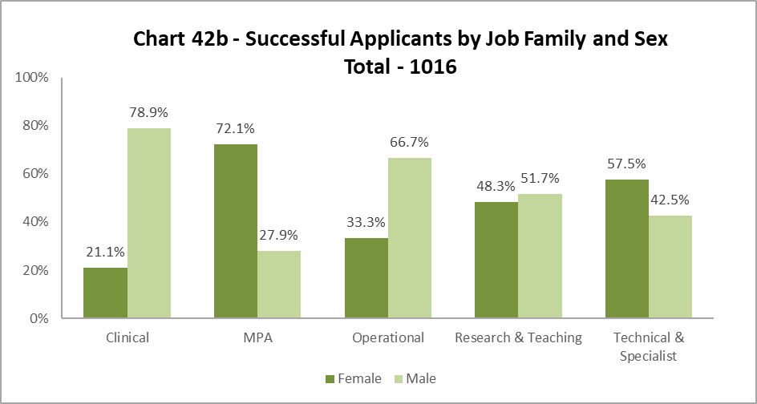

For most job families, the sex profile of applicants reflects those who are successful applicants, however in Research and Teaching, Females are proportionally more successful than Males, whilst in Clinical this is reversed.

# Profile by Sexual Orientation

32.8% of all staff have not answered the question on Sexual Orientation. As such ‘Not known/blank’ figures have been excluded from these graphics but have been included in the statistics which are used to create them.

## By College

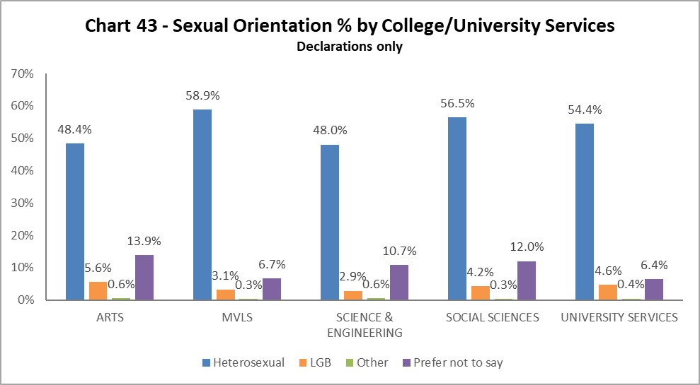

Arts have the highest proportion of staff who have declared as LBG compared to other Colleges/US; Science and Engineering has the smallest proportion. However, all Colleges/US have increased the percentage of LGB staff declarations compared to 2017-18.

## By Grade 10 Staff

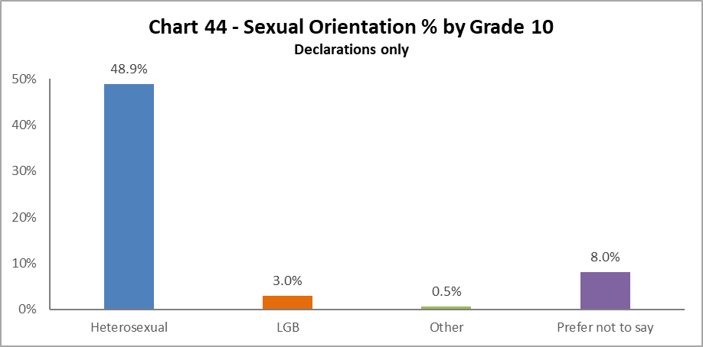

3% of Grade 10 staff identify as LGB, this is an increase of 0.3% from 2017-18.

## By Job Family

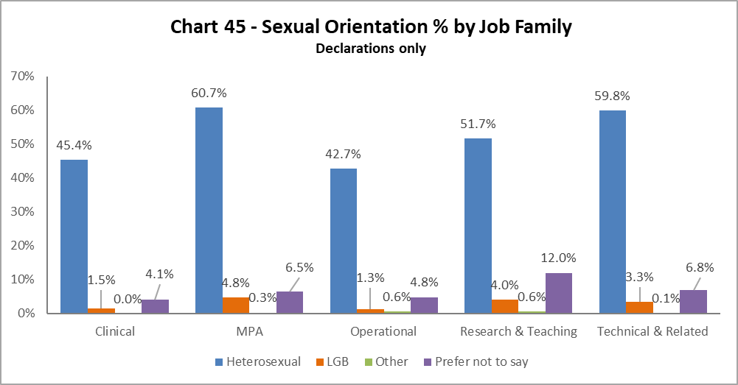

The highest proportion of LGB staff (4.8%) are in the MPA job family, an increase of 1.1% from 2017-18, with the lowest in Clinical and Operational.

## By Grade

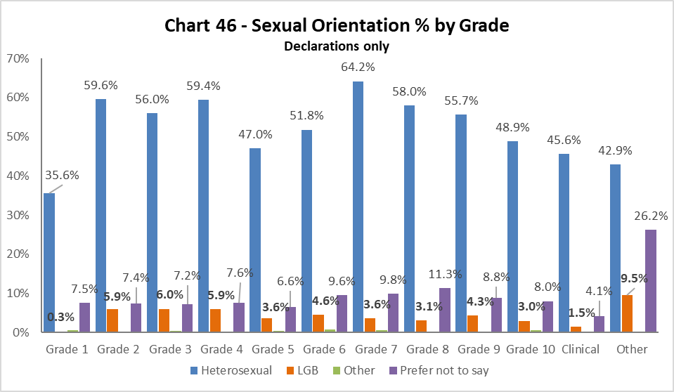

LGB staff are even spread across the grades, with the highest proportion in Grade 3. The only drop in declaration rates has been in Grade 5.

## By Full/Part Time

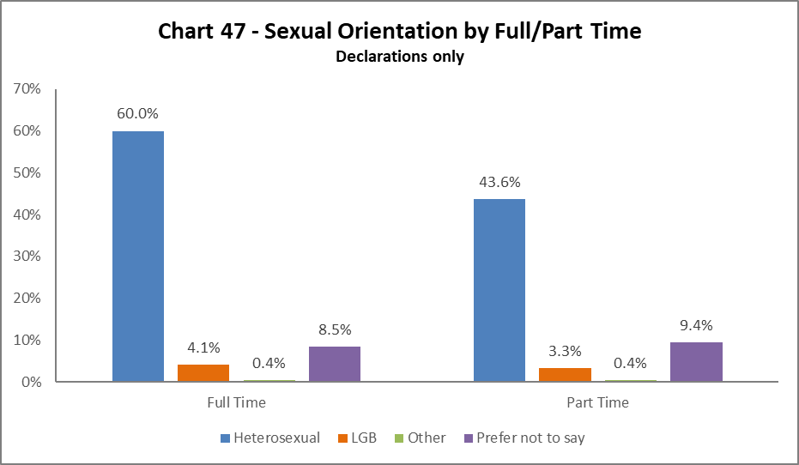

Most LGB staff work full time, however the proportion of LGB staff have increased in both full time and part time roles since last year.

## By Contrast Type

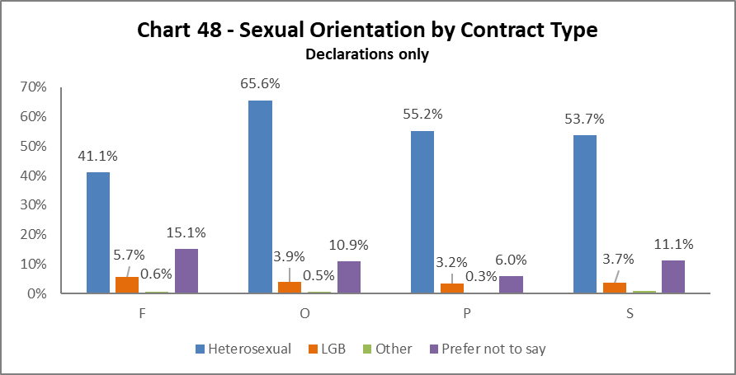

The highest proportion of LGB staff are those in the Fixed term (code F) contracts, this reflects 2017-18. The lowest proportion are on Open Ended (code P) contracts.

## By Nationality

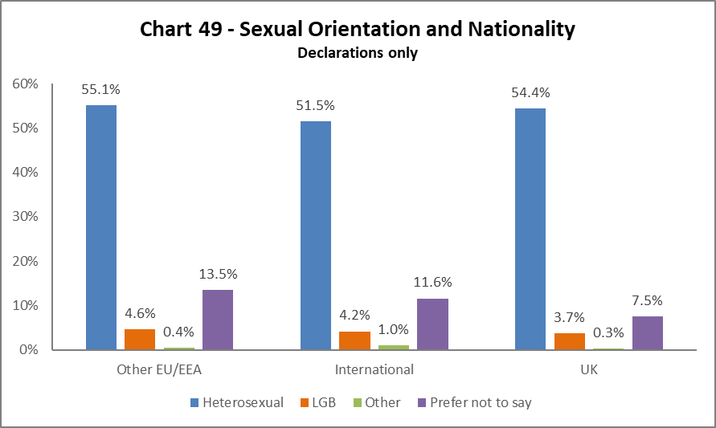

The highest proportion of LGB staff are from the EU/EEA, an increase of 0.9% on 2017-18 figures. There has been an 0.7% increase in LGB staff from the UK. International LGB staff figures are static compared to last year.

## Recruitment – by Applications and Successful Applicants

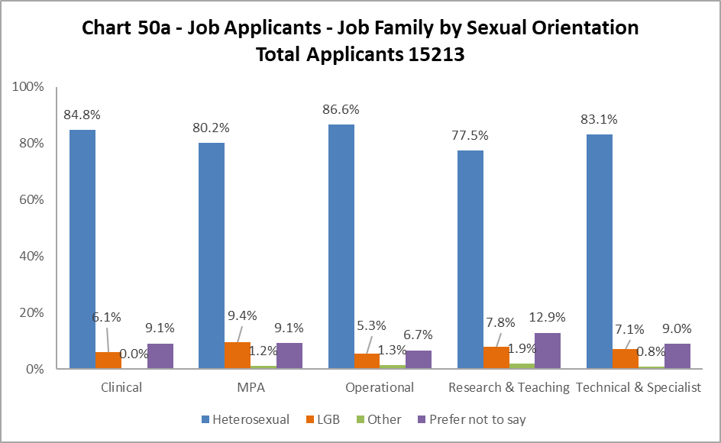

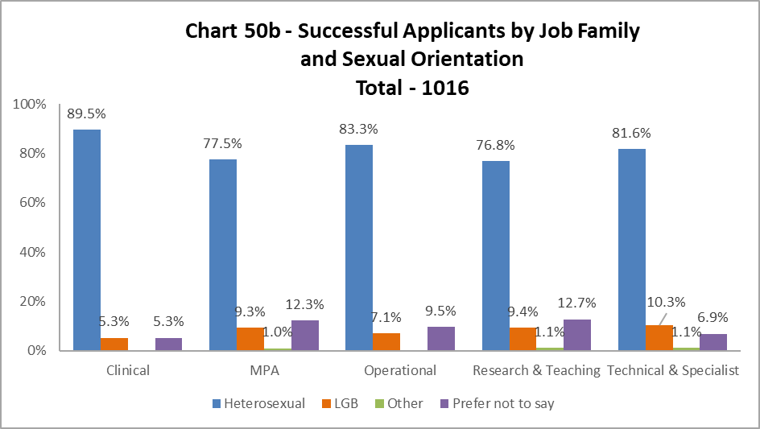

The percentages declaring Sexual Orientation at application stage are fairly high, including those declaring as LGB. The proportion of successful LGB applicants closely match that of the applicant pool across the job families, with Technical & Specialist showing an increase of 3.2%.

# Academic Promotions

|  |  |  |  |  |  |  |
| --- | --- | --- | --- | --- | --- | --- |
| **Table 11 - Academic Promotions 2019 - R&T and Clinical Job Families Only** | | | | | | |
| Grade Applied For |  | **Female** | | **Male** | | **Overall** |
| **No.** | **%** | **No.** | **%** | **No.** |
| **GRADE 7** | Apps | 15 | 52% | 14 | 48% | 29 |
| Successful | 14 | 56% | 11 | 44% | 25 |
| **Promoted (%)** | **93%** | | **79%** | | **86%** |
| **GRADE 8** | Apps | 29 | 42% | 40 | 58% | 69 |
| Successful | 28 | 45% | 34 | 55% | 62 |
| **Promoted (%)** | **97%** | | **85%** | | **90%** |
| **GRADE 9** | Apps | 26 | 46% | 31 | 54% | 57 |
| Successful | 23 | 52% | 27 | 54% | 50 |
| **Promoted (%)** | **88%** | | **87%** | | **88%** |
| **READER** | Apps | 7 | 33% | 14 | 67% | 21 |
| Successful | 6 | 40% | 9 | 60% | 15 |
| **Promoted (%)** | **86%** | | **64%** | | **71%** |
| **CLINICAL** | Apps | 5 | 83% | 1 | 17% | 6 |
| Successful | 3 | 75% | 1 | 25% | 4 |
| **Promoted (%)** | **0%** | | **100%** | | **67%** |
| **PROFESSOR** | Apps | 31 | 58% | 22 | 42% | 53 |
| Successful | 24 | 55% | 20 | 45% | 44 |
| **Promoted (%)** | **77%** | | **91%** | | **83%** |

**OVERALL SUCCESS RATE = 200 / 235 = 85%**

**OVERALL FEMALE SUCCESS RATE = 87% and OVERALL MALE SUCCESS RATE = 84%**

Table 11 provides breakdown by Sex of the Academic Promotions 2018-19 process. In general, slightly more Males (52%) applied for promotion than Females (48%). Females were more successful than Males in Grades 7-9 and Reader, while Males were more successful in Clinical roles and applications to Professor.

# Regrading for Professional & Support Staff

|  |  |  |  |  |  |  |
| --- | --- | --- | --- | --- | --- | --- |
| **Table 12 - Regrading 2018-19 - Professional and Support Staff by Grade** | | | | | | |
| Grade Applied |  | **Female** | | **Male** | | **Overall** |
| For | **No.** | **%** | **No.** | **%** | **No.** |
| **GRADE 1-5** | Apps | 20 | 69% | 9 | 31% | 29 |
| Successful | 17 | 65% | 9 | 35% | 26 |
| **Promoted (%)** | **85%** | | **100%** | | **90%** |
| **GRADE 6-10** | Apps | 30 | 71% | 12 | 29% | 42 |
| Successful | 19 | 63% | 11 | 37% | 30 |
| **Promoted (%)** | **63%** | | **92%** | | **71%** |

|  |  |  |  |  |  |  |
| --- | --- | --- | --- | --- | --- | --- |
| **Table 13 - Regrading 2018-19 - Professional and Support Staff by Job Family** | | | | | | |
| **Job Family** |  | **Female** | | **Male** | | **Overall** |
| **No.** | **%** | **No.** | **%** | **No.** |
| **MPA** | Apps | 37 | 93% | 3 | 8% | 40 |
| Successful | 26 | 90% | 3 | 10% | 29 |
| **Promoted (%)** | **70%** | | **100%** | | **73%** |
| **OPS** | Apps | 3 | 50% | 3 | 50% | 6 |
| Successful | 0 | 0% | 3 | 100% | 3 |
| **Promoted (%)** | **0%** | | **100%** | | **50%** |
| **TECH & SPEC** | Apps | 10 | 40% | 15 | 60% | 25 |
| Successful | 10 | 42% | 14 | 58% | 24 |
| **Promoted (%)** | **100%** | | **93%** | | **96%** |

**OVERALL SUCCESS RATE = 56 / 71 = 79%**

**OVERALL FEMALE SUCCESS RATE = 72% and OVERALL MALE SUCCESS RATE = 95%**

Table 12 above shows in all Grades Males are more likely than Females to be successful in the Regrading process, reflecting previous years. This is within the context of there being a significantly larger proportion of Females in these grades – Grade 1-5 are 64 % Female and Grades 6-10 are 61% Female. Further investigation would be required to understand this.

Table 13 shows a similar pattern to Table 12, with Males more likely to be successful in all job families compared to Females. It should be noted that the Technical & Specialist job family has had significant success in the Regrading process for both Males and Females.

# Equal Pay

The University has a duty to publish pay gap information by 30th April every two years under Regulation 7 of the Equality Act 2010 (Specific Duties) (Scotland) Regulations 2012. The most recent version was published on 30 April 2019.

Our Gender Pay Gap was calculated at 17.9%.  This is the percentage difference between Male’s average hourly pay and Female’s average hourly pay (excluding overtime). The University recognises the gender pay gap is significant and has established a Gender Pay Working Group which report to Human Resources Committee to address this.

**END.**

1. Source: [Scotland’s Census data; Additional and commissioned tables](https://www.scotlandscensus.gov.uk/ods-web/data-warehouse.html); Identity; Table AT_147_2011
2. As with last year MRC staff have been removed from this category and reallocated to the relevant grade based on salary scales.
3. University Strategy 2015-2020