GENERAL PROCEDURES FOR THE ORDERING, STORAGE, USE AND DISPOSAL OF RADIOACTIVE MATERIALS WITHIN THE UNIVERSITY OF GLASGOW

1 Introduction

The holding, use and disposal of radioactive materials in the UK is controlled by Regulations and Acts of Parliament. The two most important of these are:
‘Environmental Authorisations (Scotland) Regulations 2018’ (EASR 18) and
‘The Ionising Radiation Regulations 2017' (IRR 17). Compliance with the legislation is controlled by the environment agencies and the Health and Safety Executive respectively; in Scotland the controlling environment agency is called the Scottish Environment Protection Agency (SEPA).

Any company or individual wishing to use radioactive materials must apply for a permit under Regulation 23 of EASR 18. When granting these permits, SEPA will apply limits to the types of isotopes and activities held and strict conditions on the disposal of radioactive waste. These conditions are enforced by SEPA and failure to comply can be prosecuted under law.

Historically within the University each building using radioisotopes carried its own set of permits with their own holding and disposal limits. A consequence of this was each department had its own system for ensuring compliance with the regulations.

As part of its general review policy SEPA has decided to issue the University with ‘single site’ permits governing Gilmorehill and Garscube campuses. This requires the University to adopt campus-wide protocols dealing with the holding, storage, use and disposal of radioactive materials.

2 University Structure

The University Court carries the ultimate responsibility for the safety of its employees and visitors to the University and Heads of School are responsible for implementing safety arrangements within their units. Court is advised on safety matters by the University Health, Safety & Wellbeing Committee (HSWC). The HSWC oversees the work of the Radiation Protection Service (RPS) and receives the annual report of the RPS from the Radiation Protection Adviser. The remit of the RPS is to provide advice on ionising radiation, laser safety, microwave radiation, ultraviolet radiation and EMF radiation including mobile phones and mobile phone transmitting stations. The RPS also provides specialist services including the provision of personal radiation dosimeters, monitoring equipment, laboratory contamination surveys and the disposal of radioactive waste.

The RPS is overseen by the Radiation Protection Adviser (RPA) and his deputy, the Radiation Protection Officer (RPO). There is a full-time technician and a part-time administrator.

The head of each academic unit using ionising radiation is required by IRR 17 to appoint a suitable Local Radiation Protection Supervisor (LRPS) who is responsible for writing departmental local rules and ensuring that personnel within the department abide by these rules. Other duties include registering new radiation workers with the RPS and keeping records of the ordering, receipt, use and disposal of radioactive material.

When first registering with the RPS, a radiation worker must sign the registration form stating that he/she has read and understood the local rules and systems of work applicable to the academic unit.

3 Ordering Procedure

Each building/unit will be issued with holding and disposal limits and it is imperative that these limits are not exceeded. Every building/unit will also have to show the SEPA inspector that they have protocols in place which guarantee the limits cannot be breached. It is important to note that the holding limits are instantaneous limits and disposal limits are monthly.

Depending on the size of the building/unit and the numbers of orders placed, the LRPS may control the ordering system themselves or deputies may be appointed. The protocol is as follows:

(a) Before placing an order the end user must determine if, after placing the order, they are within building limits.
(b) Written orders must be countersigned by the LRPS or their deputy.
(c) Telephoned orders are allowed, however, the LRPS must be informed before the order is placed.
(d) Your LRPS will inform you of the correct delivery address.

Isotopes will be delivered initially to the RPS for contamination monitoring and the isotope, location and activity will be logged; this procedure is used as a secondary monitoring system. The RPS will deliver the isotopes to individual building/unit LRPS. On receipt of the isotope the LRPS will:

(i) Enter into their record-keeping system the isotope, activity and storage location. If, at this stage, it is found that the isotope ordered will breach the building limits then it must be returned unopened to the RPS.
(ii) Each isotope ordered will be issued with a duplicate record card (in addition to any electronic record); one card will travel with the isotope and be completed by each user, the other card will remain with the DRPS. An example of a record card is shown in the appendix.
(iii) Each aliquot taken from a source should be regarded as a separate isotope and should have its own record card and unique identification number.

(iv) When the isotope has been used up or has decayed below a certain limit (see academic local rules) then the empty vial should be disposed to the appropriate solid waste bin and the completed record card returned to the LRPS.

4 Storage and Use of Radioisotopes

(a) All radioisotopes must be stored in a safe and secure manner preferably, but not exclusively, in Controlled Radiation Areas. Storage of radioactive materials outwith controlled areas is permitted, however, the fridge, freezer or other storage container must have adequate locks fitted.
(b) There are handling limits for both Controlled and Supervised Areas which should not be exceeded. If it is suspected that an experiment may require more activity than that specified in the handling limits, then advice must be sought from the LRPS or the University Radiation Protection Adviser. The current handling limits can be found in the publication ‘Radiation Protection Notes’ copies of which can be obtained from the RPS.
(c) All work involving unsealed radioisotopes must be conducted in Supervised or Controlled Radiation Areas.
(d) All experimental procedures must have a risk assessment undertaken before being implemented. A generic Risk Assessment template can be found on the RPS web page.
(e) For each generic experimental procedure, a determination should be made regarding the expected split between the relevant waste streams and it is no longer acceptable to assume a waste split of say 80:20 liquid: solid waste.
(f) A full and complete record must be kept on a record card or electronically showing the history of that radioactive material from the date it is brought into the unit to its use and ultimate disposal

5 Disposal of Radioactive Waste

Use of unsealed radioisotopes invariably produces some low level radioactive waste. There are two types of waste stream: liquid and solid. To determine the relative percentages towards each stream, it is essential that for each type of experiment an accurate determination has been made for both liquid and solid waste. The results of this prior experiment can be used for all subsequent experiments of the same generic type.

Liquid Radioactive Waste
(a) All liquid (non-solvent) radioactive waste must be disposed to sinks marked with the legend ‘Caution this sink is used for the disposal of radioactive isotopes’ as disposal to non-marked sinks is an offence.
(b) Each disposal sink will be given a monthly disposal limit for each isotope and these limits must not be exceeded.
(c) Each disposal sink should have a log-sheet posted nearby and any disposals must be noted in the log-sheet as well as the record card. The log-sheet should contain the following information as a minimum: location, user, type of isotope, activity disposed and cumulative total for each isotope.
(d) No contaminated organic solvents or any unsuitable liquids are to be disposed as liquid waste as these should be collected in a suitable container and sent to the RPS for off-campus disposal.
(e) The monthly totals for each isotope should be collated by the LRPS and sent to Janice Thompson, RPO.

Solid Radioactive Waste
(i) Solid waste must be segregated and disposed to suitably marked containers; these can be found in both Supervised and Controlled Radiation Areas.
(ii) Waste bins will be marked and segregated into three groups which are: Tritium and Carbon 14 (C¹⁴) taken together; Phosphorous 32 (P³²) only; and any other beta/gamma (including S³⁵, Cr⁵¹, I¹²⁵ etc).
(iii) A log sheet (similar to that for liquid disposals) should accompany each waste bin and should be completed at the time disposals are made. This is in addition to recording on the isotope record card.
(iv) When the waste bins/bags are full, or when the log sheet indicates that three months have passed since the first deposit, the contents should be transferred to the RPS. A correctly completed waste label, available from the RPS, should accompany the consignment.
(v) There is a ‘round robin’ waste collection by the RPS every Tuesday afternoon, however, individual collections can be arranged by telephoning the RPS office.
(vi) Please note that "sharps" (ie, needles, broken glass etc) should not be deposited in the normal radioactive waste bin but should be deposited in special ‘sharps’ containers. Please note the RPS does not keep a stock of sharps containers.
(vii) The following will not be collected by the RPS:
(a) bags with incorrectly completed waste labels
(b) overly heavy bags
(c) bags which are leaking
(d) bags which are burst
(e) bags containing putrescent materials (animal carcasses etc)
(viii) Animal carcasses and other putrescent waste will be collected by special arrangement with the RPS.
(ix) The LRPS should keep an accurate record of all solid waste sent to the RPS. The RPS will provide a monthly report of all waste disposed together with the disposal route. Each individual department will thus be able to prove a ‘cradle to grave’ path for each isotope ordered.
(x) The waste collection and disposal service, provided free by the RPS, is for normal waste arising from ongoing experiments and research. It does not cover the disposal of unwanted stock isotopes and disposal of these items through the solid waste route will be borne by the departments concerned. It is therefore recommended that unwanted isotopes be disposed, as far as possible, by the liquid waste disposal route.

6 Contamination Control
It is part of each academic unit’s Local Rules that users regularly monitor their work area (see Radiation Protection Notes Section 7) before, during and after working with unsealed radioisotopes and this should continue as before. Additionally, each Controlled/Supervised Radiation Area is thoroughly monitored periodically by either the LRPS or other designated staff. It has been traditional to record this exercise simply (ie, ticking a check box) however as part of our new Authorisation, SEPA has indicated that they wish the recording of contamination monitoring to be more formalised with ‘tick boxes’ no longer acceptable.

Each Controlled Radiation Area should have a floor plan which has been divided up into monitoring sections; the number of sections depends on the size of the room. A log sheet detailing the results of the contamination surveys should be kept with the following being the minimum information required:

(a) Room No
(b) Date of survey
(c) Section monitored ie, A, B etc
(d) Type of monitor used – Mini E, EP15 etc
(e) Monitor calibration due date - should be on monitor
(f) Result for each section, either in cps or Bq/cm² (conversion on monitor)
(g) Monitor background reading (taken outwith the radiation area)
(h) Any reading above the ‘acceptable’ level of 3 Bq/cm² should be noted in a separate incident log together with the remedial action taken.

If Tritium is used in the area then, in addition to the above, swabs should be taken and analysed in a liquid scintillation counter. The RPS has produced an interactive Excel spreadsheet for recording swab results and this will be made available on our website or can be sent via e-mail on request.

The frequency of the monitoring depends on the usage of the relevant area; heavily used Controlled Areas should be monitored on a weekly basis whilst less used areas can be monitored monthly.

It is not proposed to extend the above procedures to include Supervised Areas and present arrangements for contamination control of these areas should proceed as before. It is recommended, however, that an incident log be kept whenever an area of contamination is discovered.

7 Internal Source Audits
(a) The RPS will carry out an independent isotope stock check of each department/ unit's holdings every six months.
(b) Additionally each building/unit should carry out their own regular internal audit and for larger departments this should be done on a monthly basis.

8 Notification of Occurrences

Radiation Protection Supervisors shall notify the Radiation Protection Service (RPS) whenever a quantity of a radioactive substance, which was under their control and which exceeds the quantity specified in Column 1 of the table in Appendix 2, has been released or is likely to be released into the atmosphere as a gas, aerosol or dust or has been spilled or otherwise released in such a manner as to give rise to significant contamination.

Where there is reasonable cause to believe that a quantity of a radioactive substance exceeding the limits in Column 2 of the table in Appendix 2 is lost or has been stolen, again the RPS must be informed. A full investigation will be carried out by the RPS and the HSE and SEPA informed.

It should be noted that the quantities in the table in Appendix 2 refer to levels that must be reported to the HSE and SEPA. Whenever lower levels of contamination are discovered the RPS will assist with decontamination

9 Emergency Procedures

Where a radiation accident is accompanied by serious personal injury, treatment of the injury takes precedence over decontamination and containment of contamination. If a member of staff needs to visit the local Accident and Emergency (currently Queen Elizabeth University Hospital) It is advisable to forewarn A & E of the nature and activity of the contamination so that preparations for the reception of the patient can be made. This information should be put in writing and be carried by a responsible person accompanying the patient to the hospital.

Laboratory Fires and Explosions

In the event of a fire or explosion affecting a Controlled or Supervised Radiation Area, building fire drills should be followed and the Local Radiation Protection Supervisor and the University Radiation Protection Service should be informed. In the event of the fire brigade arriving before the LRPS or the URPS, a responsible person should give relevant information regarding the location, type and activity of any radiochemicals within the fire area. It is considered radiologically safe for emergency services to enter Supervised Radiation Areas because of the low handling and storage limits, but chemical suits and breathing apparatus should always be worn when entering Controlled Radiation Areas and then only on the advice of a responsible person. It is essential that each LRPS/responsible person should have at their disposal an up to date list of all the Supervised and Controlled Areas within their areas of responsibility.

These procedures should be read in conjunction with each building/unit "Local Rules" and any other relevant Health and Safety policy, together with the ‘Radiation Protection Notes’ published by the Radiation Protection Service and available from the RPS office in the Kelvin Building.

James M Gray June 2015
University RPA Amended, March 2020
Appendix 1

Examples of a Record Card and a Waste Label – both can be obtained from the main Radiation Protection office in the Kelvin Building or can be posted out to you on request;
Office Tel no: 0141 330 4471

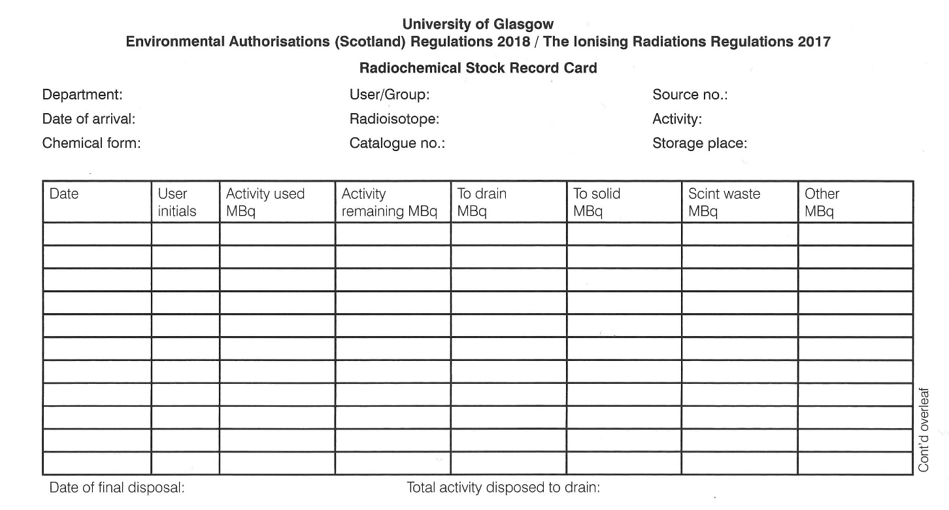

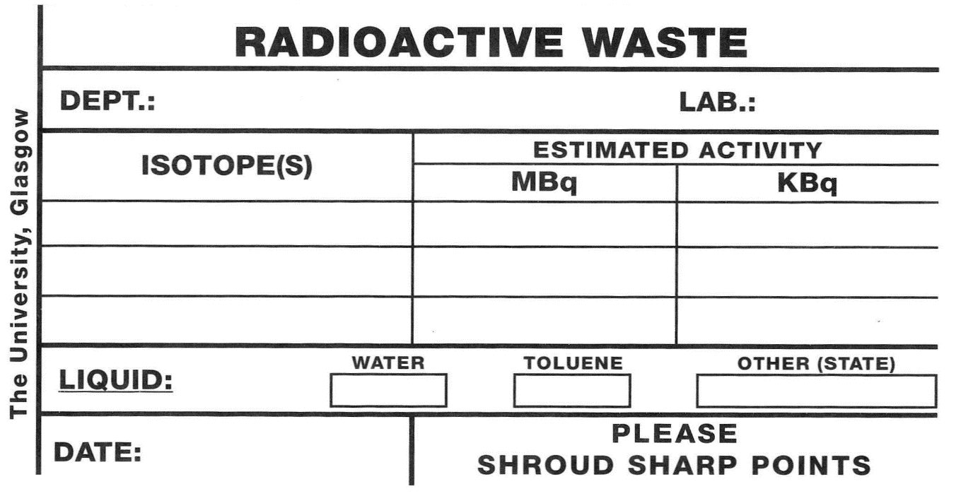

Appendix 2

 | Quantity for notification of release or spillage. (Bq) | Quantity of notification of loss or theft. (Bq)
Tritium | 1 x 10¹² | 1 x 10¹⁰
Carbon 14 | 1 x 10¹¹ | 1 x 10⁸
Phosphorous 32 | 1 x 10¹⁰ | 1 x 10⁶
Phosphorous 33 | 1 x 10¹¹ | 1 x 10⁹
Sulphur 35 | 1 x 10¹¹ | 1 x 10⁹
Chlorine 36 | 1 x 10¹⁰ | 1 x 10⁷
Calcium 45 | 1 x 10¹⁰ | 1 x 10⁸
Chromium 51 | 1 x 10¹² | 1 x 10⁸
Iron 55 | 1 x 10¹¹ | 1 x 10⁷
Technetium 99m | 1 x 10¹³ | 1 x 10⁸
Iodine 125 | 1 x 10¹⁰ | 1 x 10⁷
Iodine 131 | 1 x 10¹⁰ | 1 x 10⁷

Excerpt from Schedule 7 IRR17 Regulation 31, for the most common isotopes used in Glasgow University – see IRR17 for the full listing.

